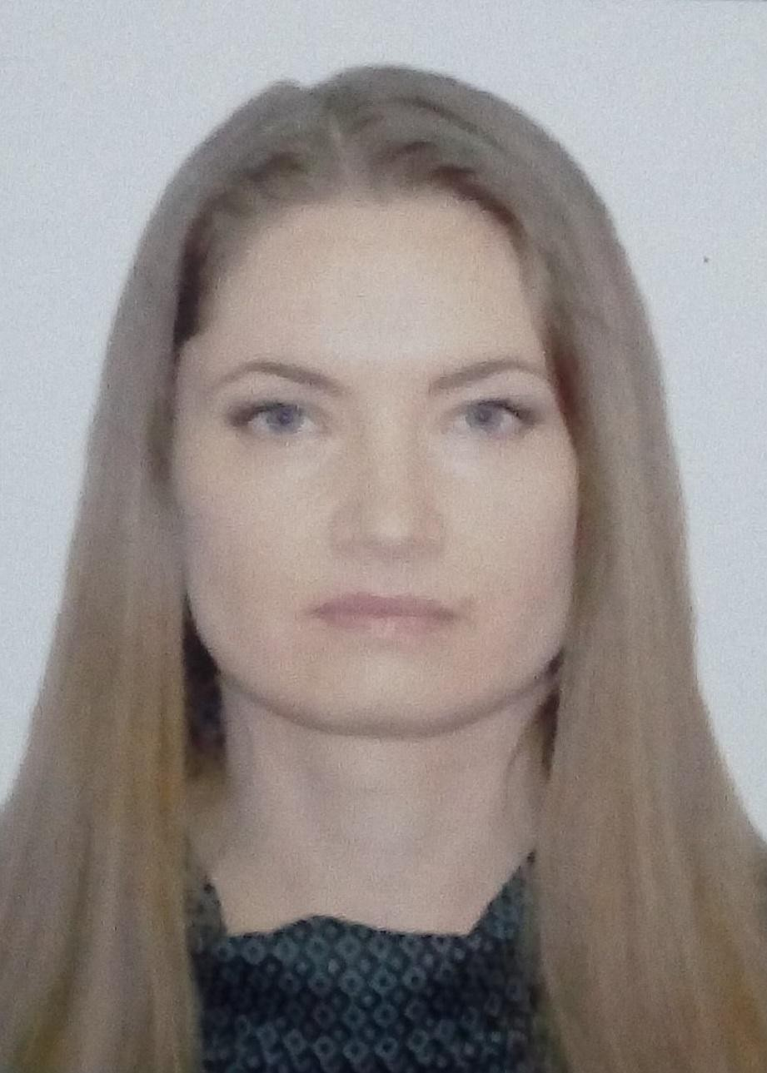

Gagauz Marianna

Personal Information
Zelinski Str Chisinau, Moldova
+37379200440
maryanne127@gmail.com
Birth date 31/07/1979
Married with two children (16 and 19 years)

Objective
Teacher of English

Skills
Class management, understanding the individual needs of students, good pronunciation in English, good computer knowledge, practicing audio and video material with students, experienced working with different British and American manuals.

Work Experience
2001-2006
“The Lyceum of Foreign Languages, Univers Moldova”- English Teacher
- Secondary school classes- English
- High school classes- English and English literature

April 2007-July 2009
“Bergen Limo”, NJ USA- Dispatcher
2010-2017 Private Teaching
2016-2023 European Language Centre “ORATORICA”
March 2018- on going “American Language Center”
(patenta 2018-2023, contract 2023-on going)
SETRL (Supporting English Teaching and Learning for Russians): November 2022 – May 2024
AmEA (American English Academy Online): June 2024 – January 2025

Education
1996-2001
The Moldova State University -English language and literature -License degree

Professional Development:
October 2017- May 2018 Impact English Training (ALC)
META MOLDOVA trainings for teachers
ORATORICA Trainings
Cartego Cambridge Online Day Trainings
Pearson Longman Trainings
Current:

The Essentials of Educating Adults (Alison)
OPEN COURSE -Fostering Student Motivation and Engagement (December 2025-on going)

