CURRICULUM VITAE – CERLAT IACOB

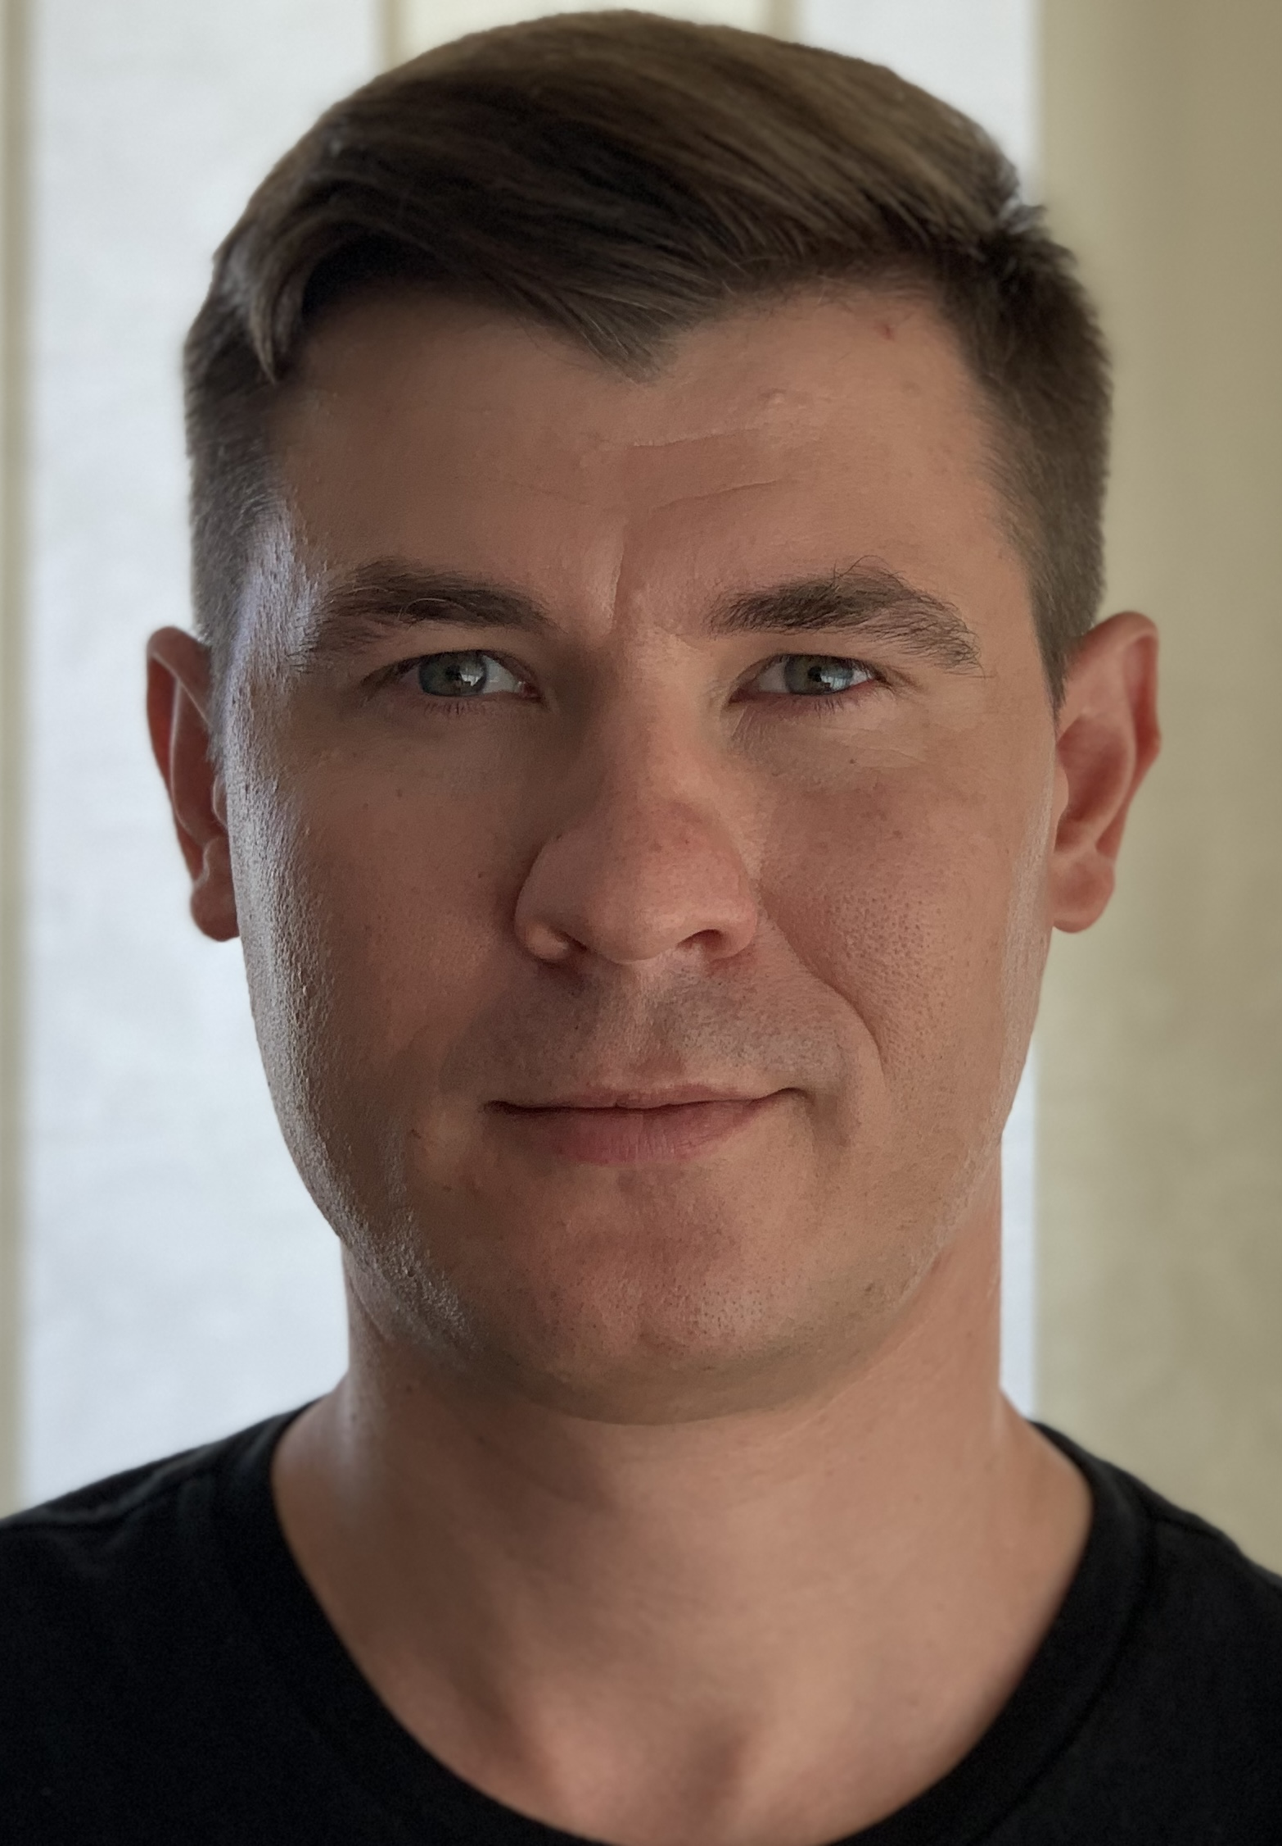

Date of birth: 27 February 1987
Nationality: Romanian / Moldavian Gender: Male
Phone nr: +40742763367/+37360035125
E-mail: cerlatiacob@gmail.com
Skype ID: Cerlat. Iacob

EDUCATION
- 10/2012– 03/2014
Master’s degree in Drilling Engineering, Oil-Gas University of Ploiesti, Romania
- 10/2008 –07/2012
- Bachelor’s Degree in petroleum and Gas Engineering, Oil-Gas University of Ploiesti, Romania
- 09/2003- 06/2007 Polytechnic College, Chisinau, R. Moldova

LANGUAGES
- Native -Romanian
- Fluent – Russian
- Professional working proficiency – English
- Professional working proficiency - France

EMPLOYMENT HISTORY

12.2021-Present
Repede Pressure Control
Chief Executive Officer (CEO)
Supervising production flow
- Supervising appliance with API requirements
- Develop business strategy
- Banks negotiating
- Participation in elaboration of strategic policy by top management of
company
- Develop and implement of sales strategies
- Analisys of contracts documents and tendering process documents
- Develop and implement solutions to optimize and streamline
the production process.

09.2022-02.2023
Geofluid Paris, SEER Griny-Viry, Griny 2 Project
Drilling supervisor Geofluid France
Drilling Supervision on deep geothermal doublet Wells in Paris Grigny , Gringny 2

11.2021-09.2022
Alpine Geothermal Power Productio S.A
Drilling supervisor AGEPP
Drilling Supervision on deep geothermal Wells in SWISS, Lavey 1.
https://www.agepp.ch/

09/2019-11.2021
GPC INSTRUMENTATION PROCESS, Paris.
Drilling supervisor
Drilling Supervision on deep geothermal Wells. Drilling Doublets Geothermal. Bobigny.
http://www.geoproduction.fr/fr
http://www.thinkgeoenergy.com/new-geothermal-heating-project-targets-deeper-depths-in-paris-area/

09/2018-09.2019
OMV Petrom S.A., member of OMV Group, Bucharest, Romania
Drilling supervisor/ Gas and oil.

- Implementing drilling operations and ensuring that are completed as per schedule. Planning, organising, and coordinating oil rig operations. Make regular daily drilling reports on the progress of operations. Implementing safety measures and regularly monitoring them for irregularities.
- Systematic documentation of the oil rig operations.
- Managed all logistics for equipment to and from locations
- Used water/oil-based MUD’s
- Drilled oil and gas horizontal wells.
- Drilled wells in exaggerated folds diapiric area – with cavings and pack off tendency.
- Projects using long 8,5” sections – 1000m-1800m open hole.
- Drilling heterogeneous reservoirs.
- Projects using depleted reservoirs with differential sticking tendency.
- Projects using partial and total losses zones.
- Drilled side-tracks wells.
- Well control
- HPHT projects
- Managed and create SIMOPS.

01/2016-09/2018
- Drilling supervisor offshore, GSP Saturn (amphion), North Sea Operations, Winter shall Nord zee, Netherlands. Operator Gazpromneft Sakhalin, Dolginskoe field (Arctic Region), Pechora Sea, Russia
- Implementing drilling operations and ensuring that are completed as per schedule. Planning, organising, and coordinating oil rig operations. Make regular daily drilling reports on the progress of operations. Implementing safety measures and regularly monitoring them for irregularities.
- Systematic documentation of the oil rig operations.
- Managed all logistics for equipment to and from locations
- Used water/oil-based MUD’s
- Differential sticking zones.
- Projects using partial and total losses zones.

01/2014-12/2016
Toolpusher offshore, GSP Uranus (Amphion), Azov Sea Operations, Temriuk. From 1st june 2016, operator PRIAZOVNEFT, well GEOLOGICHESKAYA#1-

- Management of the daily drilling operations, monitoring the work process and handling any potential problems
- Making sure that all the required equipment, resources and materials are present at the site
- Selecting, hiring, and controlling workers and making sure they have a proper training
- Scheduling the crew members’ shifts and rotas
- Making sure that all health and safety regulations are being obliged, such as the wearing of special protective clothing and the proper use of safety equipment
- Managing emergencies
- Liaising with oil company representatives that visit and inspect the oil site
- Conducting or making sure that regular inspections of the rig are being performed
- Providing assistance to other crew members, like the rig manager and the driller, for the rig’s effective operation

08/2012-01/2014
OMV Petrom S.A., member of OMV Group, Bucharest, Romania
Drilling supervisor/ Gas and oil onshore/offshore.
- Implementing drilling operations and ensuring that are completed as per schedule. Planning, organising, and coordinating oil rig operations. Make regular daily drilling reports on the progress of operations. Implementing safety measures and regularly monitoring them for irregularities.
- Systematic documentation of the oil rig operations.
- Drilled horizontal and deviated wells using CwD for first section TVD – 1000m- 2000m.
- Drilled horizontal and deviated wells more than 500m-1000m.
- Projects using long 8,5” sections – 1000m-1500m open hole.
- Drilling heterogeneous reservoirs – drilled wells with salt intercalations.
- Projects using depleted reservoirs – MD – 2500m-3500m.
- HPHT projects

07/2011 – 08/2012
Casco Petroleum Middle East LTD. Barda Rash, Kurdistan Region, Iraq
Night Drilling supervisor

- Planning, organising and coordinating oil rig operations. Make regular daily drilling reports on the progress of operations. Implementing safety measures and regularly monitoring them for irregularities.
- Systematic documentation of the oil rig operations.
2008 - 2012 Scholarship from ASCOM S.A. drilling company. (During university’s holidays (summer and winter) work in rig site in Kazakhstan and Iraq)

PROFESSIONAL TRAINING
- 09/2023 IWCF Level 4, Petroleum-Gas
University of Ploiesti, Romania, Certificate Expiry Date: 09.2023
10/2018 Defensive drive course
- 09/2018 BOSIET approved course.
- 09/2018 Stuck pipe course.
- 05/2012 – 09.2014 IGD_Drilling_Class
- 09/2014 DSV Training Package
- 06/2014 Open wells - Landmark
- 08/2012 Makeup of Tubular Goods (Casing and Tubing) OMV Petrom SA, Bucharest, Romania
- 05/2012 Introduction to HSE Drilling Operation, Malvo Invest, Ploiesti, Romania
- 2008-2012 Scholarship from ASCOM S.A. drilling company. (During university’s holidays work in rig site)

PROJECTS
- Well projection
- Fluids Transportation and Storage
- Projection of well operating conditions in situations of continuous gas lift or using rod pumps
- My license thesis was on the subject: well projections with large diameter (I have obtained 9.0 out of 10)
Awards
- 10/2008 – 07/2012 University Scholarship awarded by ASCOM Group S.A.

COMPUTER SKILLS
- MS Office (Word, Excel, Power Point).

PERSONAL
- Responsible, ambitious, flexible, and efficient, I take hard work seriously, though possessing a good sense of humour, with an aptitude for creative problem solving and analysis with attention to detail. Good team skills and strong communication abilities

- Driver’s license A,B,C

