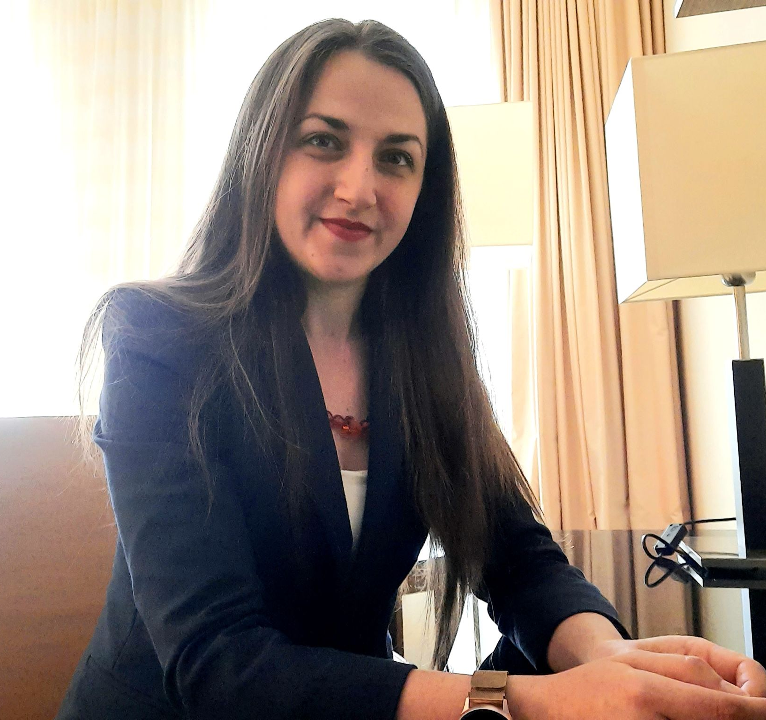 |  | Olga Rusu
 |  | Deputy-director of the Department, Head of the Division
 |  | Stratup Tracker
PERSONAL INFORMATION |  | WORK EXPERIENCE
  Chișinău, Moldova |  | Deputy-head of the Department, head of the division  National Bank of Moldova, Financial Stability Department, Macroprudential Policy Division | May 2023 – now  Head of the division  National Bank of Moldova, Financial Stability Department, Systemic Risk Analysis Division | Mar 2023 – May 2023  Deputy Head of the division  National Bank of Moldova, Financial Stability Division | Feb 2017 – Mar 2023  Economist (1Y 10M) / Head of the unit (1Y 4M)  National Bank of Moldova, Banking Supervision Department, Financial Stability and Banking Resolution Division Financial Stability Unit | Nov 2013 – Jan 2017  Cashier (11M) / Accountant (11M) / Economist (1Y 6M)  “Banca de Economii” JSC | Aug 2010 – Nov 2013
 +37369355621

ohomina@gmail.com
Age 34 years
Trying to make this world better!
SKILLS |  | EDUCATION AND TRAINING
- Banking & Finance  - Financial analysis  - Risk Assessment  - Leadership & Management  - Business Strategy  - Marketing  - Accounting  - Data Processing |  | Certified Startup Tracker  Startup Academy Moldova| 2021  Leadership and Management Training  Train of Trainers Program  2021  Master of Economic Sciences (Banking Administration)  Academy of Economic Studies of Moldova | 2012  Licentiate in Economic Sciences (Finance and Banks)  Academy of Economic Studies of Moldova | 2010  Bachelor’s degree in real sciences  Academy of Economic Studies of Moldova | 2007
Tracking Projects |  | Languages |  | Digital Skills
Team Tracker  AgTech Accelerator, AgTech Innovation Lab, Moldova | 2022  Team Tracker  Digital Upgrade Cahul, Startup City Cahul Project, Moldova | 2022-2023 |  | Russian  Romanian English  French | Native  Native  Proficient User  Idependent User | MS Office  MATLAB  EViews  PowerBI | Proficient User  Basic User  Basic User  Independent User

