


Chisinau, Moldova | December 01, 2022

Reference No: MD-22-11 – Dark Fiber Services

Invitation to participate in the Services procedure

The Research and Educational Networking Association of Moldova RENAM (State identification number 1012620003140) intends to purchase the Services in scope of the GEANT project ”The development of the optical infrastructure of the RENAM network in the municipality of Chisinau to improve the access of educational and research institutions”.

Specification form is presented in Annex1.

The schematic diagrams of lots 1-3 are presented in Annexes 2-4.

The general schematic diagram is presented in Annex 5.

KMZ files are presented in Annex 6.

The services are VAT exempt.

Potential supplier should provide the following documents:
- Quotation form with prices in Euro;
- Filled Specification Form;
- European single procurement document (DUAE);
- Enterprise registration certificate

Awarding
- Under this procurement, RENAM can award one or more contracts for services that RENAM requires.
- The number of Lots for this procurement are set out in Annex 1 below and represent the required service that meet RENAM’s requirements in areas of the network.
- For all Lots RENAM’s requires Bidders to design for Routes that must terminate in the A-end and B-end (PoPs).
- Bidders are asked to fill out all pricing related aspects in Annex A (Pricing and CDD Template).

We invite You to participate in the procurement procedures and submit a procurement offer not later than 16:00 at local (Chisinau) time of January 16, 2023.

Annexes:
- Annex 1: Specification Form;
- Annex 2: Schematic diagram of Lot 1;
- Annex 3: Schematic diagram of Lot 2;
- Annex 4: Schematic diagram of Lot 3;
- Annex 5: General schematic diagram
- Annex 6: KMZ files.

Sincerely,

Research and Educational Networking
Association of Moldova RENAM,
Chairman of RENAM Administration Council
Dr. Petru Bogatencov

Annex 1 Specification Form
Lot name | A-end | B-end | Dark Fiber max. distance, m | Fiber count | Dark Fiber Connectivity Service | Contract Term (IRU) with Extensions, years | Max CDD days | Fiber standard | Maximum end-of- life attenuation guaranteed value [dB], 1310nm | Maximum end-of- life attenuation guaranteed value [dB], 1550nm
Lot 1  UTM2 - ISA | UTM2 | ASEM | 1500 | 18 | Underground (as an exception, partially aerial) | 15+3 *2  or/and 10+3*2 | ≤ 120 | G.652D | 1dBm | 0,7dBm
Lot 1  UTM2 - ISA | ASEM | SCMSAM | 900 | 16 | Underground (as an exception, partially aerial) | 15+3 *2  or/and 10+3*2 | ≤ 120 | G.652D | 0,5dBm | 0,4dBm
Lot 1  UTM2 - ISA | SCMSAM | USEFS(M) | 2200 | 14 | Underground (as an exception, partially aerial) | 15+3 *2  or/and 10+3*2 | ≤ 120 | G.652D | 1,5dBm | 1dBm
Lot 1  UTM2 - ISA | USEFS(M) | MUSIC SCHOOL | 1400 | 12 | Underground (as an exception, partially aerial) | 15+3 *2  or/and 10+3*2 | ≤ 120 | G.652D | 1dBm | 0,5dBm
Lot 1  UTM2 - ISA | MUSIC SCHOOL | ASEM CAMIN | 1200 | 10 | Underground (as an exception, partially aerial) | 15+3 *2  or/and 10+3*2 | ≤ 120 | G.652D | 1dBm | 0,5dBm
Lot 1  UTM2 - ISA | ASEM CAMIN | USM CAMIN | 300 | 8 | Underground (as an exception, partially aerial) | 15+3 *2  or/and 10+3*2 | ≤ 120 | G.652D | 0,5dBm | 0,3dBm
Lot 1  UTM2 - ISA | USM CAMIN | UTM3 CAMINE | 2500 | 6 | Underground (as an exception, partially aerial) | 15+3 *2  or/and 10+3*2 | ≤ 120 | G.652D | 1,5dBm | 1dBm
Lot 1  UTM2 - ISA | UTM3 CAMINE | UTM3-7 | 500 | 4 | Underground (as an exception, partially aerial) | 15+3 *2  or/and 10+3*2 | ≤ 120 | G.652D | 0,5dBm | 0,4dBm
Lot 1  UTM2 - ISA | UTM3-7 | ISA | 1300 | 2 | Underground (as an exception, partially aerial) | 15+3 *2  or/and 10+3*2 | ≤ 120 | G.652D | 1dBm | 1dBm
Lot 2 UTM2-ULIM | UTM2 | ULIM | 1300 | 6 | Underground (as an exception, partially aerial) | 15+3 *2  or/and 10+3*2 | ≤ 120 | G.652D | 1dBm | 0,5dBm
Lot 3  UTM2-GENETICA | UTM2 | AMTAP CAMIN1 | 1300 | 30 | Underground (as an exception, partially aerial) | 15+3 *2  or/and 10+3*2 | ≤ 120 | G.652D | 1dBm | 0,5dBm
Lot 3  UTM2-GENETICA | AMTAP CAMIN1 | USM CULTURA | 1500 | 28 | Underground (as an exception, partially aerial) | 15+3 *2  or/and 10+3*2 | ≤ 120 | G.652D | 1dBm | 0,7dBm
Lot 3  UTM2-GENETICA | USM CULTURA | ASM | 1500 | 14 | Underground (as an exception, partially aerial) | 15+3 *2  or/and 10+3*2 | ≤ 120 | G.652D | 1dBm | 0,7dBm
Lot 3  UTM2-GENETICA | ASM | IMINOVA | 3500 | 10 | Underground (as an exception, partially aerial) | 15+3 *2  or/and 10+3*2 | ≤ 120 | G.652D | 2dBm | 1,5dBm
Lot 3  UTM2-GENETICA | IMINOVA | UTM9 | 2700 | 8 | Underground (as an exception, partially aerial) | 15+3 *2  or/and 10+3*2 | ≤ 120 | G.652D | 1,5dBm | 1dBm
Lot 3  UTM2-GENETICA | UTM9 | UTM9 CAMIN3 | 300 | 2 | Underground (as an exception, partially aerial) | 15+3 *2  or/and 10+3*2 | ≤ 120 | G.652D | 0,5dBm | 0,4dBm
Lot 3  UTM2-GENETICA | UTM9 | MOTHER& CHILD | 1600 | 6 | Underground (as an exception, partially aerial) | 15+3 *2  or/and 10+3*2 | ≤ 120 | G.652D | 1dBm | 0,7dBm
Lot 3  UTM2-GENETICA | MOTHER& CHILD | GENETICA | 3500 | 4 | Underground (as an exception, partially aerial) | 15+3 *2  or/and 10+3*2 | ≤ 120 | G.652D | 2dBm | 1,5dBm

Annex 2 The schematic diagram of lot 1

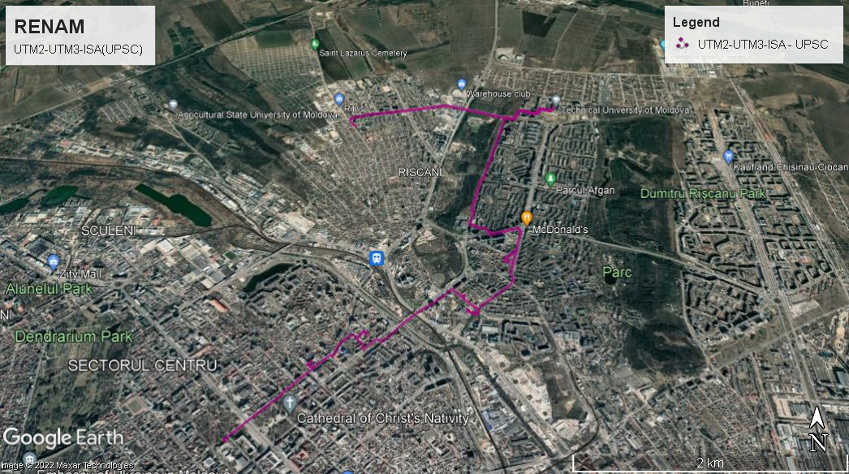

Annex 3 The schematic diagram of lot 2

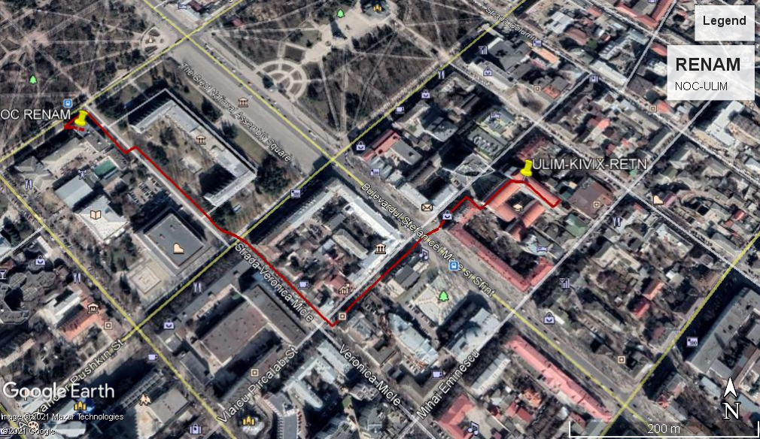

Annex 4 The schematic diagram of lot 3

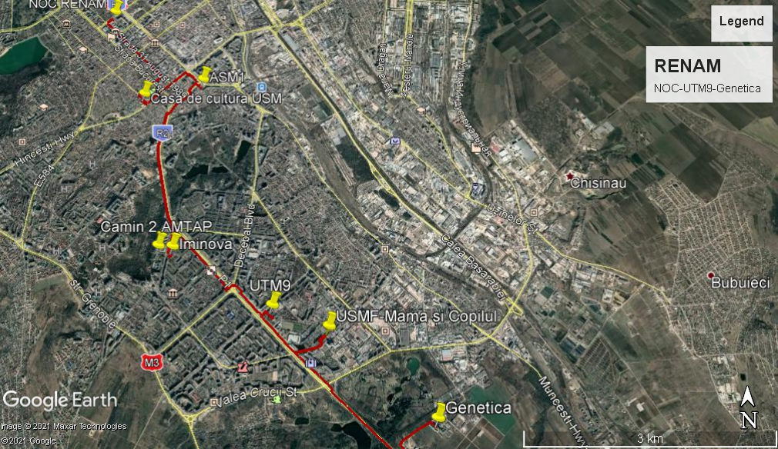

Annex 5 The general schematic diagram

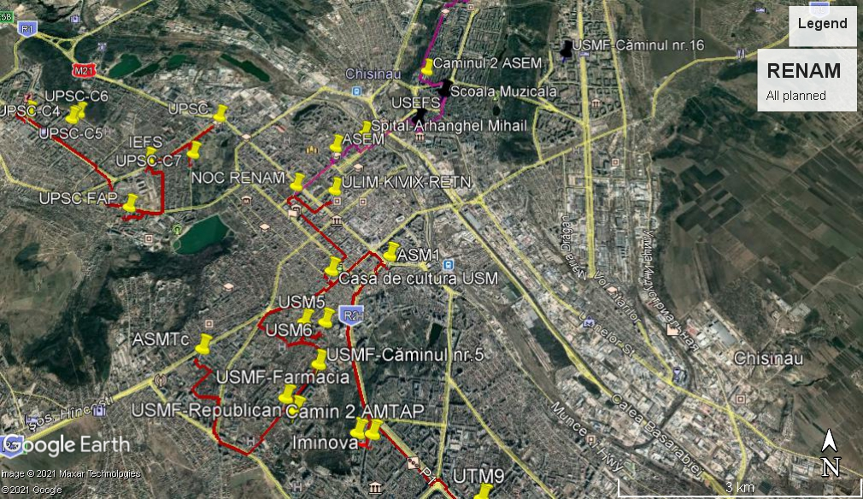

Annex 6 KMZ files
Lot 1

Lot 2

Lot 3

