Request for Quotation

FROM | NORWEGIAN REFUGEE COUNCIL
Address | Bucuresti 41
City | Chisinau
Country | Moldova
Phone # | 076030078
Email | md.procurement@nrc.no

The office of the Norwegian Refugee Council invites your company to submit a price quotation for the following items in accordance with the requirements detailed below. You may use your company format or fill up the table below. Please carefully read the instructions below.

Request for Quotation Requirements
RFQ # : | RFQ-MOL-CO-24-026 | Currency | MDL
RFQ Issuing Date: | 18.07.2024 | Bid Validity Period (days): | (Preferably 30 days)
RFQ Closing Date: | 25.07.2024 | Required Delivery Date: | 01.08.2024
RFQ Closing Time: | 16:00 | Required Delivery Destination: | Chisinau, Bucuresti 41
Questions to the RFQ | md.procurement@nrc.no | Required Delivery Terms: | N/A

# | Description |  | Specification | Photo | Unit | Estimated Qty | Unit price, incl. Tax (MDL) | Total Price incl. Tax (MDL)
1 | Frezer |  | Frezer 64 W | 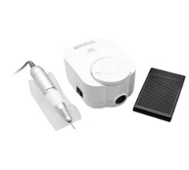 | Pcs | 9
2 | Scissors |  | plcuticle scissors pro smart 41 type 3, 41/3 | 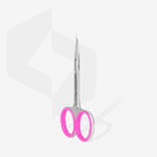 | pcs | 9
3 | Files 180/240 grit |  | The 180/240 grit file is designed for processing the nail, giving shape | 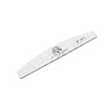 | pcs | 9
4 | Orange sticks |  | The orange nail sticks are made of natural orange wood with polished and smooth surface, which helps to remove the skin around the nail. | 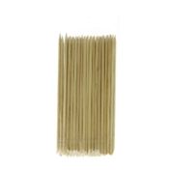 | pcs | 9
5 | Cutter head Flame |  | for cuticle removal and cleaning | 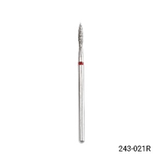 | pcs | 9
6 | Umbrella milling head |  | for removing material from the nail, ceramic, rounded cone, red collar | 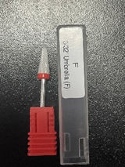 | pcs | 9
7 | Acetone |  | nail polish remover solution | 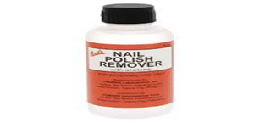 | pcs | 9
8 | Cuticle oil |  | cuticle oil 60 ml | 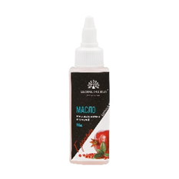 | pcs | 9
9 | Table lamp |  | Table lamp for suitabl for nails beauty | 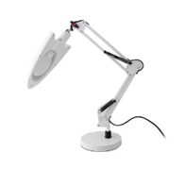 | pcs | 9
10 | Cuticle pliers |  | diameter 8 mm, equivilant to staleks | 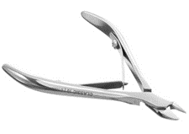 | pcs | 9
11 | Electric sterilizer |  | Power: 10W  Dimensions (+/-):  external - 35 * 20.5 * 24 cm  internal - 30 * 16 * 18 cm | 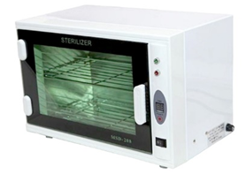 | pcs | 9
12 | Vacuum cleaner (aspirator) for dust X5 60w |  | equivilant to Icoral marble material | 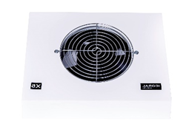 | pcs | 9
13 | Cuticle removal solution |  | equivilant to Icoral | 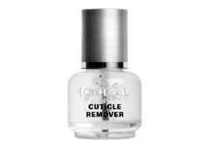 | pcs | 9
14 | Hand cream |  | 1000 ml, equivilant to Icoral | 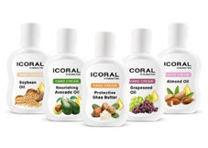 | pcs | 9
15 | Hand scrub |  | 1000 ml, equivilant to Icoral | 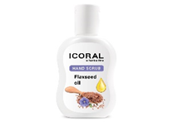 | pcs | 9
16 | Dust brush |  | Plastic material, synthetic hair type | 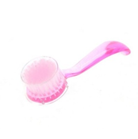 | pcs | 9
17 | Dehydrator for nail preparation |  | equivilant to Icoral, 15 ml | 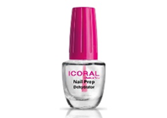 | pcs | 9
18 | Micro-scissors SE-90/2 |  | equivilant to Staleks | 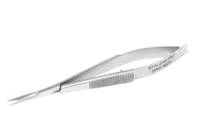 | pcs | 9
19 | Nitrile gloves |  | equivilant to mumu plus | 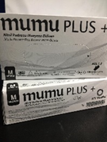 | pcs | 9
20 | Hand support |  | plastic or silicone. | 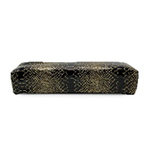 | pcs | 9
21 | cuticle nippers |  | equivilant to pro expert 100, 7 mm, ne-100-7 | 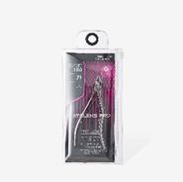 | pcs | 9
22 | Lamp |  | Gel drying lamp | 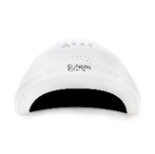 | pcs | 9
23 | Sterilizer with ball |  | equivilant to G-70 | 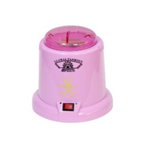 | pcs | 9
24 | Autoclave paper instrument sterilizing bags |  | 75*150mm, 100 bucăți | 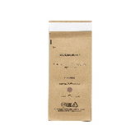 | pcs | 9
25 | Primer acid free 15 ml |  | The acid-free primer leaves no stickiness. | 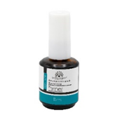 | pcs | 9
26 | Strong base 12 ml |  | Strong Long Lasting Base Coat is a universal coating, strong long lasting base coat 12 ml | 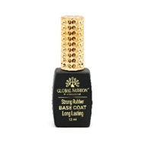 | pcs | 9
27 | Builder gel |  | Nail shaping gel 15 gr | 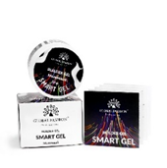 | pcs | 9
28 | Top |  | Universal top coat without sticky layer (finish) top diamond 12ml, applied when finishing the work |  | pcs | 9
29 | Flat brush no.8 |  | Flat brush for applying gel coat | 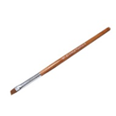 | pcs | 9
30 | Thin brush 00 |  | Substring brush 00 for drawing 9mm | 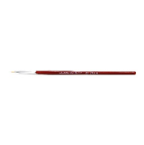 | pcs | 9
31 | Chamomile color palette |  | Palette CHAMOMILE (20 tips matt) | 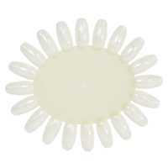 | pcs | 9
32 | Dosing pump |  | 160 ml | 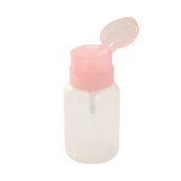 | pcs | 9
33 | French milky base coat |  | 30 ml | 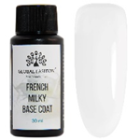 | pcs | 9
34 | Top coat matte |  | 15 ml | 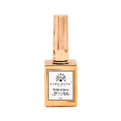 | pcs | 9
35 | Nail decorations |  | mixed colored stones | 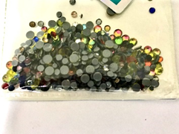 | pcs | 9
36 | Arctic White construction gel |  | french gel, 15 gr | 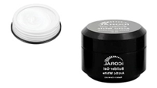 | pcs | 9
37 | Black elitte Semi-permanent nail polish |  | pale pink | 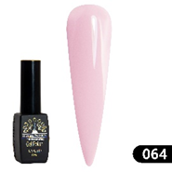 | pcs | 9
38 | Black elitte Semi-permanent nail polish |  | coffee color | 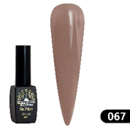 | pcs | 9
39 | Black elitte Semi-permanent nail polish |  | pink color | 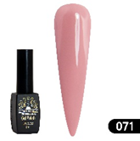 | pcs | 9
40 | Black elitte Semi-permanent nail polish |  | Coral sparkling color | 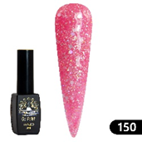 | pcs | 9
41 | Cat eye nail polish with gel polish 24d wild |  | Grey with metal glow | 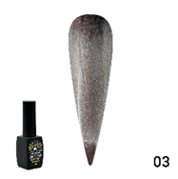 | pcs | 9
42 | Lint-free nail wipes |  | 1000 buc | 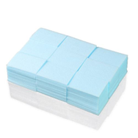 | pcs | 9
43 | Brushes sam -20 oval gel |  | 3 buc în set | 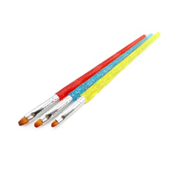 | pcs | 9
44 | Manicure pusher P-4 |  | modelul P4 | 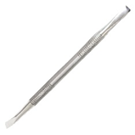 | pcs | 9
45 | Manicure tub |  | plastic |  | pcs | 9
 |  |  | TOTAL PRICE (including taxes and delivery)
Delivery of all items shall be made to Chisinau address mentioned in the Request for Quotation Requirements above.

All deliveries are expected door-to-door, which includes bringing items to the exact floor or level, as instructed by NRC staff during delivery.

Delivery Lead Time (in days, from receipt of NRC Purchase Order)-Chisinau
Bid Validity Period (in days from receipt of NRC Purchase Order):
Defects liability and warranty period for electric items:
Country of origin of the goods

Payment Terms: ___________

Payment Terms means the statement by a company about when and how it should be paid for goods or services that it has supplied, NRC prefer that Payment will be made after the delivery within 30 days of receipt of goods/ services, by bank transfer. If not, would you please provide us with your payment terms above.

Name

Position

Date Signature

Stamp

We, understand that activities and materials used under this project are subject to EU sanctions and that compliance with EU sanctions is mandatory. We undertake that through the implementation of activities under this contract, we will not engage in transactions with, or provide resources or support to, any individual or entity that is subject to sanctions administered by the European Union, the United Nations, or the United States. We further undertake to remain compliant with all origin of goods requirements and prohibitions stipulated under EU sanctions including, but limited to, Council Regulation (EU) No 692/2014 and Council Regulation (EU) 2022/263.

RFQ Terms & Conditions
Manner of Submission:
- By hand in a sealed envelope to NRC office located Address: Chisinau, Bucuresti 41
OR
- By email to the dedicated and secured email address: md.tenders@nrc.no (offers received on other email addresses will not be considered)
- Before the Closing date & Time mentioned above. Companies who do not submit their quotation by this deadline will not be considered

Valid offer should include the following documents:
- Filled & Signed RFQ
OR
- Detailed Bidder’s offer, preferably with the photos of the proposed items
- Annex 1: Ethical Standard Declaration (Signed)
- Copy of the Company's Extras

Requirements:
- All Bids must include all customs and taxes payable in the country of delivery unless the RFQ specifically requests differently
- Bids must be submitted in the currency indicated in the RFQ. Bids in other currency might not be accepted
- Bids must be valid for the validity period indicated in the RFQ. Bids not meeting this validity period might be disqualified
- All enquires and questions should be addressed to the email given in the RFQ details section. All questions and answers will be shared with all invited suppliers.
- NRC reserves the right to accept or reject the whole or part of your quotation based on the information provided. Incomplete quotations which do not comply with our conditions will not be considered.

Assessment Criteria:
- All bids received and accepted will be evaluated based on the following:
- Step 1: Administrative compliance check: Each bid will be checked to ensure compliance with all the RFQ requirements – PASS / FAIL
- Step 2: Ability to provide warranty certificates for electrical items - PASS / FAIL
- Step 3: Ability to provide all the items
  - Yes
  - No
- Step 4: Delivery time in working days to any Chisinau location
  - 1-3
  - 3-5
  - More than 5
- Step 5: Financial Evaluation: Price comparison will be based on the total least financial offer of the matching specifications.

NRC is obliged to ensure that its procurement decisions are clearly justified and documented and keeping within the Donors mandatory principles. In that regard, full and on-the-spot access must be granted to representatives of NRC, the Donor or any organisation or person mandated by it, to premises belonging to NRC or its contractors. The right to access shall include all documents and information necessary to assess or audit the implementation of the contract.  NRC also expects suppliers who process personal data to comply with the General Data Protection Regulation (EU GDPR) and any relevant national legislation. Suppliers processing personal data on an NRC contract will be required to sign a data processing / sharing agreement as part of the contract. Refusal to sign such an agreement constitutes refusal of the contract terms and forfeiture of the contract on the part of the supplier.  If the activities of the contract take place in areas with Explosive Hazards, NRC accepts no liability for injury and/or death to contractor’s staff or damage to contractor’s property. | Anti-money laundering, anti-bribery, anti-corruption and anti-terrorism legislation and donor regulations require NRC to screen contractors against various international lists to ensure due diligence. Submission of the quotation constitutes acceptance of these screening practices.  NRC aims to purchase products and services with minimum environmental impact. Environmental considerations form part of the NRC selection criteria, and NRC reserves the right to reject quotations provided by suppliers not meeting these standards.  All suppliers doing business with NRC should maintain high standards on ethical and environmental issues, respect and apply basic human and social rights, ensure non-exploitation of child labour, and give fair working conditions to their staff. Suppliers will be required to sign and submit an Ethical Standards Declaration, together with their bid.  NRC reserves the right to reject quotations provided by suppliers not meeting these standards.

Signature & Stamp

Please complete, sign and stamp the below table:

Bidder’s general business details

- General information
Company name:
Address:
Company Registration No:
Contact person:
Contact Telephone No:
Email/Fax:
Bank Name:
Bank Address / Branch:
IBAN:
Tax Number:
Date:
Stamp:

- Owners/Managers
Please fill in the below table with the full names and the year of birth of the company’s owner(s) and manager(s)*:

Full name | Date of birth

