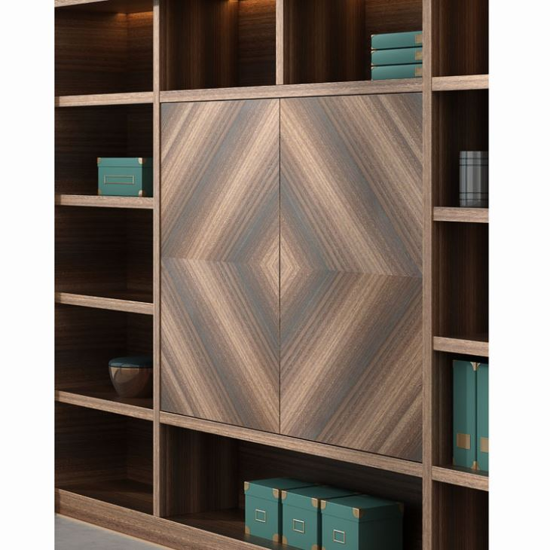
Lot nr.9.7. Dulap cu rafturi director

