Task Book
regarding the acquisition of the Hybrid Private 5G Network Extension (local UPF) through the procurement procedure Local Open Procedure
- Name of the Contracting Authority: IP Technical University of Moldova
- Organizer of the procurement procedure: IP Technical University of Moldova
- CPV Code: 32524000-2 – Telecommunications system
- List of requested goods/services:
No. d/o | Name of the requested goods/services | Quantity | Full technical specification requested, reference standards
LOT 1 Technical solution for private 5G UTM hybrid network
1.1 Network equipment
1.1.1 | 5G UPF system, including accessories and installation materials | 1 pcs. | Technical solution that implements the 5G network service – UPF – and is integrated with the local UTM network, which includes the necessary networking equipment for integration, accessories and installation materials and complies with the provisions of the technical requirement.
1.1.2 | 5G gNodeB radio system, including accessories and installation materials | 1 pcs. | Technical solution that implements dedicated indoor radio coverage for the laboratory room chosen by UTM, on an area of 100m2, which includes the necessary accessories and installation materials and complies with the provisions of the technical requirement.
1.1.3 | SIM cards for the hybrid private 5G UTM network | 20 pcs. | SIM cards, compatible with 5G SA technology, will need to be provisioned in the hybrid private 5G network of Future Networks laboratories and offered in the physical format desired by UTM (MiniSIM, MicroSIM, NanoSIM).
1.2 Network services
1.2.1 | Annual support services for 5G UPF | 2 years. | Support, maintenance and upgrade services for the 5G UPF system installed within UTM.
1.2.2 | Annual support services for gNodeB 5G | 2 years. | Support, maintenance and upgrade services for the 5G gNodeB system installed within UTM.
The estimated value is 234,500.00 EUR

Contents
Task Book 1
Acronyms 3
1 Introduction, objectives and scope 4
1.1 Introduction 4
1.2 Objection 4
1.3 Scope 5
2 Infrastructure provided by UTM 6
2.1 High-capacity LAN connectivity and racks available in the university's data center 6
2.2 Space for installing radio equipment and Core elements 6
3 Implementation requirements 7
3.1 General requirements 7
3.2 Coverage requirements and service availability 7
3.3 Technical requirements 8
3.3.1 Definitions and key terms 8
3.3.2 Design requirements 9
3.3.3 Security requirements 12
3.3.4 Functional requirements 12
4 The relationship between UTM and the selected bidder 14
4.1 General framework for collaboration 14
5 Execution of works 15
5.1 Project phases 15
5.1.1 Implementation 15
5.1.2 Exploitation 16
6 Conditions for network implementation 17
6.1 Preventive and corrective monitoring 17
6.2 Governance model 17
6.2.1 Contract Manager 17
6.2.2 Project development 18
6.3 Service Level Agreement (SLA) 18
6.3.1 Incidents 18
6.3.2 Technical support 19
6.3.3 Quality of Service (QoS) 20
6.4 Training 21

Acronyms

Term | Description
3GPP | 3rd Generation Partnership Project
5G | Fifth generation mobile communications
5GC | 5G Core
FR1 | Frequency Range 1
gNB | Next Generation Node B
GUI | Graphical User Interface
IP | Internet Protocol
KPI | Key Performance Indicator
LAN | Local Area Network
MNO | Mobile Network Operator
NPN | Non-Public Network
RAN | Radio Access Network
SA | Standalone
SIM | Subscriber Identity Module
SLA | Service Level Agreement
SNPN | Standalone Non-Public Network
TDD | Time Division Duplex
UPF | User Plane Function
UE | User Equipment
UTM | Technical University of Moldova

Introduction, objectives and scope

Introduction
The Technical University of Moldova (UTM), in partnership with the Technical University "Gheorghe Asachi" of Iași (TUIASI), is implementing the CONNECTINNO project - "Cross-Border Interconnected Mobile Networks for Education and Innovation". Within the project, UTM aims to acquire and implement a hybrid private 5G Standalone (SA) network to support educational, research and innovation activities, as well as to facilitate cross-border cooperation.
The new communications system will have to cover a laboratory within the University, thus ensuring support for teaching and research activities. The selected network solution will have to be dedicated to UTM, offering isolation for resources and being compliant with the 3GPP release 16 standard.
Thus, this technical document has the following structure:
- Objectives and scope: the main objectives of the tender are detailed;
- Infrastructure provided by UTM: the existing infrastructure that can be used by the selected subcontractor as support for the hybrid private 5G network that will be implemented is described;
- Technical requirements: the specific characteristics and requirements of the hybrid private 5G network extension to be implemented are described;
- Relationship with the selected subcontractor : the context of cooperation between UTM and the selected subcontractor is defined;
- Works execution: the project implementation plan is defined and the operating requirements for the implemented network are described ;
- Conditions for execution of works: the expected level of quality specific to the implemented services is defined.
No. of documents. | Product name | CPV code
1 | Complete 5G hybrid private network solution (local UPF) for a UTM laboratory | 32524000-2 – Telecommunications system

Objection
The purpose of this document is to establish the technical specifications and execution conditions of the project to implement a hybrid private 5G network within UTM.
Thus, the winner of the auction will design, install and integrate a hybrid private 5G network extension for UTM, will operate and maintain the network and will allocate dedicated resources to UTM, offering radio communications services with increased reliability, high bandwidth and low latency.
The implementation of the hybrid private 5G network project in the University, will have the following objectives:
- Implementation of a 5G SA network, compatible with at least 3GPP Release 16, covering a laboratory room on the UTM campus;
- Support for educational and research scenarios;
- Interoperability with the 5G Future Networks laboratories at the National University of Science and Technology Politehnica Bucharest and the “Gheorghe Asachi” Technical University of Iași, through VPN/MPLS or dedicated L2/L3 connectivity;

Scope
The purpose of this tender is to implement a hybrid private 5G network, including the necessary technical developments and associated services (planning, design, installation, configuration, optimization, software implementation, integration and commissioning) so that the resulting network operates within the parameters defined in section 3.3 Technical Requirements from this document.
In addition, the tender also includes the licenses necessary to implement the solution at the expected functional level, maintenance and follow-up services, user training and also project management services associated with the development of the hybrid private 5G network.

Infrastructure provided by UTM

High-capacity LAN connectivity and racks available in the university's data center
UTM will provide an adequate support infrastructure for the installation and operation of the hybrid private 5G network. At the connectivity level, UTM has a high-capacity LAN network with performance corresponding to the requirements of a state-of-the-art laboratory.
These resources provide the necessary conditions for the integration of Distributed 5G Core (UPF) equipment and for the operation of laboratory services.

Space for installing radio equipment and Core elements
Regarding the space for installing radio equipment and Core elements, UTM will provide a dedicated, secure and air-conditioned technical room, with controlled access, intended to host distributed Core elements (UPF) and routing and switching equipment.
The proposed rack for installation will be equipped with redundant power supply, surge protection and direct connectivity to the university network. For the installation of radio equipment (gNB), a suitable location will be identified in the laboratory room of the UTM campus, with access to electricity and fiber optics.
The beneficiary will ensure the internal permits and access to locations for installation and maintenance, complying with all occupational health and safety regulations, as well as fire protection regulations.

Implementation requirements

General requirements
The winner of the tender will have to implement a technical solution that implements a technical system at least equivalent to those described in the list of specifications present in this document.
The winner of the auction will have to offer UTM a hybrid private 5G SA network, respecting the following criteria:
- Providing all necessary services, hardware, software, licenses, accessories and materials ;
- Providing the necessary SIM cards, in the physical format desired by UTM (MiniSIM, MicroSIM, NanoSIM), both during the implementation phase and after completion of the works, including the procedures for activating and managing the cards throughout the life of the project ;
- Ensuring adequate technical personnel to implement tasks related to the design, implementation, configuration, operation and repair of the installed network ;
- Ensuring the maintenance services necessary to maintain the quality level of the service at the standard agreed upon in agreement with UTM ;
- Establishing a governance model and the necessary communication channels with UTM representatives to carry out the specified activities in good conditions throughout the project.
Additional requirements beyond those set out in this document will be discussed in advance with the successful bidder.
The winner of the tender will have to provide all the tools, instrumentation, equipment, materials, and adequate technical personnel necessary to complete the project in good execution conditions.
The responsibility of the winning bidder is to comply with the legislation in force, as well as with the quality standards associated with the execution activities specific to the implementation of the hybrid private 5G network, both at the technical and administrative level.
The winning bidder will be responsible for completing all standard actions and procedures to obtain the necessary licenses and permits for the installation of equipment associated with the implementation of the hybrid private 5G network. The winning bidder will also be responsible for documenting the implementation and installation procedures to reflect the activities described in the project planning.
The winning bidder will have to plan the execution works flexibly, validate them in advance with UTM and allocate a sufficient number of human resources.

Coverage requirements and service availability
The coverage offered by the implemented hybrid private 5G network will have to cover an area of 100 m², specific to a laboratory room on the university campus. The technical plan of the laboratory is presented in Figure 1 .
The winning bidder will have to ensure that the designed solution complies with the guaranteed bandwidth requirements defined in this document in this location.

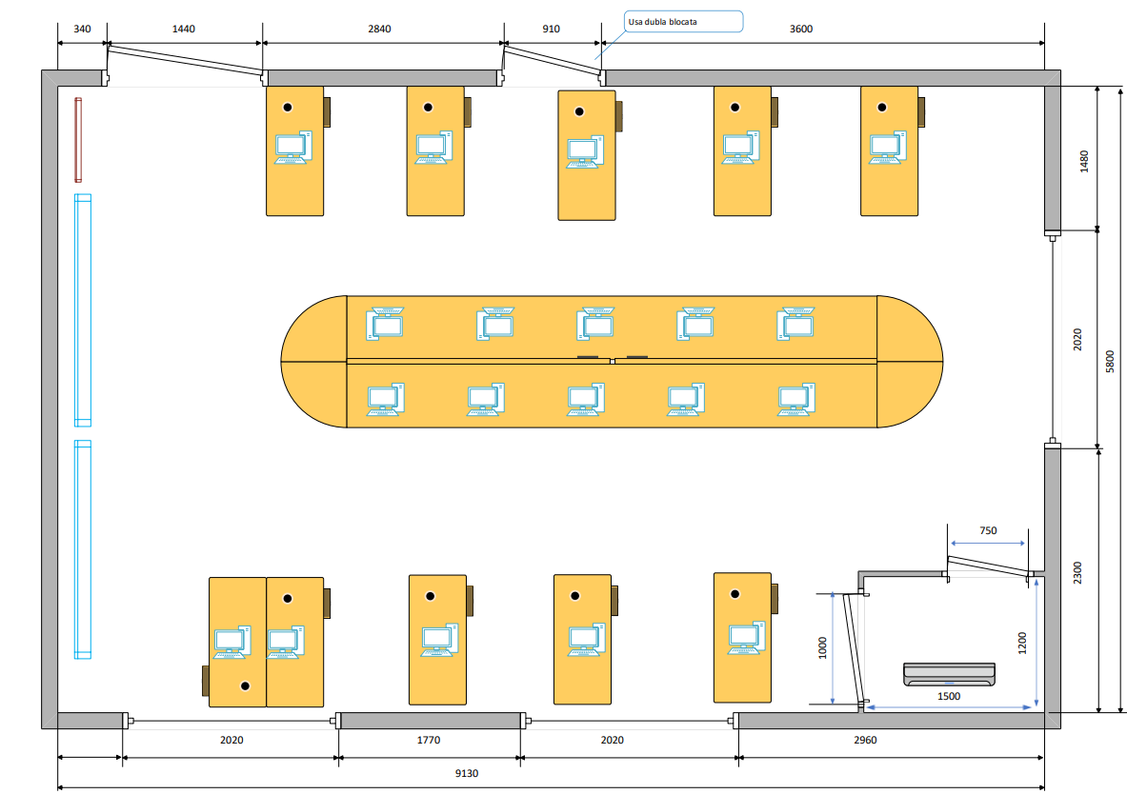Figure 1 - Room plan for the UTM 5G laboratory
To achieve this indoor coverage, the winning bidder will have to use dedicated technical solutions adapted to the specifics of the aforementioned indoor areas, using pico-cell, small-cell or equivalent radio equipment, which comply with the 3GPP release 16 standard and comply with the technical requirements expressed in section 3.3 Technical requirements.
The winning bidder will have to demonstrate compliance with coverage obligations to UTM, after the implementation of the hybrid private 5G network, according to the documentation requirements and deadlines defined in section 5.4 Reporting.

Technical requirements

Definitions and key terms
The following presents key 5G terms and concepts associated with current 3GPP standards, all with the aim of clarifying the technical requirements stipulated in the subsequent sections of this document.
Thus, two types of mobile networks are defined depending on access to communications services:
- PLMN (Public Land Mobile Network): telecommunications network that provides services to the general public. Any operator that provides telecommunications services has its own PLMN ;
- NPN (Non-Public Network): telecommunications network that provides services to a private group of users.
Regarding 5G technology, two types of networks are distinguished depending on the Core architecture typology:
- NSA (Non-Standalone): network that uses Core LTE/4G elements for control/signaling functions ;
- SA (Standalone): all network elements, both for the radio area and the Core area, comply with the 5G standard.
In either of the two scenarios presented above, several types of private networks can be created depending on the chosen architecture and how users are managed:
- SNPN (Standalone Non-Public Network): completely private network, isolated from public networks, using a dedicated PLMN;
- SHNPN (Standalone Hybrid Non-Public Network): private network, isolated from public networks, using distributed Core elements (UPF) and a dedicated PLMN ;
- SNPN with shared RAN: private network, isolated from public networks in the Core area, which includes mechanisms for sharing radio resources and uses a public or dedicated PLMN ;
- PNI-NPN (Public Network Integrated with Non-Public Network): private network, which uses distributed Core elements (UPF) and a public PLMN .

Design requirements

General design requirements
The technical solution for the UTM dedicated mobile network architecture will need to use the SHNPN (Standalone Hybrid Non-Public Network) public-private hybrid network model.
The architecture of the proposed solution must implement at least version 16 of the 3GPP standard as a 5G Standalone (5G SA) network, being able to accommodate subsequent versions of the standard. Technical solutions that are based exclusively on previous standards will be rejected.
UTM will evaluate the proposed solutions for the university-specific hybrid private 5G network in accordance with the target architecture defined in the subsequent sections of this document.
The technical solution offered will have to implement the following elements and allow adaptation to various evolutionary aspects:
- Implementation according to the SBA (Service Based Architecture) model, whereby all network functions are developed in the form of services that communicate with each other through standard messages ;
- Implementation using virtualized network functions of the NFV type (Network Functions Virtualization);
- Access to a SIM management platform specific to the hybrid private network (activation/deactivation of SIM cards);
- Implementation of network slicing functionality specific to version 16 of the 3GPP 5G SA standard.

Hybrid Private 5G Network Extension Architecture
The target technical solution for the hybrid private 5G network will need to cover the area of the target laboratory, under the responsibility of UTM, according to the specifications detailed in section 3.2 Coverage and availability requirements.
The infrastructure offered will have to have the following elements:
- The radio access network, consisting of an indoor coverage radio solution (pico-cell, small-cell, repeaters, etc.) and all associated elements (power and data cables, optical fibers, etc.);
- The transport and Core network, consisting of a distributed Core element (UPF), IP traffic routing and switching equipment and the fibers used for data transmission within the university, sized to comply with the requirements defined in sections 3.3.4.2 Performance requirements;
- Interconnection of the hybrid private 5G network, data traffic plan, with specific local network elements UTM, LAN/WAN and servers.
The target architecture for implementing the SHNPN hybrid private mobile network, which implements the Distributed Core (UPF) functionality to separate data traffic from control traffic, is graphically presented in Figure 2 .
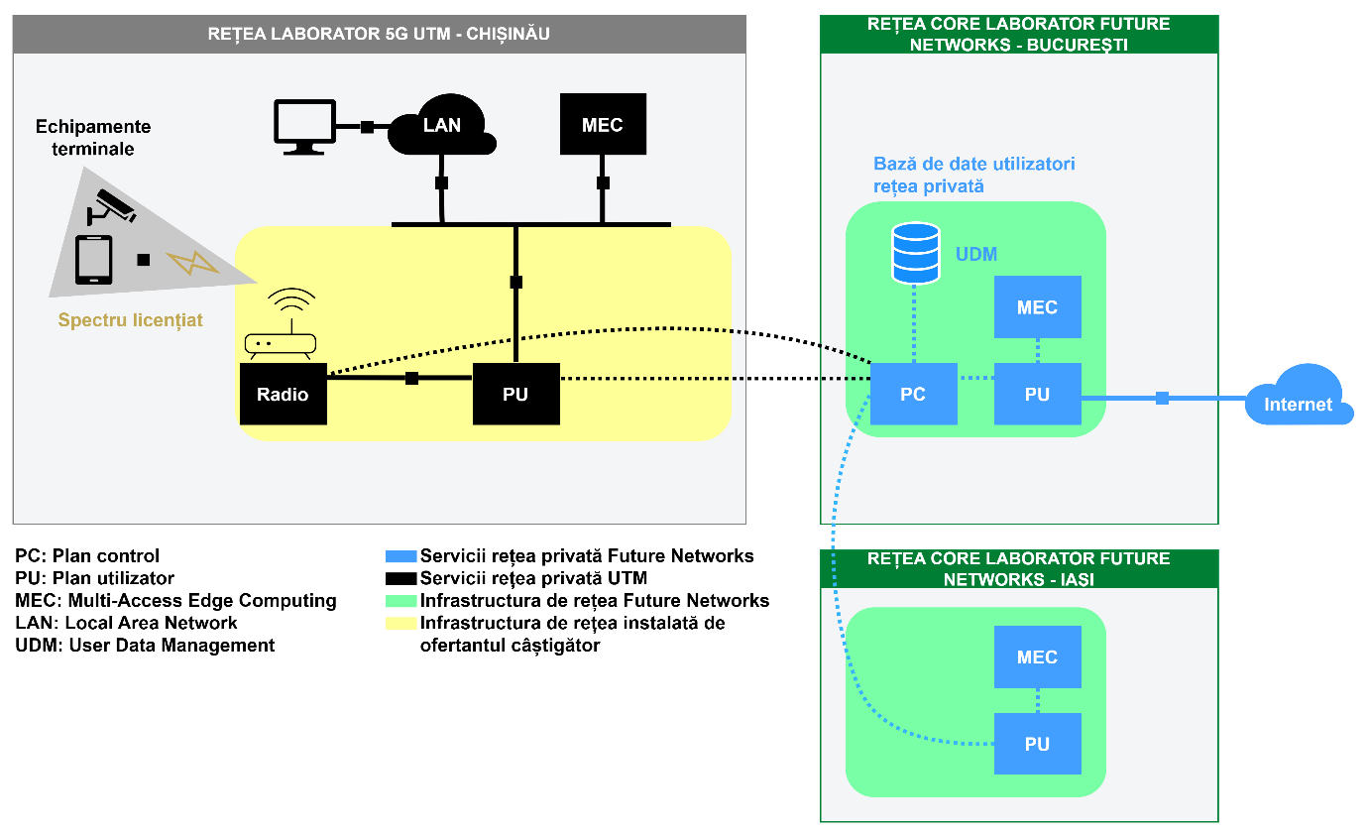
Figure 2 - Target architecture for hybrid private 5G network
The distributed Core (UPF) and radio access network elements will have to be chosen so as to allow integration with the 5G network specific to the Future Networks laboratories in Bucharest (National University of Science and Technology Politehnica of Bucharest) and Iași (Technical University "Gheorghe Asachi" of Iași), described on the laboratories' presentation page , through standardized interfaces defined by 3GPP :
- N1 interface – the interface between the UE (User Equipment) and the AMF (Access and Mobility Management Function) specific to Future Networks laboratories.
- N2 interface – the interface between gNB and the AMF specific to Future Networks laboratories.
- N3 interface – the interface between gNB and UPF (User Plane Function). It carries data traffic (user plane) between local UTM terminal equipment and the network.
- N4 interface – the interface between the SMF (Session Management Function) specific to Future Networks laboratories and the local UTM UPF.
- N6 interface – the interface between UPF and external data networks (Data Network – DN). This will interconnect with UTM business private network and the Internet (via the link to Future Networks laboratories).
The built hybrid network will have to allow the connection of a minimum number of 50 simultaneous users.

Radio access network
The radio access solution dedicated to the hybrid private 5G network dedicated to UTM will need to be sized to comply with at least the requirements set out in sections 3.3.4.2 Performance requirements.
For the correct implementation of the radio network and for an adequate allocation of resources, the winning bidder will need to perform the following actions during the solution development stage:
- To ensure the availability of guaranteed radio band resources for UTM in the amount of at least 20 MHz in the 3.4-3.8 GHz spectrum, with the possibility of expansion up to 100 MHz;
- Configure the installed radio equipment (emission levels, antenna orientation).
The radio stations that will be used for the purpose of the UTM hybrid private 5G network will need to be interconnected with the distributed Core unit (UPF) installed in the UTM premise and with the central Core solution (5GC) specific to the 5G Future Networks laboratories in Bucharest and Iași.

Transport Network and Core
The distributed Core Element (UPF) will need to be connected to the radio nodes installed within the university, to the UTM-specific LAN/WAN networks and to the central Core network (5GC) specific to the 5G Future Networks laboratories in Bucharest and Iași using a dedicated transport infrastructure or VPNs.
The Distributed Core element will need to be installed in the UTM data center. The chosen Distributed Core (UPF) solution will need to be implemented in virtualized form, and route data traffic coming from mobile users of the university's hybrid private 5G network to UTM-specific LAN/WAN networks.
The winning bidder will have to implement the distributed Core (UPF) solution according to version 16 of the 3GPP standard, while also allowing the software elements to be updated to subsequent generations of the 5G communications standard.
The winner of the auction will have to implement the Local BreakOut (LBO) concept within the university's hybrid private 5G network to route private traffic to UTM equipment (terminals, servers). In this configuration, the winner of the auction will have to ensure that UTM has the ability to connect its own networks and servers to the hybrid private 5G network and, more precisely, to the distributed Core (UPF) through a series of dedicated ports in the installed equipment for routing and switching L2/L3 IP traffic.
For this interconnection in LBO topology, at least one 10Gbps connection is required through SFP+ ports or similar. The winner of the auction will have to ensure the availability of the specified ports and the associated interconnection elements.

Spectrum considerations
The winning bidder must guarantee the allocation of a dedicated spectrum, in the amount of 20 MHz in the 3.4-3.8 GHz spectrum, for UTM's hybrid private 5G network. This must be exclusively allocated (reserved band) to UTM and must be accessible through the allocation of a dedicated network slice compatible with 3GPP version 16.
During the contract period, the bidder must ensure the availability of the guaranteed licensed spectrum use, complying with the regulations regarding the use of radio spectrum based on the established allocation schemes.
The winning bidder must allocate the bandwidth necessary to achieve, with guaranteed quality of service, the performance and sizing requirements set out in section 3.3.4.2 Performance Requirements.

Security requirements
The UTM hybrid private 5G network extension must incorporate integrity, authentication, and encryption mechanisms at both the radio access network level and the transport and Core network levels.
The winning bidder must comply with 5G cybersecurity requirements according to the 5G Security Toolbox developed by ENISA, including the use of 5G network equipment (radio, transport, Core) from authorized suppliers.

Functional requirements

Mobile data services
Access to data services according to the 3GPP 5G standard must be guaranteed, as specified in sections 3.3.4.2 Performance requirements.

Performance requirements
Regardless of the applications implemented over the UTM hybrid private 5G network extension, the following quality of service levels must be respected for all mobile terminals:
- 5G service specifications:
  - Maximum data transfer rate: The maximum value of the traffic rate that can be achieved by a single user under ideal radio conditions, without errors on the radio interface. This value is measured in a location with a single active user connected to a specific cell/antenna of the UTM hybrid private 5G network extension;
  - Reference speed for ensuring good quality for users: The performance that 95% of users can achieve in the coverage area of UTM's hybrid private 5G network extension, detailed in section 3.2 Coverage and availability requirements;
  - Latency: The network contribution to the delay associated with the transfer of a data packet. This is defined as the delay between the transmission of a packet and its reception, using a mobile device connected to the hybrid private 5G network and ready for data transfer/reception for a small packet size.
- Performance metrics:
  - Maximum data transfer rate on downstream channel: ≥ 100 Mbps;
  - Maximum data transfer rate on upstream channel: ≥ 20 Mbps;
  - Reference speed for ensuring good quality for downstream users: ≥ 50 Mbps;
  - Reference speed for ensuring good quality for users on the upstream channel: ≥ 10 Mbps;
  - Latency: < 50 ms.

The relationship between UTM and the selected bidder

General framework for collaboration
Through this tender, UTM aims to implement a hybrid private 5G network, which complies with 3GPP/5G standards, within a laboratory room at the university.
The winning bidder must provide access to UTM authorized personnel to the interfaces associated with the data plane to facilitate the integration of edge-computing applications.
To ensure proper coordination between UTM and the winning bidder, a Cooperation Framework will be established. This framework will regulate access to UTM’s hybrid private 5G network extension elements for service development by authorized university personnel and will include the following considerations:
- Coordinated task planning, scheduling different maintenance windows for necessary interventions and production launches ;
- Defining user permissions and their roles;
- Reporting associated with each intervention and establishing its purpose.

Execution of works

Project phases
This chapter aims to define the phases and stages in which the implementation of the new services is organized. This tender is divided into the following phases and sub-phases of the project, as shown in Figure 4 :
- Service implementation
- Service exploitation
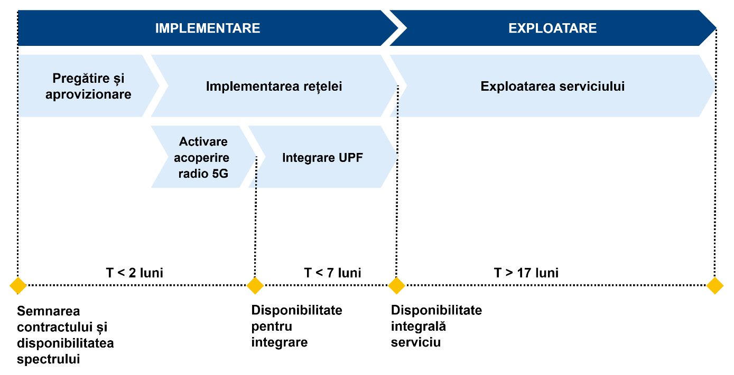
Figure 4 - Project phasing

Implementation
The Implementation Phase will begin with the signing of the contract and will end with the achievement of milestones associated with service delivery.

Preparation and supply
The first phase of the project, which will begin with the formalization of the contract, involves the preparation and provision of the materials and equipment necessary to implement the services covered by this tender. This phase will also establish the planning for the execution of the processes and the contract management mechanisms.
An indoor coverage study will be required, along with a reassessment of the infrastructure required to install the associated equipment in the UTM premise.

Installation and commissioning
The implementation phase is dedicated to the implementation, activation and delivery of the service to UTM.
A maximum period of two (2) months from the start of the contract is foreseen for ensuring 5G radio coverage in the UTM laboratory room (assuming that the UTM dedicated spectrum is available at the time of contract signing) and seven (7) months from the start of the contract for the complete delivery of the 5G UPF for UTM by the winning bidder, including its integration with the initially installed 5G radio system.
Purpose: Delivery of a hybrid private 5G network for UTM, consisting of the following components:
- Provision, delivery, activation and lifecycle management of SIMs for UTM. In this phase, the number of SIMs agreed with UTM in physical format will be delivered. The quantity associated with each format will be specified by UTM to the winning bidder during this phase;
- Implementation of the distributed Core element (UPF);
- Activation of the 5G service in the target laboratory room, with dedicated resources assigned to the UTM hybrid private 5G network and integration with the local UPF and the main Core network (5GC) ;
- Interconnecting the local UPF with LAN/WAN networks and specific UTM servers;
- Specialized Operation and Maintenance services, including project management.
Coverage and quality of service thresholds:
- The coverage resulting from this phase must ensure satisfactory quality of service across the entire target laboratory area;
- The value of the network performance indicators, associated with the quality of service, must meet or exceed the minimum requirements specified in chapter 3.3.3 Functional requirements.

Exploitation
The Exploitation Phase begins with the completion of the Implementation Phase and extends until the end of month 24 of the contract period.
To begin the Exploitation phase, UTM must formally validate the service.
The purpose of this phase includes:
- Operation and maintenance of the network and all constructive elements throughout the life cycle of UTM's hybrid private 5G network;
The starting month of the Operation phase cannot exceed the established term of seven (7) months from the start of the contract.

Conditions for network implementation

Preventive and corrective monitoring
For preventive and corrective maintenance, the winning bidder will generally carry out network surveillance activities from its own locations. However, the bidder will be allowed access to the university infrastructure to perform the necessary interventions, either at the request of UTM or when absolutely necessary.
Maintenance windows will be established outside of the target laboratory's working hours for tasks that could affect the work of UTM staff. These maintenance windows will be agreed with and authorized by UTM.

Governance model
The monitoring and review of the services provided to UTM by the winning bidder will be carried out through periodic and systematic meetings. These meetings will analyze information related to compliance with the contract between the parties.
Participants in these meetings will be designated by each organization. On the part of the winning bidder, the target roles will include the Contract Manager. The bidder will submit supporting documents about these individuals and their functions in the company. UTM will have a specially designated team to manage the relationship with the bidder.

Contract Manager
The winning bidder will appoint a Contract Manager. This person will have the legal authority/power to represent the company under the contract.
Main responsibilities:
- To agree on the overall strategy, policies and objectives for the provision of the service, the development of the hybrid private 5G network and its subsequent management, ensuring alignment with the needs of UTM;
- To assess the overall service delivery and review compliance with the SLAs established in the contract;
- To define and approve new contractual commitments;
- To mediate conflicts or problems;
- In general, the contract manager will perform any other tasks related to the strategic direction of the contracted service during its validity.
Minimum requirements:
- Higher education completed with a bachelor's degree or equivalent;
- General experience: minimum 3 years;
- Specific experience: Participation in at least one project/contract in which you have carried out activities similar to the position for which you are proposed.

Considering that the object of this project includes all those listed in this requirement, it is mandatory for the bidder to prove that it has a human resource capable of participating in a project of this kind, therefore, the enumeration is cumulative, and its involvement in a previous similar project must show the fulfillment of all those listed.

Project development
Within 30 calendar days from the date of entry into force of the contract, UTM and the winning bidder will jointly establish the schedule of periodic meetings for the implementation of the project.
As part of the technical offer, the bidder will propose a GANT-type implementation schedule divided into implementation times, allocated resources and compliance with the terms defined in the technical specifications. Project control and monitoring will be structured around these meetings, which will vary depending on the project phase.

Service Level Agreement (SLA)
Communications services will be provided according to an SLA model, which will allow for the efficient evaluation and measurement of the availability of the hybrid private 5G network based on defined indicators and their comparison with the established objectives.

Incidents
Incident resolution, including corrective maintenance, encompasses all elements dedicated to ensuring the availability and proper functioning of the hybrid private 5G network, correcting errors or deficiencies that occur.
All incidents and requests will be assigned a priority level, allowing for their objective resolution based on importance.
The UTM requirements for this service are presented in Table 2 , with improvements to these specifications being appreciated.
Table 2 - Types of incidents
Priority | Incident | Description
P1 | Critical | Total hybrid private 5G network failure.
P2 | Serious | Partial hybrid private 5G network failure.
P3 | Minor | All other situations.

The general compliance indicators that will be used are presented in Table 3 .
Table 3 - Incident response
Indicator | Description | Calculation formula | Periodicity | Maximum response time
P1 response time | The maximum time elapsed between notification of a critical network incident and its acknowledgement or rejection by the offeror. | tRP1 = tAcknowledge - tNotify - tStop | Monthly | < 8 hours
P2 response time | The maximum time elapsed between notification of a serious network incident and its acknowledgement or rejection by the winning bidder. | tRP2 = tRecognition - tNotification - tStop | Monthly | < 12 hours
P3 response time | The maximum time elapsed between notification of a minor network incident and its acknowledgement or rejection by the winning bidder. | tRP3 = tRecognition - tNotification - tStop | Monthly | < 16 hours
P1 solution time | The maximum time elapsed between notification of a critical network failure and its resolution by the winning bidder. | tResolutionP1 = tResolution - tNotification - tStop | Monthly | < 24 hours
P2 solution time | The maximum time elapsed between notification of a serious network failure and its resolution by the winning bidder. | tResolutionP2 = tResolution - tNotification - tStop | Monthly | < 48 hours
P3 solution time | The maximum time elapsed between notification of a minor network fault and its resolution by the winning bidder. | tResolutionP3 = tResolution - tNotification - tStop | Monthly | < 96 hours
Where:
- tNotification is the time when the incident was notified;
- Acknowledgement is the moment when a response is provided to the incident ;
- tResolution is the time when the incident was resolved;
- tStop is the time when the incident was stopped for reasons external to the bidder.

Technical support
The general compliance indicators that will be used are presented in Table 4 .
Table 4 - Response to technical clarifications
Indicator | Description | Calculation formula | Periodicity | Maximum response time
Response time | The maximum time elapsed between the notification of a consultation or proposal for modification regarding the hybrid private 5G network from UTM and its recognition or rejection by the winning bidder. | tRP0 = tResponse - tNotification - tStop | Monthly | < 14 business days
Resolution time | The maximum time elapsed between the notification of a network consultation and its resolution by the winning bidder. | tResolveP0 = tResolution - tNotification - tStop | Monthly | < 28 business days
Where:
- tNotification is the moment when the support request was submitted;
- tResponse is the moment when a response is provided to the support request ;
- tResolution is the moment when the support request was resolved ;
- tStop is the time when the support request was stopped for reasons external to the offeror.

Quality of Service (QoS)
The general compliance indicators that will be used are presented in Table 5 .
Table 5 - Target performance parameters
Indicator | Description | Calculation formula | Periodicity | SLA
Transport network and Core availability | The time during which there is full availability of the locally deployed distributed 5G Core (UPF) and L2/L3 IP transport equipment. | DISP = (htotal - hdown) / htotal | Monthly, within normal working hours (Monday-Friday, 9-17) | ≥ 90%
Radio network availability | The time during which the radio base station is fully available. | DISP = (htotal - hdown) / htotal | Monthly, within normal working hours (Monday-Friday, 9-17) | ≥ 90%
Maximum data transfer speed | The maximum performance value measured in the UTM laboratory with a single active user connected to the radio cell specific to the hybrid private 5G network extension using exclusively UTM reserved radio resources in the 3.4-3.8 GHz spectrum. Must be equal to or greater than 100 Mbps on the downlink and greater than 20 Mbps on the uplink, as specified in section 3.3.4.2. Performance requirements. | TPUTMAX_DL = tputdlmaxreal TPUTMAX_UL = tputulmaxreal | Monthly, within normal working hours (Monday-Friday, 9-17) | ≥ 100Mbps (DL)  ≥ 20 Mbps (UL)
Latency | The maximum delay time between sending and receiving a packet, with a mobile device connected to the network and ready to transfer/receive a small packet. Calculated based on the sum of the average daily latencies divided by the number of days in the month. Must be less than 50 milliseconds, as specified in section 3.3.4.2. Performance requirements. | LATMED = ∑ (avglatday) / days_in_month | Monthly, within normal working hours (Monday-Friday, 9-17) | < 50ms
Where:
- htotal: total hours in the checked period;
- hdown: total hours in the verified period in which the network was unavailable for any reason (maintenance, incident, etc.) ;
- tputdlmaxreal: maximum data transfer rate achieved on the downstream channel;
- tputulmaxreal: maximum data transfer speed obtained on the upstream channel;
- avglatday: average daily latency recorded;
- days_in_month: the number of days in the month.

Training
The project will also include training the UTM team on the functionalities and operation of the new hybrid private 5G network extension. Specifically, the training should cover at least the following sections:
- Solution architecture: This will include information about hardware and software components, highlighting the importance of each installed element and its function within the architecture, as well as integration with other components of the UTM infrastructure;
- Basic Configuration: Explanation of the main functions of the SIM management platform associated with the hybrid private 5G network solution, including examples of service and equipment configuration;
Training can be carried out remotely and, depending on the duration and study program, can be divided into two sessions.
The training will take place within 40 working days from the moment of the final quantitative-qualitative reception of UTM's hybrid private 5G network, which will coincide with the completion of the implementation stage.

Lilia SAVA _____________________
The Project Coordinator of CONNECTINNO

https://futurenetworks.upb.ro/research/

