
Undernet SRL
Netmarket.md
Mun. Chisinau, MD-2023, str. Uzinelor 14/1
c/f: 1015600015096
c/d:MD21AG000000022512560648
TVA: 0405193
banca : BC “Moldova-Agroindbank” SA fil. Nr. 17, Chisinau. Str Vasile Alexandri 13.
cos/bancar: AGRNMD2X444
Tel. 022727502
Director: Andritchi Alexandru

Oferta comerciala
Data: 24.09.2020
Televizor VESTA LD50E6202 pret bucata: 5099 lei
Video
Brand VESTA
Model LD50E6202
Diagonala ecran 127 cm
Dimensiune ecran 50 inch
Tip LED
Rezolutie Full HD
Rezolutie ecran 1920*1080 pixeli
Tip ecran Plat

TV Tuner
Tip tuner DVB-C/T/T2

Smart TV
Smart TV Da
Sistem de operare Android
Versiune sistem de operare 9.0

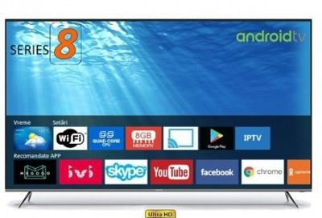
Televizor Aiwa LED 55UK555 – pret bucata: 6499 lei
Video
Brand Aiwa
Model LED 55UK555
Diagonala ecran 140 cm
Dimensiune ecran 55 inch
Tip LED
Rezolutie Ultra HD / 4K
Rezolutie ecran 3840x2160 pixeli
Tip ecran Plat

TV Tuner
Tip tuner DVB-C / T2

Smart TV
Smart TV Da
Sistem de operare Android

