  - Annex nr.3

” Republican Veterinary Diagnostic Center” P.I.

Public Bidding
Procurement of transponders (microchips)

Technical Specifications

Name of the goods | Description | Transponder tuning fork | Quantity
Transponders:  - Horses | According to „TECHNICAL REQUIREMENTS” | 498040000030001-498040000032000 | 2000
Total

TECHNICAL REQUIREMENTS
characteristics of transponders (microchips) of the horses species

General technical requirements

1.1 All horses, donkeys and descendants obtained by crossing them will be identified by applying an injectable transponder;

1.2 Injected transponders must meet the following requirements:
            - be a passive read-only transponder without an internal source of electricity, consisting of an integrated circuit - a microchip in which a unique numeric code is encoded - and an antenna, both included in a water-repellent material that can be of glass or ceramic;
            - the identification code can be read only when the transponder is activated by the signal transmitted by the reader;
            - the shell of the injected transponder is composed of complex substances, which ensure a fast encapsulation and prevent their migration;
            - the uniqueness of the identification code is guaranteed by the provider;
            - the unique identification code can not be copied or modified;
            - the unique identification code programmed only by the manufacturer during the realization of the transponder;
            - the uniqueness of the unique identification code verified by the manufacturer during the construction of the transponder.

The shape and appearance of the transponders

2.1. Material - biocompatible glass;

2.2. Subcutaneous anti-migration treatment;

2.3. Color - transparent;

2.4. Shape - cylindrical.

The size of the transponders
The transponders will have the following dimensions: - length - 11.5 mm (± 4.5%), diameter - 2.12 mm (± 4.5%).

Resistance
            - water resistance - according to IP 68;
            - Vibration resistance - according to IEC 68 PART 2-47;
            - shock resistance - according to IEC 68 PART 2-29.

Technical performance requirements
            - Use HDX or FDX-B technology in accordance with ISO 11784 and ISO 11785 standards;
            - Be legible with ISO 11785 compliant readers;
            - The reading distance should be: at least 12 cm, when reading with a portable reader and at least 50 cm, when reading with a stationary reader;
            - To transmit the correctly stored code in conditions of temperature between -20°C and + 40°C and humidity conditions between 40% rH and 80% rH;
            - Activation frequency - 134.2 kHz;
            - The code of the transponder (injected) for the identification of horses, donkeys and descendants obtained by crossing them will consist of 15 characters, having the following meaning:
- the first 3 characters indicate the country code, according to the ISO 3166 standard, for the Republic of Moldova this being 498;
- the next digit is 0 (zero);
- the following digit will represent the species code of the animal, this being 4;
- the following 10 characters after the country code (498), the digit 0 (zero) and the species code (4) represent the unique identification code.

Example
Type of means of identification | Identification code | Interpretation of the identification code
Transponder injected | 498040099999999 | 498 - country code;  0 - required number;  4 - species code for horses, donkeys and descendants obtained by crossing them;  00 – series number of 99999999 codes;  99999999 - animal serial number (unique code).

Implant / syringe
The injector used for the electronic identification of equidae must have the following characteristics:
- to be a disposable device;
- have an ergonomic format for precise and safe handling during implantation;
- be provided with specific components;
- with the role of preventing accidental, involuntary action;
- with the role of protection, isolation of the implant needle;
- be labeled with the unique registration code of the electronic identification tag.

Technical requirements for packaging of transponders (microchips)
10 pieces in a box with the indication of the tuning fork (each transponder in a separate package with a transparent part and 6 adhesive labels inscribed with the unique code of the chip).

Technical drawing for separately packaged transponder:
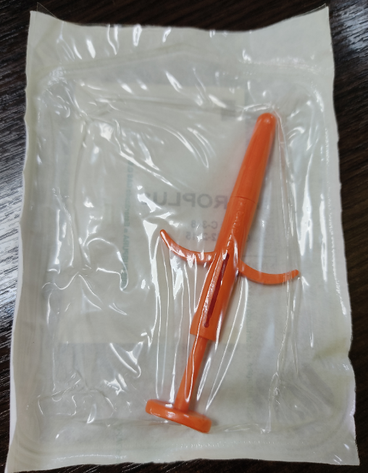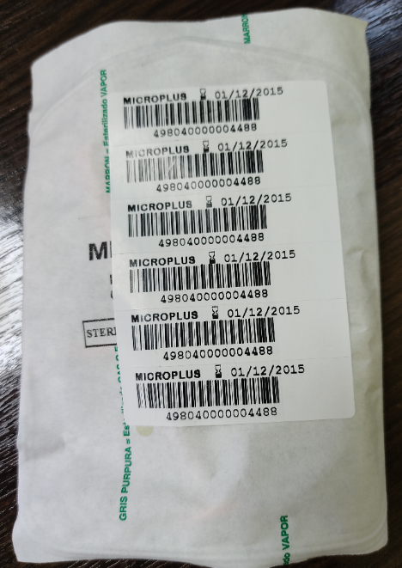
              - The front part; b) The back part.

