 |  |  |  |  |  | 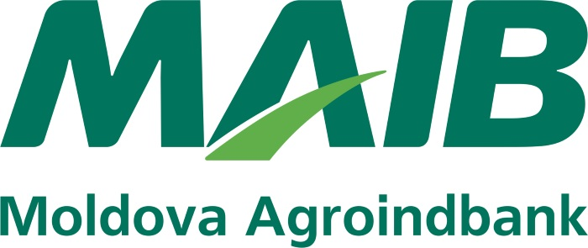
  DATE BANCARE
  Beneficiar
  S.C. NICOLAE MELNIC S.R.L.
  Cod fiscal
  1003609001947
  Banca Beneficiară
  BC'MAIB'S.A. suc.Calarasi
  Cod BIC
  AGRNMD2X768
  Cod IBAN
  MD25AG000002251624011122
  Valuta Cont
  MDL

