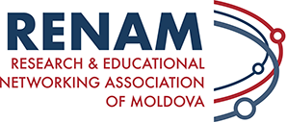
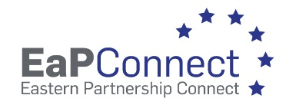

Chisinau, Moldova | February 12, 2025

Reference No: MD-25-01 - Uninterruptible Power Supply (UPS) and air-cooling systems

Invitation to participate in the procurement procedure

The Research and Educational Networking Association of Moldova RENAM (State identification number 1012620003140) intends to purchase the equipment for operating RENAM NOC as a part of implementation of the EU funded Project “EU4Digital: Connecting Eastern Partnership research and education communities with the global information society (EaPConnect2)” coordinated by GEANT Association, where RENAM Association is a partner (Grant Contract – External Actions of the European Union ENI/2019/407-452).

Specification of goods and delivery conditions are presented in the Specification Form.

The goods are VAT exempt.

Potential supplier should provide the following documents:
- Quotation form with prices in Euro;
- Filled Specification Form;
- European single procurement document (DUAE);
- Enterprise registration certificate.

The proposal should be submitted via national tendering platform (MTender) – www.achizitii.md
Evaluation criteria: in case all requirements concerning specification of goods and delivery conditions are met by the potential suppliers (the necessary conditions) the bid will be awarded according to the best price.

We invite you to participate in the procurement procedures and submit a procurement offer not later than 16:00 at local (Chisinau) time of February 28, 2024.

Annexes:
- Specification Form;
- Draft Contract.

Sincerely,

Research and Educational Networking
Association of Moldova RENAM,
Chairman of RENAM Council
Dr. Petru Bogatencov

