Annex to the Procurement notice

Technical requirements and specifications
for test equipment of machine-readable passports (MRP) and identification cards (ID)

Name of goods | Technical requirements and specifications
Lot no. 1  The equipment for performing tests according to point 8.9 (point 10.3)  „Sheet turning stress method” of the standard  SM ISO/IEC 18745-1:2018 (ISO/IEC 18745-1:2018) | The equipment should meet requirements set out at the point 8.9 of the SM ISO/IEC 18745-1:2018 (ISO/IEC 18745-1:2018) standard, including the following:  - The equipment must have the following parts:  - fixture device - for clamping the fixed sheet or machine-readable passport (MRP);  - fixture arm device, for rotation of sheet or MRP;  - device, to apply force to tested sheet or MRP.  - The equipment should prevent bending of the booklet in any other place than the axis of the booklet spine and that the distance between the rotation axis (spine) and the clamp should be not greater than 10 mm, as it is illustrated in figure 12 of the SM ISO/IEC 18745-1:2018 (ISO/IEC 18745-1:2018) standard.  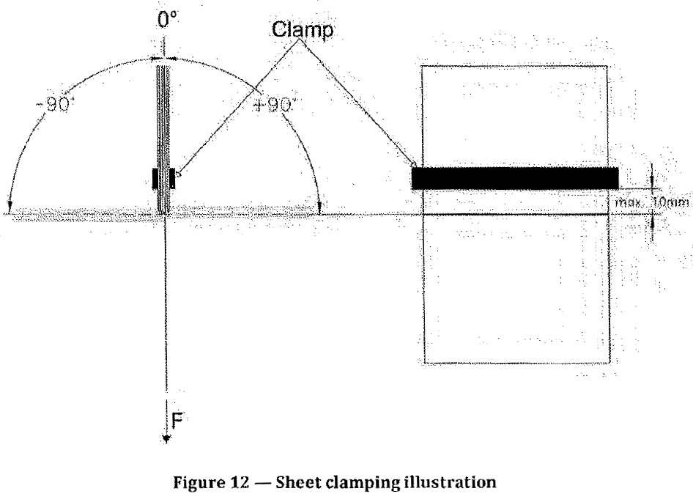  (Figure 12 of the standard SM ISO/IEC 18745-1:2018 (ISO/IEC 18745-1:2018))  - The equipment must have an integrated operating and control system that ensures the following operating parameters:  - bending frequency: f = 0,5 Hz ± 5 %;  - bending angle: a = ±90° ± 5 %;  - tensile force: F= 12,5 N ± 5 % (force applied along the whole sheet length).  The integrated operating and control system can provide and other test parameters in addition to those specified in the standard.  - The equipment must ensure compliance with the requirements of method specified at the point 8.9 „Sheet turning stress method” of the SM ISO/IEC 18745-1:2018 (ISO/IEC 18745-1:2018) standard and namely: „The entire booklet except the sheet to be tested is folded back and held in a clamp. The sheet to be tested is held in another clamp allowing for the rotation of the sheet or MRP under test around the spine between the defined angle positions”, as it is illustrated in figure 13, page 20 of the standard.
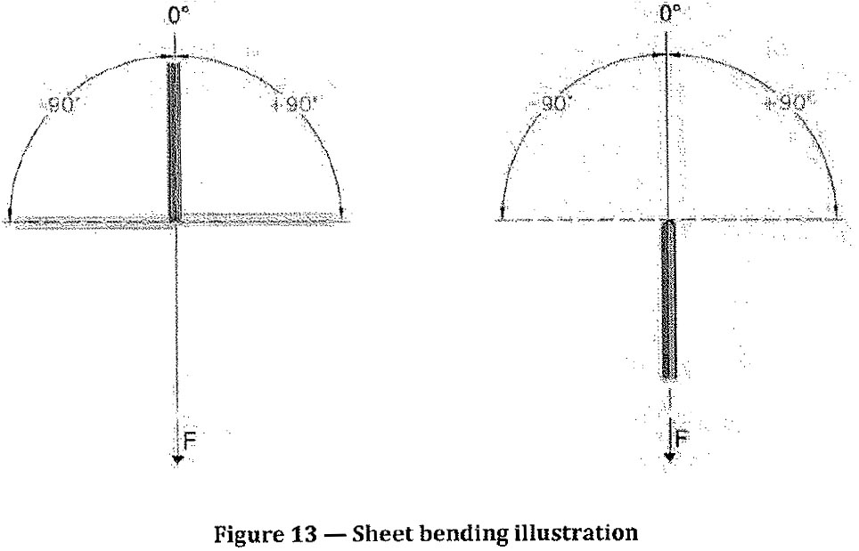
(Figure 13 of the standard SM ISO/IEC 18745-1:2018 (ISO/IEC 18745-1:2018))

- Power supplying: 210-230V, 50Hz:

- The equipment should be accompanied by:
- User manual (instructions for use);
- Technical description or another document which should attest equipment and testing method conformity to requirements of the point 8.9 of SM ISO/IEC 18745-1:2018 (ISO/IEC 18745-1:2018) standard;
- Calibration certificate SI-traceable of a bending frequency (f = 0,5 Hz);
- Calibration certificate SI-traceable of the bending angle (a = ±90°);
- Calibration certificate SI-traceable of the tensile force (F= 12,5 N).

- Additional mandatory requirements :
- The costs of transportation, installation, configuration, commissioning of the equipment and training of the Buyer’s personnel by the Supplier’s specialized and authorized personnel are included in the price of the equipment;
- The installation, regulation/adjustment and commissioning of the equipment will be carried out at the Buyer's premises, in the presence of the Supplier's representative or online through remote consultation and guidance. The supplier will provide all the necessary assistance for the commissioning of the equipment;
- The final reception shall be based on the operational tests carried out at the time of commissioning in accordance with the instructions for the operation and technical service of the equipment. The equipment must be able to carry out all the processes and performances specified in the technical offer;
- The installation and commissioning of the equipment in compliance with the established requirements is confirmed by the signing by the Parties the Act of delivery-receipt of the Goods;
- The warranty period of the equipment: 12 months from the date of signing the Act of delivery-receipt of the Goods. During the warranty period, the Supplier will ensure the proper functioning of the equipment by removing any faults or non-compliant operations within a maximum of 7 business days from the moment of the request.
Lot no. 2  The equipment for performing tests according to point 8.6 (point 10.7) „Book bend stress method (back pocket)” of the standard  SM ISO/IEC 18745-1:2018 (ISO/IEC 18745-1:2018) | The equipment should meet requirements set out at the point 8.6 of the SM ISO/IEC 18745-1:2018 (ISO/IEC 18745-1:2018) standard, including the following:  - The equipment must have the following parts::  - anvil, of non-elastic material with spherical impact area of radius r = 150 mm ± 5 % and anvil diameter: ≥ 95 mm x 125 mm.  - cushion of foam, having a density of 30 g/1 to 55 g/1 and a hardness of 150 N to 265 N as defined in method „A” of the ISO 2439:2008 standard. The minimum thickness of the cushion is 100 mm. The minimum dimension, in any direction, of the cushion surface on which the sample is placed shall be larger than 200 mm and shall be larger than the anvil.  - The equipment must ensure the application of force on MRP according to figure 7 page14 of the SM ISO/IEC 18745-1: 2018 (ISO/IEC 18745-1:2018) standard.  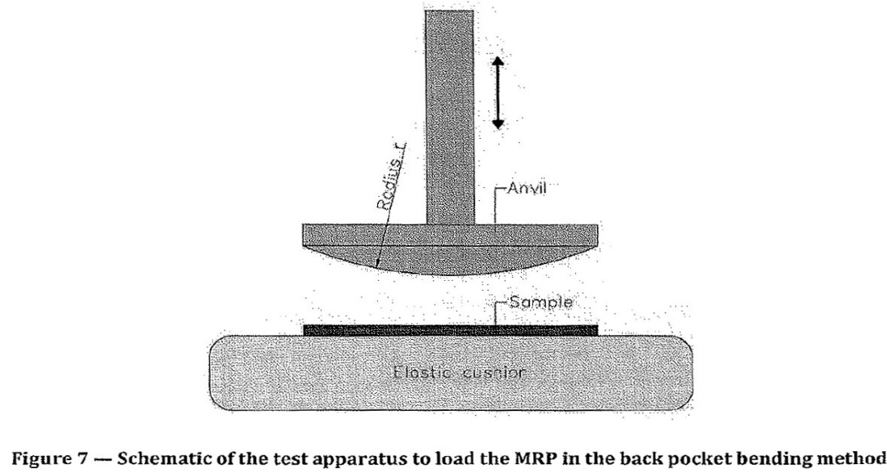  (Figure 7 of the standard SM ISO/IEC 18745-1:2018 (ISO/IEC 18745-1:2018))  - The equipment must have an integrated operating and control system that ensures the following operating parameters:  - create and apply a force of 350N on the MRP booklet by means of the spherical anvil (the force will not exceed this value and will have a tolerance of not more than - 5%);  - maintain the applied force of 350 N for 5 s ± 1 s;  - after the expiry of 5s ± 1s, remove the anvil from booklet so that it does not touch the MRP or cushion,  - ensure the performance of 100 cycles of force application on MRP.  The integrated operating and control system can provide and other test parameters in addition to those specified in the standard.  - The equipment construction should ensure the fixed position of MRP and other travel documents in a testing zone as well during the force application as anvil lifting.  - Power supplying: 210-230V, 50Hz:  - The equipment should be accompanied by:  - User manual (instructions for use);  - Technical description or another document which should attest equipment and testing method conformity to requirements of the point 8.6 of SM ISO/IEC 18745-1:2018 (ISO/IEC 18745-1:2018) standard, including specification for radius and dimensions of the anvil, resistance (assessed according to „A” method of ISO 2439:2008 standard) and density of flexible cellular (porous) material of the cushion;  - Calibration certificate SI-traceable of the applied force on the MRP (F = 350N);  - Calibration certificate SI-traceable of the time of application force on the MRP (T = 5s).  - Additional mandatory requirements :  - The costs of transportation, installation, configuration, commissioning of the equipment and training of the Buyer’s personnel by the Supplier’s specialized and authorized personnel are included in the price of the equipment;  - The installation, regulation/adjustment and commissioning of the equipment will be carried out at the Buyer's premises, in the presence of the Supplier's representative or online through remote consultation and guidance. The supplier will provide all the necessary assistance for the commissioning of the equipment;  - The final reception shall be based on the operational tests carried out at the time of commissioning in accordance with the instructions for the operation and technical service of the equipment. The equipment must be able to carry out all the processes and performances specified in the technical offer;  - The installation and commissioning of the equipment in compliance with the established requirements is confirmed by signing by the Parties the Act of delivery-receipt of the Goods;  - The warranty period of the equipment: 12 months from the date of signing the Act of delivery-receipt of the Goods. During the warranty period, the Supplier will ensure the proper functioning of the equipment by removing any faults or non-compliant operations within a maximum of 7 business days from the moment of the request
Lot no. 3  The equipment for the measurement of height, width and thickness of a ID cards, according to point 5.2 of the SM ISO/IEC 10373-1:2021 (ISO/IEC 10373-1:2020) standard | The equipment should meet all requirements set out at the point 5.2 of the SM ISO/IEC 10373-1:2021 (ISO/IEC 10373-1:2020) standard, including the following:  - The equipment for thickness measurement should ensure the cards measurement according to in point 5.2.2 of SM ISO/IEC 10373-1:2021 (ISO/IEC 10373-1:2020) standard, including:  - a micrometre with a flat anvil and spindle whose diameter is within the range of 3 mm to 8 mm, having a precision of 0,005 mm or a higher precision and a pressure range of 0,1 N/mm² to 0,4 N/mm².  The construction of the equipment can also ensure the measurement of other parameters of the card.  - The equipment for height and width measurement should ensure the measurement in any point along the entire height and width of ID-1 cards (optionally also other formats) according to point 5.2.3 al of SM ISO/IEC 10373-1:2021 (ISO/IEC 10373-1:2020) standard, consisting of:  - a level horizontal rigid surface having a deviation from flatness not greater than 3,2 µm over the width of the card;  - a measuring device/devices with a precision of 2,5 µm or a higher precision;  - a load of 2,2 N ± 0,2 N with dimensions which shall not exceed the edges of the card;  - means of calibration and verification of measuring device/devices.  - The equipment for measuring of height, width and thickness of an ID cards constructively can form of one or more blocks.  - Powering the measurement devices should be done from an autonomous source, replaced without maintenance services.  - Additional mandatory requirements :  - User manual (instructions for use);  - Technical description or another document which should attest the conformity of equipment and its performance to requirements mentioned at the point 5.2 din SM ISO/IEC 10373-1:2021 (ISO/IEC 10373-1:2020), including:  • for micrometre it should specify the diameter of flat anvil and spindle and a pressure range;  • for the horizontal rigid surface it should specify the maximum deviation from flatness level;  - Calibration certificate SI-traceable of the micrometre;  - Calibration certificate SI-traceable of the device/devices for height and width measurement;  - Calibration certificate SI-traceable of the load of 2,2 N;  - Calibration certificate SI-traceable of means of calibration and verification.  - Additional mandatory requirements :  - The costs of transportation, configuration, commissioning of the equipment by the Supplier’s specialized and authorized personnel are included in the price of the equipment;  - The adjustment and commissioning of the equipment will be carried out at the Buyer's premises, in the presence of the Supplier's representative or online through remote consultation and guidance. The supplier will provide all the necessary assistance for the commissioning of the equipment;  - The final reception shall be based on the operational tests carried out at the time of commissioning in accordance with the instructions for the operation and technical service of the equipment. The equipment must be able to carry out all the processes and performances specified in the technical offer;  - The commissioning of the equipment in compliance with the established requirements is confirmed by signing by the Parties the Act of delivery-receipt of the Goods;  - The warranty period of the equipment: 12 months from the date of signing the Act of delivery-receipt of the Goods. During the warranty period, the Supplier will ensure the proper functioning of the equipment by removing any faults or non-compliant operations within a maximum of 7 business days from the moment of the request.

