Dimensiunile si schite aproximative pentru inlocuirea timplariei la blocul claselor primare a LT "G. Calinescu"
Nota: Dimensiunile exacte a tamplariei se vor preciza la fata locului, iar schita finala va fi coordonata cu beneficiarul.

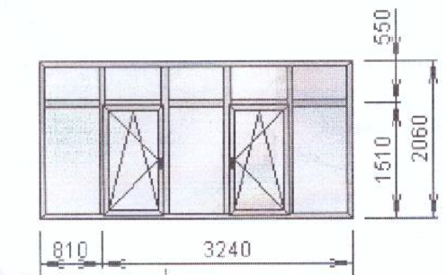

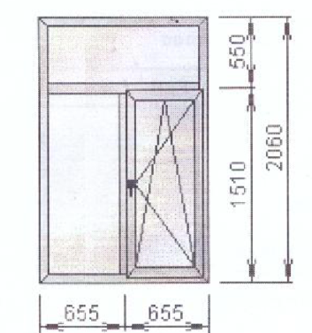

Ferestre | H, m | L, m | S, m2 | Cercevea cu deschidere in 2 pozitii, buc
1 | 2.1 | 4.15 | 8.715 | 2
2 | 2.1 | 1.38 | 2.898 | 1
3 | 2.1 | 4.2 | 8.82 | 2
4 | 2.1 | 1.38 | 2.898 | 1
5 | 2.1 | 4.2 | 8.82 | 2
6 | 2.1 | 4.15 | 8.715 | 2
7 | 2.1 | 4.15 | 8.715 | 2
8 | 2.1 | 4.15 | 8.715 | 2
9 | 2.1 | 4.15 | 8.715 | 2
10 | 2.1 | 4.15 | 8.715 | 2
11 | 2.1 | 4.15 | 8.715 | 2
12 | 2.1 | 1.38 | 2.898 | 1
13 | 2.1 | 4.15 | 8.715 | 2
14 | 2.1 | 4.15 | 8.715 | 2
15 | 2.1 | 1.38 | 2.898 | 1
16 | 2.1 | 4.15 | 8.715 | 2
17 | 2.1 | 4.15 | 8.715 | 2
18 | 2.1 | 4.15 | 8.715 | 2
19 | 2.1 | 4.15 | 8.715 | 2
20 | 2.1 | 4.15 | 8.715 | 2
21 | 2.1 | 4.15 | 8.715 | 2
22 | 2.1 | 4.15 | 8.715 | 2
23 | 1.82 | 1.25 | 2.275 | 1
24 | 1.82 | 1.25 | 2.275 | 1
25 | 2.1 | 1.38 | 2.898 | 1
26 | 2.1 | 1.38 | 2.898 | 1
27 | 2.1 | 1.38 | 2.898 | 1
28 | 2.1 | 1.38 | 2.898 | 1
29 | 2.1 | 1.38 | 2.898 | 1
30 | 2.1 | 1.38 | 2.898 | 1
31 | 2.1 | 1.38 | 2.898 | 1
32 | 2.1 | 1.38 | 2.898 | 1
TOTAL |  |  | 196.406 | 50

Usi | H, m | L, m | S, m2
1 | 2.15 | 0.95 | 2.0425
2 | 2.12 | 1.05 | 2.226
3 | 2.12 | 1.05 | 2.226
4 | 2.1 | 1 | 2.1
5 | 2.1 | 1.05 | 2.205
6 | 2.1 | 1.05 | 2.205
7 | 2.1 | 1.05 | 2.205
8 | 2.1 | 1 | 2.1
9 | 2.05 | 1 | 2.05
10 | 2.1 | 1 | 2.1
11 | 2.05 | 0.95 | 1.9475
12 | 2.1 | 1 | 2.1
13 | 2.1 | 1 | 2.1
14 | 2.1 | 1 | 2.1
15 | 2.1 | 1 | 2.1
16 | 2.15 | 1.05 | 2.2575
17 | 2.1 | 1 | 2.1
18 | 2.15 | 1.05 | 2.2575
19 | 2.15 | 1.05 | 2.2575
20 | 2.1 | 1.05 | 2.205
TOTAL |  |  | 42.88

