Caracteristici tehnice a monitoarelor
Nr. d/o | Denumirea articolului | Monitor 21.5” + Android System
1 | Model procesor (CPU) | RK3566, quad-core, up to 1.8GHz sau compatibil
2 | Memorie RAM | Minim : 2 GB, opțional 4 GB
3 | Memorie internă (eMMC): | Minim: 32 GB
4 | Sistem de Operare | Minim Android 11
5 | Dimensiune ecran | 21.5"
6 | Tip ecran | TFT/LED LCD
7 | Protectie ecan | Sticlă securizată (călită) cu grosimea minim de 3 mm.
8 | Rezolutie ecran | 1920*1080, 16:9
9 | Display colors | 16.7M Colors, 73% NTSC
10 | Contrast | 1000:1
11 | Timp de raspuns | Min 14ms
12 | Back-light Tip | WLED
13 | Luminozitate | 500 cd/m²
14 | WiFi / HotSpot | Support 2.4GHz Wi-Fi 802.11b/g/n protocol, support HotSpot
15 | Bluetooth | ^{Bluetooth 4.2}
16 | 4G | 4G network
17 | Ethernet | 10M/100M
18 | Interface | RJ45, 1-way USB-3.0 HOST, 1-way USB2.0 OTG, 2-way extended USB port, HDMI output, up to 4K, 3.5mm earphone jack, DC power input 9-36V
19 | Product Colors | Negru
20 | VESA | 75x75
21 | Speaker | 4Ω*5W*2
22 | Language | Multi-language
23 | Working Temperature | 0℃~50℃
24 | Storage Temperature | -20℃~60℃
25 | Working Humidity | 20~80%RH
26 | Storage Humidity | 10~95%RH
27 | Video format | Support H.265, H.264, VP8, MAV, WMV, AVS, H.263, MPEG4 and other video formats
28 | Audio format | MP3,WMA,WAV, APE, FLAC, AAC, OGG,M4A,3GPP and other formats
29 | Photo | Support JPG, BMP, PNG and other image formats
30 | CMS | Sistem de gestionare a contentului prin Cloud (compatibilitate cu Xiaohui Cloud Platform)
31 | Carcasa | Metal cu grosimea minim 1,8 mm, Antivandal p/u montarea in autobuze
32 | Tipurile de fixare | Tavan, perete (anexa 2), bara (anexa 1)
33 | Gestionare | Telecomandă IR - gestionare Android

Complectare:

- Cablu HDMI 10m – cîte o bucată pentru fiecare set.
- Cablu audio 3.5 jack cu reglare sunet, 6m - cîte o bucată pentru fiecare set.

Caracteristici tehnice a monitoarelor

Nr. d/o | Denumirea articolului | Monitor 21.5”
1 | Dimensiune ecran | 21.5"
2 | Tip ecran | TFT/LED LCD
3 | Protectie ecan | Sticlă securizată (călită) cu grosimea minim de 3 mm.
4 | Rezolutie ecran | 1920*1080, 16:9
5 | Display colors | 16.7M Colors, 73% NTSC
6 | Contrast | 1000:1
7 | Timp de raspuns | Min 14ms
8 | Back-light Tip | WLED
9 | Luminozitate | 500 cd/m²
10 | Interface | HDMI x 1, VGA x 1, DC-IN 9-36V
11 | Product Colors | Negru
12 | VESA | 75x75
13 | Speaker | 4Ω*5W*2
14 | Language | Multi-language
15 | Working Temperature | 0℃~50℃
16 | Storage Temperature | -20℃~60℃
17 | Working Humidity | 20~80%RH
18 | Storage Humidity | 10~95%RH
19 | Carcasa | Metal cu grosimea minim 1,8 mm, Antivandal p/u montarea in autobuze
20 | Tipurile de fixare | Tavan, perete (anexa 2), bara (anexa 1)

Instalare Bara (anexa 1)
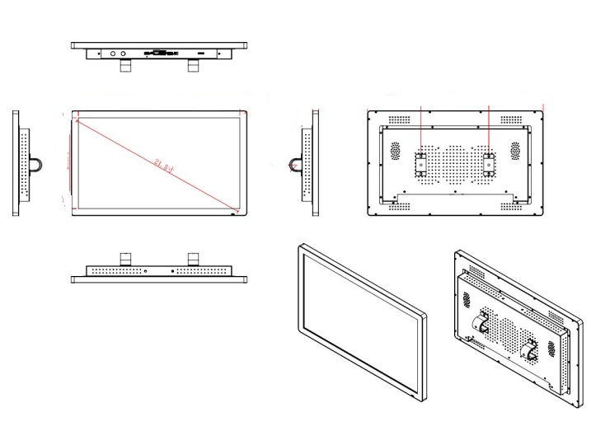

Instalare Perete sau Tavan (anexa 2)



