AGENDA

Best Practices Exchange Programs

for Bulgarian WINET Platform members in Republic of Moldova

“Innovation in wine growing techniques related to production of high-quality wines”

30 March – 02 April, 2021
Forecast: +__˚C,
LOGO / Address | TIME | ACTIVITY
30.03.2021 – Wednesday
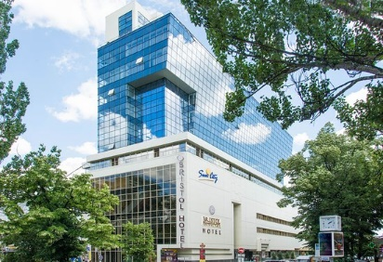  Hotel?  Address: ? | 18:00 | Arrival at hotel by car/bus (TBD)
 | 18:00 – 19:00 | Check in and accommodation at hotel and recovery time (TBD)
 | 20:00 | Dinner at the hotel
www. | 20:00 | Dinner at the hotel
31.03.2021 – Thursday
 | 07:00 – 08:00 | Breakfast at the hotel
 | 08:00 – 10:00 | Transfer from the hotel to Chateau Purcari
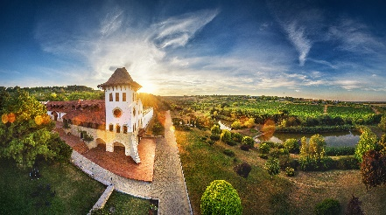  www.purcari.md  Address: Purcari, Stefan-Voda | 10:00 – 13:00 | Excursion at PURCARI WINERY  Located in the proximity to both Dniester river and the Black Sea, Purcari is a tourism site which includes two lakes and the vineyards surrounding the chateau. The Purcari cellars were built in 1827 keeping one of the most precious gems: Negru de Purcari vintage of 1948. Purcari is one of the most famous wine to the Royal Houses of Romania and United Kingdom of Great Britain.  Winery tour / Lunch & wine tasting
 | 13:00 – 16:00 | Transfer from Purcari Winery to Milestii Mici
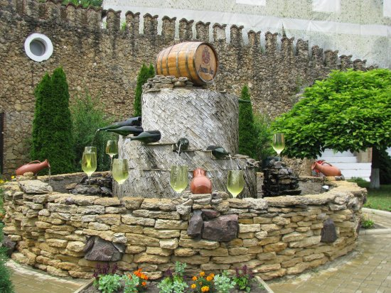  www.milestii-mici.md  Address: com. Mileștii Mici, Ialoveni | 16:00-18:00 | Excursion at MILESTII MICI WINERY  “Milestii Mici” underground cellars and winery is included in Guinness World Records in 2005 for the largest wine collection in the world, exceeding 1.5 million bottles. Also named as the Golden Collection it is kept deep below the ground and includes many unique Moldovan wines starting with the 1969 vintage. The underground galleries of “Milestii Mici” are the longest in the world stretching for over 200 kilometers. The guests of the cellar have the chance walk through the underground avenues and streets that bear the names of grape varieties and are large enough to be driven by car. After unveiling the beauty of the undergrounds, guests are welcomed to the tasting halls to enjoy exquisite wines and traditional dishes.  Winery tour & wine tasting.  Please bring warm sweaters or coats for visiting underground galleries. Average temperature there is  12-14 ˚C
 | 18:00-19:00 | Transfer from Mileștii Mici to Wine Bar
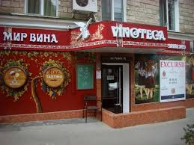 | 19:00-21:00 | Overview – National Office of Vine and Wine  Presentation of the Moldovan wine industry and of Wine of Moldova: strategy 2020-2030, history, geography, figures, grape varieties, IT projects, etc.  Wine tasting guided by sommeliers with a presentation of: indigenous varieties, PGI regions (Codru, Ștefan Vodă, Valul lui Trăian)
www.wine.md  Address: Alexander Pushkin St 15, Chișinău | 21:00-21:30 | Departure to hotel (foot walk)

Forecast: +___˚C,.

01.04.2021 – Friday
 | 07:00 – 08:00 | Breakfast at hotel
 | 08:30 – 09:00 | Transfer from the hotel to the experimental plot in Stăuceni commune
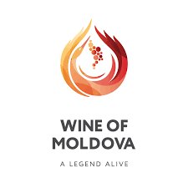  Address: Stăuceni Commune | 09:00 – 11:00 | Filed visit of the experimental plot from Stăuceni commune: ”Innovation in wine growing techniques related to production of high-quality wines”  Filed visit related to the following: chain of meteo station, experimental plots, viti soft, brochure with recommendations for wine sector, etc.  Best practices presentation  Two projects presented by NOVW representatives: “Best Grapes” and “Flave Dor”  *Please bring an umbrella in case of rain
 | 11:00 – 11:30 | Transfer from the village Stauceni to Cricova winery
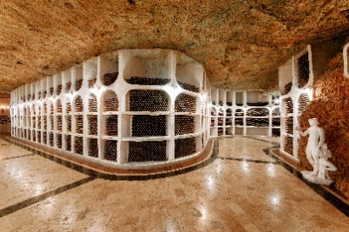  https://cricova.md/?lang=en  Address: Cricova, str. 1 Petru Ungureanu | 11:30 - 14:00 | Best Practices at CRICOVA WINERY  Winery tour / Lunch & wine tasting  Technological methods of production  Cricova is the first Moldovan company that manufactures sparkling wine by the method of the famous monk Dom Pierre Perignon – “Méthode Traditionelle”. The complex of underground galleries stretches over 120 kilometers and is the host of the National Wine Collection that includes old vintages of Moselle, Bourgogne, Bordeaux, and Porto, as well as collections of famous historical figures and world leaders.  Please bring warm sweaters or coats for visiting underground galleries. Average temperature inside is 12-14 ˚C
 | 14:00 – 15:00 | Transfer from Cricova Winery to Atu Winery
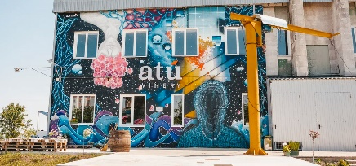  http://atu.wine/  Address: Bd. Dacia 58, mun. Chișinău | 15:00 – 17:00 | Best Practices at ATU WINERY  Guided tour / wine tasting  Innovative urban location  The first urban small winery in Moldova with the complete production cycle.
 | 17:00 – 17:20 | Transfer to restaurant
 | 17:20 – 20:00 | Dinner at restaurant
 | 20:00 – 20:30 | Departure to hotel

Forecast: +__ ˚C,
02.04.2021 – Saturday
 | 07:00 – 08:30 | Breakfast at hotel
 | 10:00-10:30 | Departure to Migdal-P  * please pack your luggage for departure back home
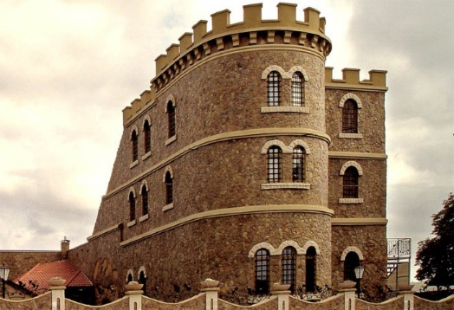  www.migdal.md  Address: str. Piata Veche 4 | 10:30-13:30 | Best Practices at “MIGDAL-P”  “MIGDAL-P” winery possesses not only with modern plant for production of wines and divines, but also with a touristic complex in the style of French Chateau including 4 tasting halls, cellars for wine storing and maturing, as well as a gallery of collection wines  Winery tour / Lunch & wine tasting
 | 14:00 | Departure to Romania

