Moldova
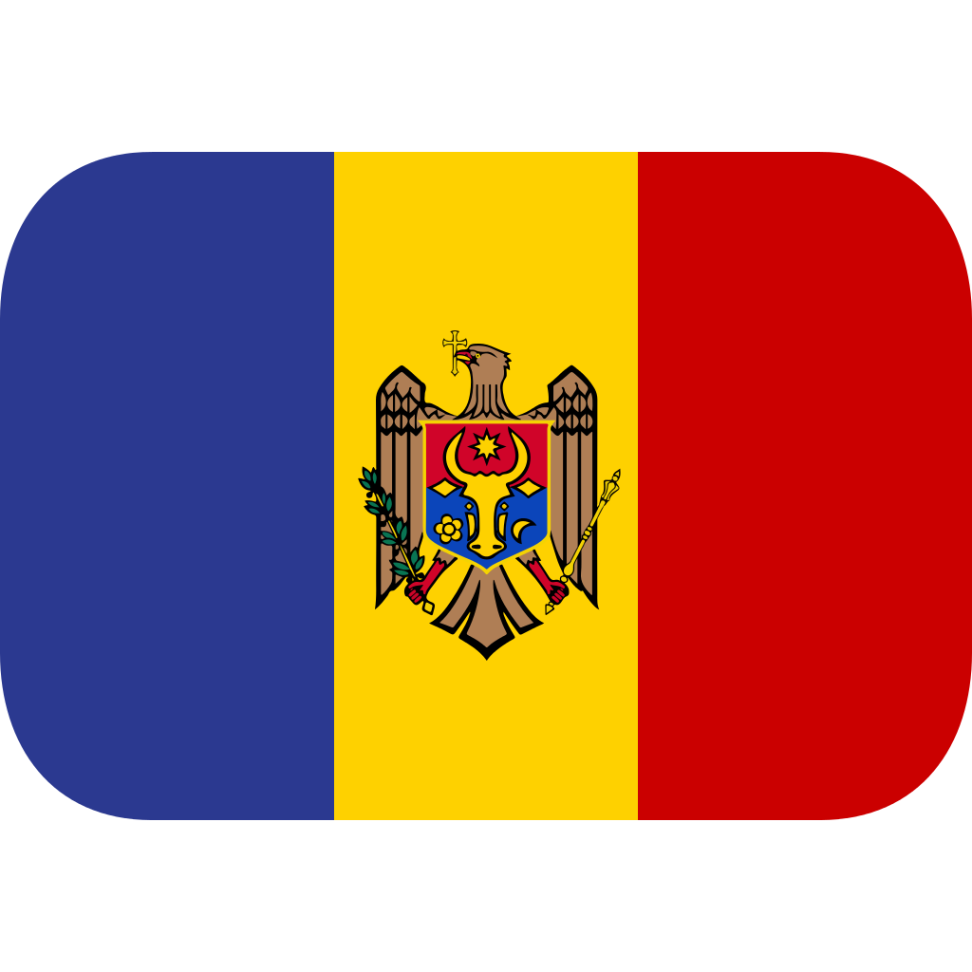
RED-North MOLDOVA
Tender - 97/29/24

Three-phase meters with connection through current transformers
Quantity of meters for purchase - 146 pcs.

Meter type:
ST402C-10A43R55-4GR1O00000-wb

Documents:
Technical Description: ST402D, ST402C Technical Description V2.0.0.0
DLMS certificate: Cert_1777_MAC_ST402C_2016_12_26
MID B: T10629R23
Declaration of Conformity: EU DECLARATION OF CONFORMITY
Type approval reactive energy: ST40x Slovacka Certifikát 116 1 221 17
Type test: NMi-14200185-03 - Poly-phase CT
Local software: PaMet version V3.9.21.0
User manual: PaMet user manual for configuration of meters V4.3.0

