Task Book
regarding the acquisition of the 5G Hybrid Private Network Solution (local UPF) through the procurement procedure Local Open Procedure
- Name of the Contracting Authority: IP Technical University of Moldova
- Organizer of the procurement procedure: IP Technical University of Moldova
- CPV Code: 32524000-2 – Telecommunications system
- List of requested goods/services:
No. d/o | Name of the requested goods/services | Quantity | Full technical specification requested, reference standards
LOT 1 Technical solution for private 5G UTM hybrid network
1.1 Network equipment
1.1.1 | 5G UPF redundant 1+1 system, including accessories and installation materials | 1 pcs. | solution that redundantly implements the 5G network service – UPF – and is integrated with the local UTM network, which includes the necessary accessories and installation materials and complies with the provisions of the technical requirement.
1.1.2 | 5G gNodeB radio system, including accessories and installation materials | 1 pcs. | Technical solution that implements dedicated indoor radio coverage for the laboratory room chosen by UTM, on an area of 100m2, which includes the necessary accessories and installation materials and complies with the provisions of the technical requirement.
1.1.3 | SIM cards for the private 5G UTM network | 20 pcs. | SIM cards, compatible with 5G SA technology, which will need to be provisioned in the private 5G network of Future Networks laboratories and offered in the physical format desired by UTM (MiniSIM, MicroSIM, NanoSIM).
1.2 Network services
1.2.1 | Annual support services for 5G UPF | 4 years. | Support, maintenance and upgrade services for the 5G UPF system installed within UTM.
1.2.2 | Annual support services for gNodeB 5G | 4 years. | Support, maintenance and upgrade services for the 5G gNodeB system installed within UTM.
The estimated value is 234,500.00 EUR
Content

Assignment 2
Acronyms 4
1 Introduction, objectives and scope 7
1.1 Introduction 7
1.2 Objectives 7
1.3 Scope 8
2 Infrastructure provided by UTM 9
2.1 High-capacity LAN connectivity and racks available in the university data center 9
2.2 Space for installing radio equipment and Core elements 9
3 Implementation requirements 10
3.1 General requirements 10
3.2 Coverage and service availability requirements 10
3.3 Technical requirements 11
3.3.1 Definitions and key terms 11
3.3.2 Design requirements 12
3.3.3 Functional requirements 17
3.3.4 Technological evolution requirements 18
4 The relationship between UTM and the selected bidder 21
4.1 General framework for collaboration 21
5 Execution of works 22
5.1 Project phases 22
5.1.1 Implementation 22
5.1.2 Exploitation 24
5.2 Reporting 24
6 Conditions for the execution of the service 25
6.1 Preventive and corrective monitoring 25
6.2 Governance model 25
6.2.1 Contract Manager 25
6.2.2 Technical Services and Operations Manager 26
6.2.3 Other conditions relating to the qualification of experts 27
6.2.4 Project development 27
6.3 Service Level Agreement (SLA) 28
6.3.1 Problem detection and response time 28
6.3.2 Incidents 28
6.3.3 Technical support 29
6.3.4 Quality of Service (QoS) 30
6.4 Training 31

Acronyms

Term | Description
3GPP | 3rd Generation Partnership Project
4G | fourth generation network
5G | fifth generation network
5G-AI | 5G Infrastructure Association
5G-PPP | 5G Infrastructure Public Private Partnership
5GC | 5G Core
AGV | Automated Guided Vehicle
you | Artificial Intelligence
API | Application Programming Interface
It | Augmented reality
CISA | Container as a Service
CNF | Cloud-native Network Functions
CPE | Customer Premises Equipment
MR | Down Link
DN | Data Network
DRB | Data Radio Bearer
DSS | Dynamic Spectrum Sharing
E2E | End to End
eMBB | Enhanced Mobile Broadband
eNB | evolved Node B
ETSI | European Telecommunications Standards Institute
FR1 | Frequency Range 1
FR2 | Frequency Range 2
GIS | Geographic Information System
gNB | Next Generation Node B
GNSS | Global Navigation Satellite System
GPS | Global Positioning System
GUI | Graphical User Interface
HSS | Home Subscriber Server
IaaS | Infrastructure as a service
ICE | Inland, Coastal & Estuary
IoT | Internet of Things
IP | Internet Protocol
JSON | JavaScript Object Notation
KPIs | Key Performance Indicators
LAN to | Local Area Network
LCM | Lifecycle Management
LTE-M | LTE Machine Type Communications
MANO | Management and Orchestration
MCx | Mission Critical Communications
MEC | Multi-access Edge Computing
MIMO | Multiple Input Multiple Output
ML | Machine Learning
MME | Mobile Management Entity
mMTC | massive Machine Type Communications
MNO | Mobile Network Operator
MPLS | Multiprotocol Label Switching
MQTT | Message Queuing Telemetry Transport
NBI | Northbound Interface
NB-IoT | Narrowband IoT
NFV | Network Function Virtualization
No. | Radio
NES | Non-Stand Alone
NSSAI | Network Slice Selection Assistance Information
NRC | Network Slice Template
NVR | Network Video Recorder
OBD | On-Board Diagnostics
OBU | On-Board Units
NDP | Packet Data Network
PLC | Programmable Logic Controller
PLMN | Public Land Mobile Network
PMR | Private Mobile Radio
PRS | Positioning Reference Signal
QoS | Quality of Service
PGW | Packet Data Network Gateway
RAN | Radio Access Network
S-NSSAI | Single Network Slice Selection Assistance Information
SADDLE | Stand Alone
SBA | Service Based Architecture
SDN | Software Defined Network
card | Subscriber Identity Module
ALS | Service Level Agreement
SGW | Serving Gateway
SRS | Sounding Reference Signal
eu | User Equipment
the | Up Link
URLLC | Ultra-Reliable and Low Latency Communications
V2X | Vehicle-to-Everything
VHF | Very High Frequency
VNF | Virtual Network Function
VR | Virtual Reality

Introduction, objectives and scope

Introduction
The Technical University of Moldova (UTM), in partnership with the Technical University "Gheorghe Asachi" of Iași (TUIASI), is implementing the CONNECTINNO project - "Cross-Border Interconnected Mobile Networks for Education and Innovation". Within the project, UTM aims to acquire and implement a private 5G Standalone (SA) network to support educational, research and innovation activities, as well as to facilitate cross-border cooperation.
The new communications service will have to cover a laboratory within the University, thus ensuring support for teaching and research activities. The selected network solution will have to be dedicated to UTM, offering isolation for resources, high availability and reliability. At the same time, the implemented network will have to comply with the 3GPP release 16 standard, with the possibility of being progressively improved according to the evolution of the 5G architecture.
Thus, this technical document has the following structure:
- Objectives and scope: the main objectives of the tender are detailed;
- Infrastructure provided by UTM: the existing infrastructure that can be used by the selected subcontractor as support for the private 5G network that will be implemented is described;
- Technical requirements: the specific characteristics and requirements of the 5G private network to be implemented are described;
- Relationship with the selected subcontractor : the context of cooperation between UTM and the selected subcontractor is defined;
- Works execution: the project implementation plan is defined and the operating requirements for the implemented network are described ;
- Conditions for execution of works: the expected level of quality specific to the implemented services is defined.
No. of documents. | Product name | CPV code
1 | Complete 5G hybrid private network solution (local UPF) for a UTM laboratory | 32524000-2 – Telecommunications system

Objection
The purpose of this document is to establish the technical specifications and execution conditions of the project to implement a private 5G network within UTM.
Thus, the winner of the auction will design, install and integrate a private 5G network, offered as a service to UTM, will operate and maintain it 24x7 and will allocate dedicated resources to UTM, offering radio communications services with increased reliability, high bandwidth and low latency.
The implementation of the private 5G network project in the University, defined as a turnkey Infrastructure as a Service (IaaS) solution, will have the following objectives:
- Implementation of a 5G SA network, compatible with at least 3GPP Release 16, covering a laboratory room on the UTM campus;
- Support for educational and research scenarios (network slicing, edge computing, IoT, V2X, AI/ML);
- Interoperability with the 5G Future Networks laboratories at the National University of Science and Technology Politehnica Bucharest and the “Gheorghe Asachi” Technical University of Iași , including through VPN/MPLS or dedicated L2/L3 connectivity;
- Providing access to APIs and metrics for students and faculty, for laboratory and research purposes;
- Support for piloting and validating cross-border use cases (V2X, MCX).

Scope
The purpose of this tender is to implement an Infrastructure as a Service (IaaS) solution for a private 5G network, including the necessary technical developments and associated services (planning, design, installation, configuration, optimization, software implementation, integration and commissioning) so that the resulting network operates within the parameters defined in section 3.3 Technical Requirements from this document.
In addition, the tender also includes the licenses necessary to implement the solution at the expected functional level, maintenance and follow-up services, user training, cooperation with third parties for the development of new services and applications, and also project management services associated with the development of the private 5G network.

Infrastructure provided by UTM

High-capacity LAN connectivity and racks available in the university's data center
UTM will provide an adequate support infrastructure for the installation and operation of the private 5G network. At the connectivity level, UTM has a high-capacity LAN network, with redundancy and performance corresponding to the requirements of a state-of-the-art laboratory.
These resources provide the necessary conditions for the integration of Distributed Core 5G (UPF) equipment and for the continuous operation of laboratory services.

Space for installing radio equipment and Core elements
Regarding the space for installing radio equipment and Core elements, UTM will provide a dedicated, secure and air-conditioned technical room, with controlled access, intended to host distributed Core elements (UPF) and routing and switching equipment.
The proposed rack for installation will be equipped with redundant power supply, surge protection and direct connectivity to the university network. For the installation of radio equipment (gNB), a suitable location will be identified in the laboratory room on the UTM campus, with access to electricity and fiber optics.
The beneficiary will ensure the obtaining of internal permits and access to locations for installation and maintenance, complying with all occupational health and safety regulations, as well as fire protection regulations.

Implementation requirements

General requirements
The winner of the tender will have to implement a technical solution that implements services at least equivalent to those described in the list of specifications present in this document.
The winner of the auction will have to offer UTM a guaranteed Infrastructure as a Service service, respecting the following criteria:
- Providing all necessary services, hardware, software, licenses, accessories and materials ;
- Providing the necessary SIM cards, in the physical format desired by UTM (MiniSIM, MicroSIM, NanoSIM), both during the implementation phase and after completion of the works, including the procedures for activating and managing the cards throughout the life of the project ;
- Ensuring adequate technical personnel to implement tasks related to the design, implementation, configuration, operation and repair of the installed network ;
- Ensuring the maintenance services necessary to maintain the quality level of the service at the standard agreed upon in agreement with UTM ;
- Establishing a governance model and the necessary communication channels with UTM representatives to carry out the specified activities in good conditions throughout the project.
Unforeseen events and/or additional costs associated with the private Infrastructure as a Service network will not be allowed under any circumstances. Additional requirements beyond those set out in this document will be discussed in advance with the successful bidder.
The winner of the tender will have to provide all the tools, instrumentation, equipment, materials, and adequate technical personnel necessary to complete the project in good execution conditions.
The responsibility of the winning bidder is to comply with the legislation in force, as well as with the quality standards associated with the execution activities specific to the implementation of the private 5G network, both at the technical and administrative level.
The winning bidder will be responsible for completing all standard actions and procedures to obtain the necessary licenses and permits for the installation of equipment associated with the implementation of the private 5G network. The winning bidder will also be responsible for documenting the implementation and installation procedures to reflect the activities described in the project planning.
The winning bidder will have to plan the execution works flexibly, validate them in advance with UTM and allocate a sufficient number of human resources.

Coverage requirements and service availability
The coverage offered by the implemented private 5G network will have to cover an area of 100 m², specific to a laboratory room on the university campus . The technical plan of the laboratory is presented in Figure 1 .
The winning bidder will have to ensure that the designed solution complies with the guaranteed bandwidth requirements defined in this document in these locations.

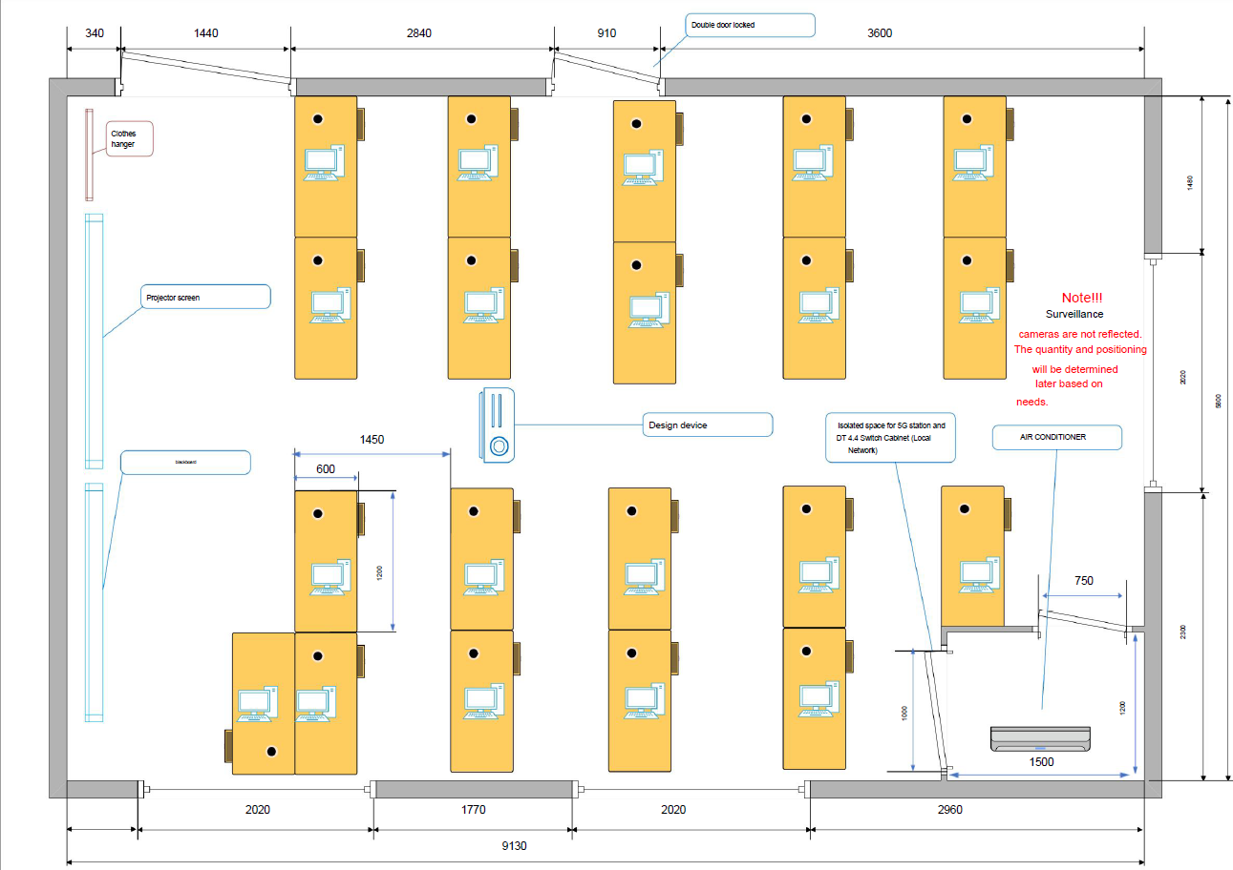
Figure 1 - Room plan for the UTM 5G laboratory
During the validity period of the contract associated with this tender, UTM will have the possibility to increase the number of rooms in which it wishes to have indoor coverage by a maximum of two (2) more than those indicated in the previous list. At the same time, compatibility with radio solutions intended for outdoor coverage will have to be ensured. Thus, the winning bidder will have to take this into account in the bidding and design stages of the coverage.
To achieve this indoor coverage, the winning bidder will have to use dedicated technical solutions adapted to the specifics of the aforementioned indoor areas, using pico-cell, small-cell or equivalent radio equipment, which comply with the 3GPP release 16 standard and comply with the technical requirements expressed in section 3.3 Technical requirements.
The winning bidder will have to demonstrate compliance with coverage obligations to UTM, after the implementation of the private 5G network, according to the documentation requirements and deadlines defined in section 5.4 Reporting.
If UTM does not positively validate compliance with the coverage obligations, it may conduct an external audit, the costs of which will have to be borne by the winning bidder.

Technical requirements

Definitions and key terms
The following presents key 5G terms and concepts associated with current 3GPP standards, all with the aim of clarifying the technical requirements stipulated in the subsequent sections of this document.
Thus, two types of mobile networks are defined depending on access to communications services:
- PLMN (Public Land Mobile Network): telecommunications network that provides services to the general public. Any operator that provides telecommunications services has its own PLMN ;
- NPN (Non-Public Network): telecommunications network that provides services to a private group of users.
Regarding 5G technology, two types of networks are distinguished depending on the Core architecture typology:
- NSA (Non-Standalone): network that uses Core LTE/4G elements for control/signaling functions ;
- SA (Standalone): all network elements, both for the radio area and the Core area, comply with the 5G standard.
In either of the two scenarios presented above, several types of private networks can be created depending on the chosen architecture and how users are managed:
- SNPN (Standalone Non-Public Network): completely private network, isolated from public networks, using a dedicated PLMN;
- SHNPN (Standalone Hybrid Non-Public Network): private network, isolated from public networks, using distributed Core elements (UPF) and a dedicated PLMN ;
- SNPN with shared RAN: private network, isolated from public networks in the Core area, which includes mechanisms for sharing radio resources and uses a public or dedicated PLMN ;
- PNI-NPN (Public Network Integrated with Non-Public Network): private network, which uses distributed Core elements (UPF) and a public PLMN .

Design requirements

General design requirements
The architecture of the proposed private 5G network, both at the hardware and software level, as well as at the management, exploitation, operation and maintenance systems level, will have to be designed following the following criteria:
- Resilience, availability and recovery capacity: The architecture will have to guarantee maximum service availability in the event of communication line failures that may impact the 5G service. The winning bidder will have to ensure that intervention time and service unavailability are minimized using the necessary techniques and procedures;
- Flexibility: The architecture will need to adapt to the evolving network changes that will be necessary to meet future latency, bandwidth (uplink and downlink) and traffic volume requirements;
- Scalability: The implemented hardware and software architecture will need to be able to easily accommodate new functionalities and services, being able to respond quickly to increases in network traffic;
- Security and isolation: The winning bidder will have to include in the network architecture all the necessary technical security elements to guarantee the isolation of the UTM private mobile infrastructure from other traffic sources.
The technical solution for the UTM dedicated mobile network architecture will need to use the SHNPN (Standalone Hybrid Non-Public Network) public-private hybrid private network model.
The architecture of the proposed solution must implement at least version 16 of the 3GPP standard as a 5G Standalone (5G SA) network, being able to accommodate subsequent versions of the standard. Technical solutions that are based exclusively on previous standards will be rejected.
UTM will evaluate the proposed solutions for the university-specific private 5G network in accordance with the target architecture defined in the subsequent sections of this document.
The technical solution offered will have to implement the following elements and allow adaptation to various evolutionary aspects:
- Implementation according to the SDN (Software Defined Network) paradigm that defines the concept of separation between the data plane and the control plane, a concept that allows local consumption of useful data coming from mobile users within the university within the private network;
- Implementation according to the SBA (Service Based Architecture) model, whereby all network functions are developed in the form of services that communicate with each other through standard messages ;
- Implementation using virtualized network functions of the NFV type (Network Functions Virtualization);
- Implementation of a SIM management platform specific to the private network (activation/deactivation of services) ;
- Implementation of Mission Critical Communications (MCx) services ;
- Implementation of network slicing functionality specific to version 16 of the 3GPP 5G SA standard.

5G Private Network Solution Architecture
The target technical solution for the private 5G network will need to cover the area of the target laboratory, under the responsibility of UTM, according to the specifications detailed in section 3.2 Coverage and availability requirements.
The infrastructure offered will have to have the following elements:
- The radio access network, consisting of an indoor coverage radio solution (pico-cell, small-cell, repeaters, etc.) and all associated elements (power and data cables, optical fibers, etc.) ;
- The transport and Core network, consisting of a redundant distributed Core element (UPF), IP traffic routing and switching equipment and the fibers used for data transmission within the university, sized to comply with the requirements defined in sections 3.3.3.2 Initial performance requirements and 3.3.4 Technological evolution requirements ;
- Interconnection of the private 5G network, data traffic plan, with specific local network elements UTM, LAN/WAN and servers.
The target architecture for implementing the SHNPN hybrid private mobile network, which implements the Distributed Core (UPF) functionality to separate data traffic from control traffic, is graphically presented in Figure 2 .
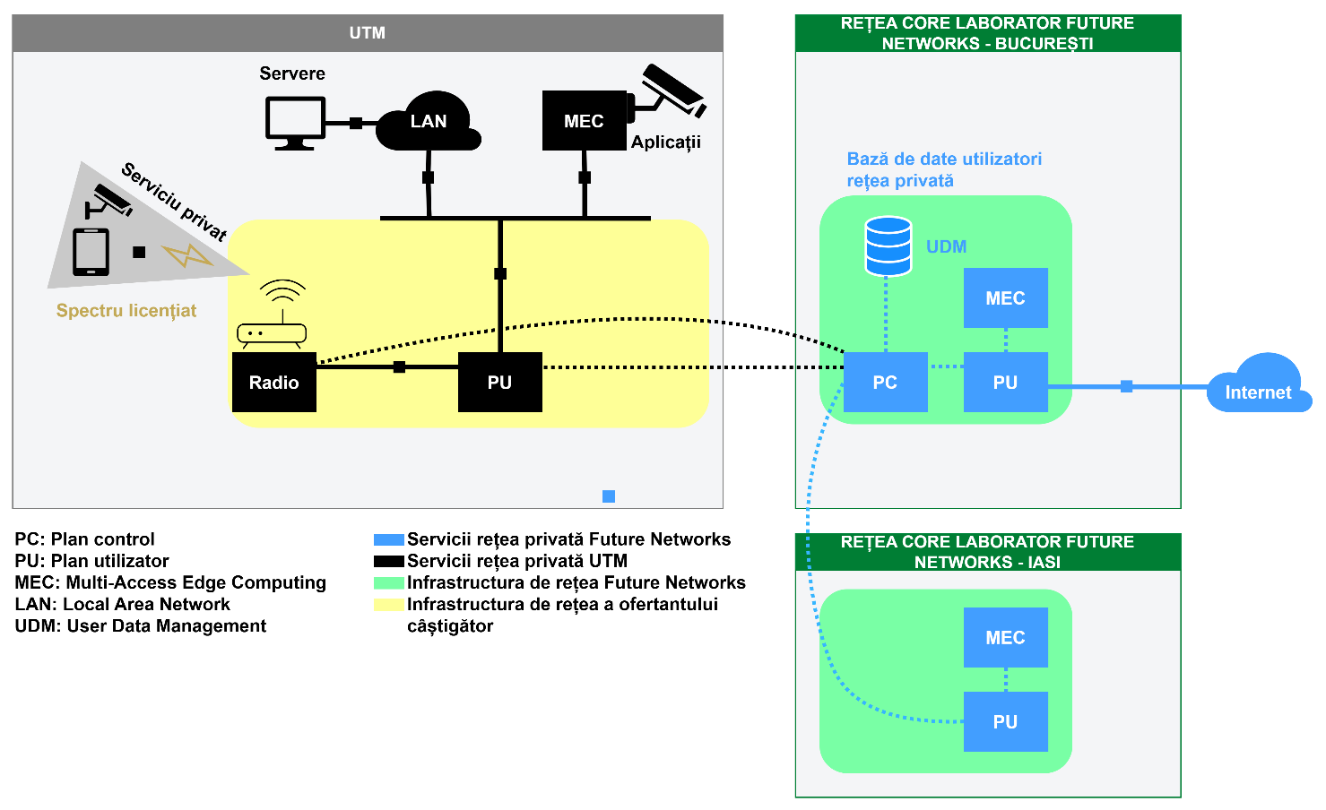
Figure 2 - Target architecture for private 5G network
The distributed Core (UPF) and radio access network elements will have to be chosen so as to allow integration with the 5G network specific to the Future Networks laboratories in Bucharest (National University of Science and Technology Politehnica of Bucharest) and Iași (Technical University "Gheorghe Asachi" of Iași), described on the laboratories' presentation page , through standard interfaces defined by 3GPP :
- N1 interface – the interface between the UE (User Equipment) and the AMF (Access and Mobility Management Function) specific to Future Networks laboratories.
- N2 interface – the interface between gNB and the AMF specific to Future Networks laboratories.
- N3 interface – the interface between gNB and UPF (User Plane Function). It carries data traffic (user plane) between local UTM terminal equipment and the network.
- N4 interface – the interface between the SMF (Session Management Function) specific to Future Networks laboratories and the local UTM UPF.
- N6 interface – the interface between UPF and external data networks (Data Network – DN). This will interconnect with UTM private networks and the Internet (via the link to Future Networks laboratories).
The built hybrid network will have to allow the connection of a minimum number of 100 simultaneous users.
All elements of the target network typology will need to be chosen to avoid the following risks:
- Single points of failure
- Susceptibility to intrusion
- Infrastructure damage:
- Damaged interconnection lines
- Between terminals and base stations
- Between base stations and the Distributed Core Facility (DCP)
- Between base stations and the main Core unit, used for control traffic
- Damaged terminal equipment
- Damaged power lines
- Wrong configurations

Radio access network
The radio access solution dedicated to the private 5G network dedicated to UTM will need to be sized to comply with at least the requirements set out in sections 3.3.3.2 Initial performance requirements and
3.3.4 Technological evolution requirements.
For the correct implementation of the radio network and for an adequate allocation of resources, the winning bidder will need to perform the following actions during the solution development stage:
- To ensure the availability of guaranteed radio band resources for UTM in the amount of at least 20 MHz in the 3.4-3.8 GHz spectrum, with the possibility of expansion up to 100 MHz ;
- Configure the installed radio equipment (emission levels, antenna orientation).
The radio stations that will be used for the purpose of the UTM private 5G network will need to be interconnected with the distributed Core unit (UPF) installed in the UTM premise and with the central Core solution (5GC) specific to the 5G Future Networks laboratories in Bucharest and Iași.

Transport Network and Core
The distributed Core Element (UPF) will need to be implemented in a redundant manner, in a 1 + 1 configuration, and will be connected to the radio nodes installed within the university, to the UTM-specific LAN/WAN networks and to the central Core network (5GC) specific to the 5G Future Networks laboratories in Bucharest and Iași using a dedicated transport infrastructure or VPNs.
The Distributed Core element will need to be installed in the UTM data center. The chosen Distributed Core (UPF) solution will need to be implemented in virtualized form, using the NFV (Network Functions Virtualization) paradigm, and route data traffic coming from mobile users of the university's private 5G network to UTM-specific LAN/WAN networks.
The winning bidder will have to implement the distributed Core (UPF) solution according to version 16 of the 3GPP standard, while also allowing the software elements to be updated to subsequent generations of the 5G communications standard.
The 5G private network solution installed in UTM will have to facilitate the implementation of data traffic re-routing techniques to isolate the flows specific to the UTM private user group from the rest of the data traffic transmitted through the public network of the winning bidder. To this end, the winner of the auction will have to implement the Local BreakOut (LBO) concept within the university's private 5G network to route private traffic to UTM equipment (terminals, servers).
In this configuration, the winner of the auction will have to ensure that UTM has the ability to connect its own networks and servers to the private 5G network and, more precisely, to the distributed Core (UPF) through a series of dedicated ports in the installed equipment for routing and switching L2/L3 IP traffic.
For this interconnection in LBO topology, at least two 10Gbps connections are required through SFP+ ports or similar. The winner of the auction will have to ensure the availability of the specified ports and the associated interconnection elements.
The winning bidder will have to guarantee an MTU of at least 1500 bytes.
The winning bidder must clearly define the interfaces associated with the Distributed Core Function (UPF) linked to the private network specific to the 5G Future Networks laboratories. These interfaces are essential for controlling data flows and enabling connections with third-party applications to be implemented. This is a necessary condition for orchestrating and managing resources, developing a multi-access Edge Computing (MEC) solution, and implementing the use cases desired by the UTM.

Spectrum considerations
The proposed solution for allocating the radio spectrum required for the UTM private 5G network must be based on the 3GPP standard and be fully adaptable to its evolution towards 3GPP/5G SA versions 16, 17 and 18.
The winning bidder must guarantee the allocation of a dedicated spectrum, in the amount of 20 MHz in the 3.4-3.8 GHz spectrum, for UTM's private 5G network. This must be exclusively allocated (reserved band) to UTM and must be accessible through the allocation of a dedicated network slice compatible with 3GPP version 16.
During the contract period, the bidder must ensure the availability of the guaranteed licensed spectrum use, complying with the regulations regarding the use of radio spectrum based on the established allocation schemes.
The winning bidder must allocate the bandwidth necessary to achieve, with guaranteed quality of service, the performance and sizing requirements set out in section 3.3.3.2 Initial Performance Requirements.

Other design requirements

Availability
The transport and Core network, consisting of routing and switching equipment for L2/L3 IP traffic and a Distributed Core Facility (UPF) node in 1 + 1 redundancy, must provide a service availability of at least 99% monthly.
The radio access network supporting the UTM reserved spectrum resources must provide service availability of at least 99.7% monthly.

Redundancy
The winning bidder must guarantee the continuous operation 24 hours a day, 365 days a year of the installed 5G service.
The proposed solution should maximize the number of redundant components to ensure service continuity in the event of any failure.

Security
The UTM private network solution must incorporate integrity, authentication, and encryption mechanisms at both the radio access network level and the transport and Core network levels.
The winning bidder must comply with 5G cybersecurity requirements according to the 5G Security Toolbox developed by ENISA, addressing the following aspects:
- Conducting a 5G risk analysis every two (2) years;
- Reviewing their suppliers' security practices, taking into account 5G risk factors ;
- Implementing technical and organizational measures to manage existing risks, ensuring secure oversight procedures and applying strict access requirements to 5G network elements and functions to minimize access by external entities;
- Managing risks arising from suppliers' activities and ensuring their compliance with security requirements, including the application of risk reduction measures provided for in European security schemes;
- Developing a supplier diversification strategy to limit the network's dependence on a single or several high-risk manufacturers;
- Use of 5G network equipment (radio, transport, Core) from authorized suppliers ;
- Transmission to UTM of the results of the risk analysis, including a report on the implemented security practices and the supplier diversification strategy.

Scalability
The technical solution specific to UTM's 5G private network must have the technical capacity to expand its capacity to handle a larger number of components than those initially proposed, necessary to comply with the basic scenario described in the document. This includes expanding the number of base stations and updating hardware/software components.
Both the initial requirements and those that evolve with the services are detailed in section 3.3.4 Technological evolution requirements.

Functional requirements

Mobile data services
Access to data services according to the 3GPP 5G standard must be guaranteed, as specified in sections 3.3.3.2 Initial performance requirements, 3.3.3 Functional requirements and 3.3.4 Technological evolution requirements.

Initial performance requirements
Regardless of the applications implemented over the UTM private network solution, the following quality of service levels must be respected for all mobile terminals, both portable and installed in vehicles:
- 5G service specifications:
  - Maximum data transfer rate: The maximum value of the traffic rate that can be achieved by a single user under ideal radio conditions, without errors on the radio interface. This value is measured in a location with a single active user connected to a specific cell/antenna of the UTM private network solution;
  - Reference speed for ensuring good quality for users: The performance that 95% of users can achieve in the coverage area of UTM's private network solution, detailed in section 3.2 Coverage and availability requirements;
  - Latency: The network contribution to the delay associated with the transfer of a data packet. This is defined as the delay between the transmission of a packet and its reception, using a mobile device connected to the private 5G network and ready for data transfer/reception for a small packet size.
- Performance metrics:
  - Maximum data transfer rate on downstream channel: ≥ 100 Mbps;
  - Maximum data transfer rate on upstream channel: ≥ 20 Mbps;
  - Reference speed for ensuring good quality for downstream users: ≥ 50 Mbps;
  - Reference speed for ensuring good quality for users on the upstream channel: ≥ 10 Mbps;
  - Latency: < 20 ms.

Technological evolution requirements

Desired evolution
The winning bidder must submit a Technology Evolution Plan based on the proposed architecture for the UTM 5G private network project. This plan must include at least the following points:
- Initial implementation technological scenario ;
- Intermediate update stages;
- Final implementation scenario;
- Execution calendar.
It will be appreciated if the private network solution for UTM is initially implemented according to the 5G SA 3GPP release 16 architecture.
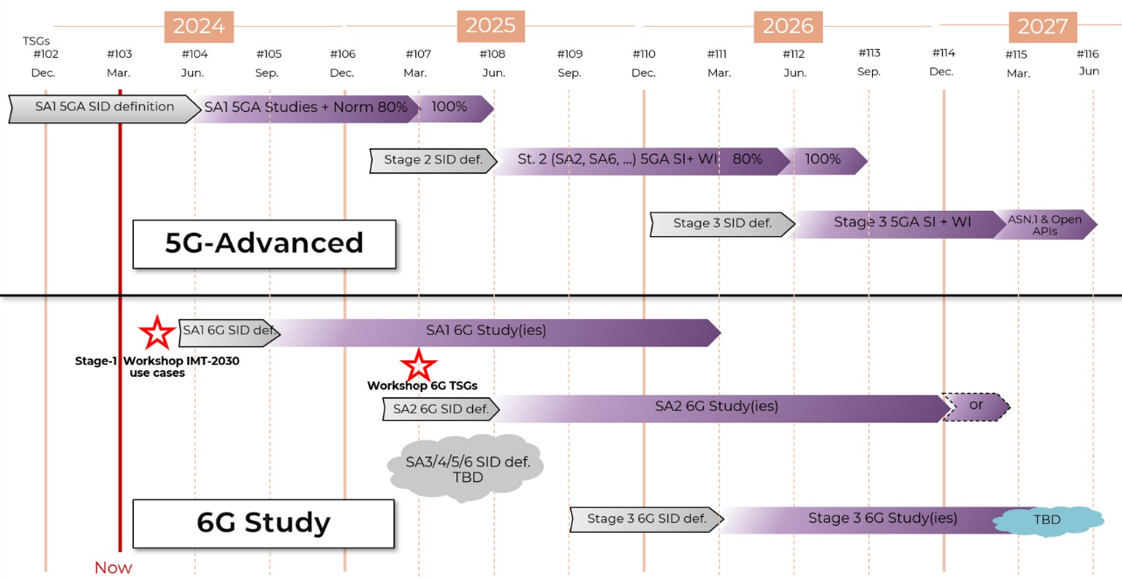
Figure 3 - 5G SA network development schedule according to 3GPP
The technological evolution of the private network offered to UTM must follow the strategic commercial progression of the winning bidder. It must commit to making available software/hardware updates to the UTM private network within a maximum period of six (6) months from the inauguration of the UTM laboratory.
For reference, a detailed timeline of the development and delivery stages for the different versions and phases of the 5G SA protocol, according to 3GPP (the international body responsible for the development and standardization of this protocol), is included in Figure 3 .

Design requirements for technological evolution

Radio access network
If the winning bidder does not initially propose a network solution based on the 3GPP 5G SA version 16 standard, it must ensure the adaptation of the radio resources for the UTM private network to this standard within a maximum of 3 months from the conclusion of the contract. This includes performing the necessary hardware and software updates to convert the base stations to gNB 5G NG-RAN.

Transport Network and Core
If the winning bidder does not initially propose a network solution based on the 3GPP 5G SA version 16 standard, it must ensure the adaptation of the distributed Core components for the UTM private network to the 3GPP/5G SA standard within a maximum of 3 months from the signing of the contract. This includes performing the necessary hardware and software updates, as well as updating the network functions and interfaces corresponding to the 5GCN (core network specific to the 5G standard).

Other design requirements associated with technological evolution
The winning bidder must guarantee the implementation of all technologies, functionalities and capabilities specific to the 3GPP/5G SA standard starting with version 16. This includes the use of network functions virtualization (NFV) and software-defined networking (SDN) to accommodate the separation of data and control planes, as well as network segmentation according to needs.
The winning bidder must also ensure the implementation of network slicing solutions that allow the management and operation of multiple virtual networks on a common physical infrastructure. This functionality should provide differentiated capabilities and dedicated quality of service levels (such as traffic rate, latency, etc.) for the UTM private network solution.

Requirements for network performance evolution
The implementation associated with the private network solution for UTM must address the essential aspects related to the 3GPP/5G SA standard, version 16 and later, covering various requirements specific to reference use scenarios:
- uRLLC: Ensure the ability to implement services that require low latency and increased reliability (uRLLC), such as the use of 5G cameras connected to edge processing systems equipped with AI graphics accelerators for video analysis or the use of ultra-reliable networks to improve the performance of critical communications solutions;
- eMBB: To ensure the ability to implement services with high bandwidth requirements (eMBB), such as real-time communication for high-quality video conferencing or high-definition video transmission .
In the implementation phase , according to the 5G SA standard, the winning bidder must use the performance requirements provided in the 3GPP technical specification TS 22.261 as a reference.

The relationship between UTM and the selected bidder

General framework for collaboration
Through this tender, UTM aims to implement a private 5G network service, which complies with 3GPP/5G standards, within a laboratory room at the university.
The winning bidder must provide access to UTM authorized personnel to the interfaces, network functions, and data traffic control mechanisms associated with the data plan to facilitate the development of third-party applications.
To ensure proper coordination between UTM and the winning bidder, a Cooperation Framework will be established. This framework will regulate access to UTM private network elements for service development by authorized university personnel and will include the following considerations:
- Coordinated task planning, scheduling different maintenance windows for necessary interventions and production launches ;
- Defining user permissions and their roles;
- Reporting associated with each intervention and establishing its purpose.

Execution of works

Project phases
This chapter aims to define the phases and stages in which the implementation of the new services is organized. This tender is divided into the following phases and sub-phases of the project, as shown in Figure 4 :
- Service implementation
- Service operation
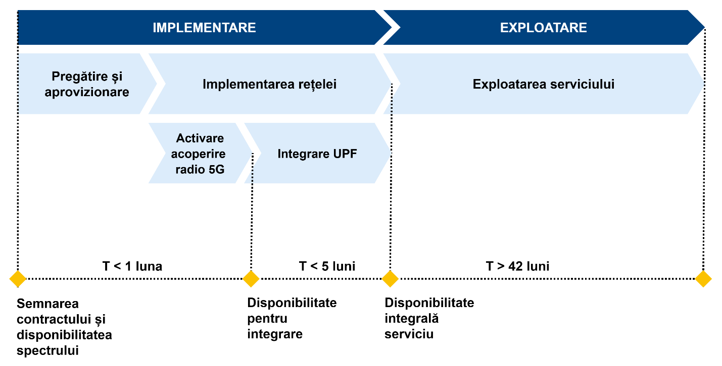
Figure 4 - Project phasing
During each phase and sub-phase, a series of deliverables will be generated, as specified in section 5.2 Reporting. These deliverables must be approved within the governance framework set out in section 6.2 Governance Model. Without this approval, subsequent sub-phases cannot begin.

Implementation
The Implementation Phase will begin with the signing of the contract and will end with the achievement of milestones associated with service delivery.

Preparation and supply
The first phase of the project, which will begin with the formalization of the contract, involves the preparation and provision of the materials and equipment necessary to implement the services covered by this tender. This phase will also establish the planning for the execution of the processes and the contract management mechanisms.
An indoor coverage study will be required, along with a reassessment of the infrastructure required to install the associated equipment in the UTM premise.
The Implementation Plan will be developed and delivered to UTM and must include, at least:
- Defining all UTM requirements in advance in order to successfully implement the private network;
- Project implementation and management planning: project development, which will include all technical aspects of the solution (final design, architecture, technologies used, sizing and test plan) and the operation plan (procedures and tools for providing associated services);
- Defining a clear and detailed implementation and commissioning protocol, with defining responsibilities;
- Test plan: the winning bidder must present a plan detailing the specific tests for the contracted services, in accordance with the regulations in force for each type of system and/or service;
- Training plan.
This implementation plan will be presented within the offer. If during the analysis phase restrictions are identified that could affect the installation of any element, alternative solutions must be proposed and their impact on the initially planned activities assessed.
During this analysis phase, the Execution Project must be developed, which will include all technical aspects related to the implementation, operation and exploitation of the services to be implemented. It must detail the current situation and any restrictions detected that could cause a change in the original work plan. This document must include, at a minimum, the following information:
- Inventory list: equipment and cabling elements provided by the winning bidder according to the contractual solution;
- Equipment installation locations and description of how the installations will be carried out;
- The wiring diagram that will be made and the description of how the installations will be carried out.
The proposal in the Execution Project must be reviewed and accepted by UTM before any type of installation or site preparation is carried out. Finally, all previously mentioned plans will also be reviewed and drafted as part of this section.

Installation and commissioning
The implementation phase is dedicated to the implementation, activation and delivery of the service to UTM. A maximum period of one (1) month from the start of the contract is foreseen for ensuring 5G radio coverage in the UTM laboratory room (assuming that the UTM dedicated spectrum is available at the time of contract signing) and six (6) months from the start of the contract for the complete delivery of the 5G private network service for UTM by the winning bidder, including its integration with the initially installed 5G radio system.
Purpose: Delivery of a private network service for UTM, consisting of the following components:
- Provision, delivery, activation and lifecycle management of SIMs for UTM. In this phase, the number of SIMs agreed with UTM in physical format will be delivered. The quantity associated with each format will be specified by UTM to the winning bidder during this phase;
- Implementation of the distributed Core element (UPF);
- Activation of the 5G service in the target laboratory room, with dedicated resources assigned to the UTM private network and integration with the local UPF and the main Core network (5GC) ;
- Interconnecting the local UPF with LAN/WAN networks and specific UTM servers;
- Specialized Operation and Maintenance services, including project management.
Coverage and quality of service thresholds:
- The coverage resulting from this phase must ensure satisfactory quality of service across the entire target laboratory area;
- The value of the network performance indicators, associated with the quality of service, must meet or exceed the minimum requirements specified in chapter 3.3.3 Functional requirements.
For any element to be considered delivered in the completion of the various subphases, it must pass the established acceptance protocol, proposed by the winning bidder and approved by UTM.
Any installation to be carried out by the winning bidder in UTM facilities must be previously approved by UTM and comply with established protocols and implementation planning. The winning bidder is responsible for carrying out administrative procedures to obtain all necessary work permits.

Exploitation
The Operation Phase begins with the completion of the Implementation Phase and extends until the end of month 48 of the contract period.
To begin the Exploitation phase, UTM must formally validate the service. This process will be initiated by the winning provider. Acceptance can be total or partial, depending on the achievement of the objectives of the Implementation phase. If acceptance is partial, the provider will provide a detailed report and an estimated date for the remediation of the reported issues.
The purpose of this phase includes:
- Operation and maintenance of the network and all constructive elements throughout the life cycle of UTM's 5G private network service;
- Support for implementing new services over UTM's private network;
- Post-integration optimization services for network components;
- Specialized Operation and Maintenance services, including project management, system configuration and necessary systems engineering work;
- Establishing the implementation team according to the Governance Model and holding periodic technical meetings.
The starting month of the Operation phase cannot exceed the established term of six (6) months from the start of the contract.
For any service to be considered satisfactory during the Operation phase, it must be formally approved by UTM.

Report
The winning bidder will periodically inform the representatives of UTM regarding the various aspects related to the monitoring of the network quality and the service level agreements, as established by UTM. Service quality monitoring and control reports will be prepared.

Conditions for service execution

Preventive and corrective monitoring
For preventive and corrective maintenance, the winning bidder will generally carry out network surveillance activities from its own locations. However, the bidder will be allowed access to the university infrastructure to perform the necessary interventions, either at the request of UTM or when absolutely necessary.
The network parameters monitoring service will operate 24x7 and maintenance windows will be established outside of the target laboratory's working hours for tasks that could affect the work of UTM staff. These maintenance windows will be agreed with and authorized by UTM, always aligned with the needs of the service.

Governance model
The monitoring and review of the services provided to UTM by the winning bidder will be carried out through periodic and systematic meetings. These meetings will analyze information related to compliance with the contract between the parties, with a special focus on the bidder's performance in meeting the objectives specified in the specifications.
Participants in these meetings will be designated by each organization. On the part of the winning bidder, the target roles will include the Contract Manager and the Manager of Technical Services and Operations. The bidder will submit supporting documents about these individuals and their functions in the company. UTM will have a specially designated team to manage the relationship with the bidder.

Contract Manager
The winning bidder will appoint a Contract Manager. This person will have the legal authority/power to represent the company under the contract.
Main responsibilities:
- To agree on the overall strategy, policies and objectives for the provision of the service, the development of the private network and its subsequent management, ensuring alignment with the needs of UTM at all times ;
- To assess the overall service delivery and review semi-annual compliance with the SLAs established in the contract;
- To provide guidelines for initiating the process of renewing or improving the installed private network;
- Make decisions regarding potential risks identified by the Service Manager that require the intervention of contract managers ;
- To approve initiatives to improve service delivery;
- To promote cooperation and innovation in service provision;
- To define and approve new contractual commitments;
- To mediate conflicts or problems that cannot be resolved by Service Managers;
- In general, the contract manager will perform any other tasks related to the strategic direction of the contracted service during its validity.
Minimum requirements:
- Higher education completed with a bachelor's degree or equivalent;
- Professional certification: Professional certificate in program management or project management - to be proven by a nationally/internationally recognized diploma/certificate or other documents that can prove the requested professional certification;
- General experience: minimum 3 years;
- Specific experience: Participation in at least one project/contract in which you have carried out activities similar to the position for which you are proposed.

Technical Services and Operations Manager
The winning bidder will also appoint a Technical Services Manager.
Main responsibilities:
- Coordination of work team activities ;
- Implementation of the actions established for the development of the private network ;
- Proposing changes to the private network ;
- Ensuring compliance with applicable methodologies and procedures and proposing changes to maximize the efficiency and effectiveness of the private network ;
- Monitoring progress in service delivery, improving services and updating associated documentation ;
- Reviewing performance indicators to comply with UTM requirements ;
- Planning the necessary actions to correct service deviations, minimize risks and improve service efficiency and quality ;
- Reviewing service levels at established intervals, identifying the causes of deviations from performance indicators and informing about possible penalties according to the contract;
- Identify potential risks for escalation to the Contract Manager, including those arising from third party actions;
- Resolving service provision conflicts that cannot be resolved by the operations team;
- Escalating unresolved conflicts to the Contract Manager;
- Ensuring general compliance with the cooperation framework specified in section 4.1 General Cooperation Framework;
- Generating service reports;
- Participating in periodic meetings to present the status of the service and propose improvements;
- In general, the service manager will perform any other tasks related to the operational management of the contracted services during their validity period.
Minimum requirements:
- Higher education completed with a bachelor's degree or equivalent in the field of telecommunications engineering ;
- General experience: minimum 5 years;
- Specific experience: Participation in at least one similar project in which activities similar to the position for which it is proposed have been carried out. A similar project is understood to mean a project in which a private 5G network was implemented: hardware and virtualization infrastructure implementation, 5G network component implementation, private network testing and validation.
Considering that the object of this project includes all those listed in this requirement, it is mandatory for the bidder to prove that it has a human resource capable of participating in a project of this kind, therefore, the enumeration is cumulative, and its involvement in a previous similar project must show the fulfillment of all those listed.

Other conditions relating to the qualification of experts
Bidders must submit in the technical offer, for each key expert requested, the following information/documents:
- CV – in Europass format, signed and dated by the holder;
- Copies of relevant documents demonstrating compliance with the requirements regarding studies, relevant specific expertise and experience requested and presented in the CV, such as:
  - Copy of diploma, certifications, other relevant diplomas;
  - Recommendations issued by the final beneficiary of the project/contract, signed or countersigned by the contracting authority/private beneficiary as final beneficiary, or other edifying documents showing the activities carried out and highlighting similar specific professional experience.
- Declaration of availability signed by the proposed person (if he/she is not an employee of the Contractor);
The contracting authority reserves the right to:
- Verify the accuracy of the information and evidence provided by bidders and request other documents/information to clarify the experience of the proposed project team;
- Contact the final beneficiaries of the projects/contracts presented for professional experience, in order to confirm those presented by the bidders.
NOTE:
Certificates/diplomas/supporting documents issued in a language other than Romanian will be presented in the original language, accompanied by an authorized translation into Romanian.
It is not acceptable for the minimum qualification requirements for an expert to be met by multiple individuals.

Project development
Within 30 calendar days from the date of entry into force of the contract, UTM and the winning bidder will jointly establish the schedule of periodic meetings for the implementation of the project. As part of the technical offer, the bidder will propose a GANT-type implementation schedule divided into implementation times, allocated resources and compliance with the terms defined in the technical specifications. Project control and monitoring will be structured around these meetings, which will vary depending on the project phase. Bidders are expected to include in their proposals a comprehensive presentation of the project approach, identifying critical aspects and highlighting development opportunities.

Service Level Agreement (SLA)
Communications services will be provided according to an SLA model, which will allow for the efficient evaluation and measurement of the availability of the private 5G network based on defined indicators and their comparison with the established objectives.
The mutually negotiated SLA level will have to be maintained under all circumstances, including during employee absences, leaves and vacations.
Within contractual commitments, infrastructure availability is the most critical aspect.

Problem detection and response time
In no case will a support system involving a response from an automated computer system provided by the successful bidder be considered valid. Instead, a dedicated communication channel must be established through the Technical Manager of the successful bidder and the UTM, as indicated in section
6.2.2 Technical Services and Operations Manager.
This communication channel will be used to monitor the response times established in sections 6.3.2 Incidents and 6.3.3 Technical Support.

Incidents
Incident resolution, including corrective maintenance, encompasses all elements dedicated to ensuring the availability and proper functioning of the private 5G network, correcting errors or deficiencies that occur.
All incidents and requests will be assigned a priority level, allowing for their objective resolution based on importance.
The UTM requirements for this service are presented in Table 2 , with improvements to these specifications being appreciated.
Table 2 - Types of incidents
Priority | Incident | Description
P1 | Critical | Total network failure.
P2 | Serious | Partial network failure in a production area. Service outage affecting more than 20% of users.
P3 | Minor | All other situations.

The general compliance indicators that will be used are presented in Table 3 .
Table 3 - Incident response
Indicator | Description | Calculation formula | Periodicity | Maximum response time
Response time P1 | The maximum time elapsed between notification of a critical network incident and its acknowledgement or rejection by the offeror. | tRP1 = tAcknowledge - tNotify - tStop | Monthly | < 1 hour
P2 response time | The maximum time elapsed between notification of a serious network incident and its acknowledgement or rejection by the offeror. | tRP2 = tRecognition - tNotification - tStop | Monthly | < 4 hours
P3 response time | The maximum time elapsed between notification of a minor network incident and its acknowledgement or rejection by the offeror. | tRP3 = tRecognition - tNotification - tStop | Monthly | < 8 hours
Solution time P1 | The maximum time elapsed between notification of a critical network failure and its resolution by the bidder. | tResolutionP1 = tResolution - tNotification - tStop | Monthly | < 2 hours
Solution time P2 | The maximum time elapsed between notification of a serious network failure and its resolution by the tenderer. | tResolutionP2 = tResolution - tNotification - tStop | Monthly | < 8 hours
P3 solution time | The maximum time elapsed between notification of a minor network fault and its resolution by the tenderer. | tResolutionP3 = tResolution - tNotification - tStop | Monthly | < 48 hours

Where:
- tNotification is the time when the incident was notified;
- Acknowledgement is the moment when a response is provided to the incident ;
- tResolution is the time when the incident was resolved;
- tStop is the time when the incident was stopped for reasons external to the bidder.

Technical support
The general compliance indicators that will be used are presented in Table 4 .
Table 4 - Response to technical clarifications
Indicator | Description | Calculation formula | Periodicity | Maximum response time
Response time | The maximum time elapsed between the notification of a consultation or proposal for modification regarding the private network from UTM and its recognition or rejection by the offeror. | tRP0 = tResponse - tNotification - tStop | Monthly | < seven (7) days
Resolution time | The maximum time elapsed between the notification of a network consultation and its resolution by the bidder. | tResolveP0 = tResolution - tNotification - tStop | Monthly | < fourteen (14) days
Where:
- tNotification is the moment when the support request was submitted;
- tResponse is the moment when a response is provided to the support request ;
- tResolution is the moment when the support request was resolved ;
- tStop is the time when the support request was stopped for reasons external to the offeror.

Quality of Service (QoS)
The general compliance indicators that will be used are presented in Table 5 .
Table 5 - Target performance parameters
Indicator | Description | Calculation formula | Periodicity | Maximum response time
Transport network and Core availability | The time during which there is full availability of the Distributed Core Facility (DCP) and the L2/L3 IP transport network. Must be equal to or greater than 99%, as specified in section 3.3.2.3.1. | DISP = (htotal - hdown) / htotal | Monthly | ≥ 99%
Radio network availability | The time during which each radio base station is fully available. Must be equal to or greater than 99.7% for each base station in the UTM private network, as specified in section 3.3.2.3.1. | DISP = (htotal - hdown) / htotal | Monthly | ≥ 99.7%
Maximum data transfer speed | The maximum performance value measured in the UTM laboratory with a single active user connected to the radio cell specific to the private network solution using exclusively UTM reserved radio resources in the 3.4-3.8 GHz spectrum. Must be equal to or greater than 100 Mbps on the downlink and greater than 20 Mbps on the uplink, as specified in section 3.3.3.2. Initial performance requirements. | TPUTMAX_DL = tputdlmaxreal TPUTMAX_UL = tputulmaxreal | Monthly | ≥ 100Mbps (DL)  ≥ 20 Mbps (UL)
Latency | The maximum delay time between sending and receiving a packet, with a mobile device connected to the network and ready to transfer/receive a small packet. Calculated based on the sum of the average daily latencies divided by the number of days in the month. Must be less than 20 milliseconds, as specified in section 3.3.3.2. Initial performance requirements. | LATMED = ∑ (avglatday) / days_in_month | Monthly | < 20ms
Where:
- htotal: total hours in the checked period;
- hdown: total hours in the verified period in which the network was unavailable for any reason (maintenance, incident, etc.) ;
- tputdlmaxreal: maximum data transfer rate achieved on the downstream channel;
- tputulmaxreal: maximum data transfer speed obtained on the upstream channel;
- avglatday: average daily latency recorded;
- days_in_month: the number of days in the month.

Training
The project will also include training the UTM team on the functionalities and operation of the new 5G private network solution. Specifically, the training should cover at least the following sections:
- Solution architecture: This will include information about hardware and software components, highlighting the importance of each installed element and its function within the architecture, as well as integration with other components of the UTM infrastructure ;
- Basic Configuration: Explanation of the main functions of the SIM management platform associated with the 5G private network solution, including examples of service and equipment configuration;
- Basic Diagnostics: Explanation of diagnostic tools associated with UTM's 5G private network solution.
Training can be carried out remotely and, depending on the duration and study program, can be divided into two sessions so as not to affect the functioning of UTM services.
The training will take place within 20 working days from the moment of the final quantitative-qualitative reception of UTM's private 5G network, which will coincide with the completion of the implementation stage.

Lilia SAVA _____________________
The Project Coordinator of CONNECTINNO

https://futurenetworks.upb.ro/research/

