Annex to the Procurement Notice

TECHNICAL REQUIREMENTS

Lot no. 1
Equipment for carrying out tests according to art. 8.5 (art. 10.6) "Impact stress method" from the standard SM ISO/IEC 18745-1:2018 (ISO/IEC 18745-1:2018)
The equipment must be capable of creating a forced impact on the passport/travel document, which will simulate the stamping of the document at the border control posts. The equipment must meet the requirements set out in art. 8.5 of the SM ISO/IEC 18745-1:2018 (ISO/IEC 18745-1:2018) standard, including containing a stamp for creating the impact, a guidance and steering system to ensure the method of testing established in art. 8.5 of the SM ISO/IEC 18745-1:2018 (ISO/IEC 18745-1:2018) standard, a flat, solid surface for holding the passport / travel document, other parts.
Stamp
The face of the stamp is a flat, solid steel surface with a diameter of 29 mm and has the characteristics, elements and dimensions specified in Figure 4 and Figure 5 of art. 8.5 of the standard SM ISO/IEC 18745-1:2018 (ISO/ IEC 18745-1:2018), including the nominal diameter of the central circular groove of 1 mm and the accumulated tolerance of the groove distances shall be ±0.5 mm.
The stamp must be made as a single piece of mass M, flat-surfaced steel of at least 12 mm thickness, where the 2 mm surface material shall have a Shore D hardness of 50 units.
The stamp must have mass M (kg), which, when dropped onto the document from a height H (mm) (which must be in the range of 0.05 m and 0.20 m) will define an impact velocity according to the acceleration formula of inert bodies under Earth's gravity, so that the product P = H*M has the value of 0.02 kgm.
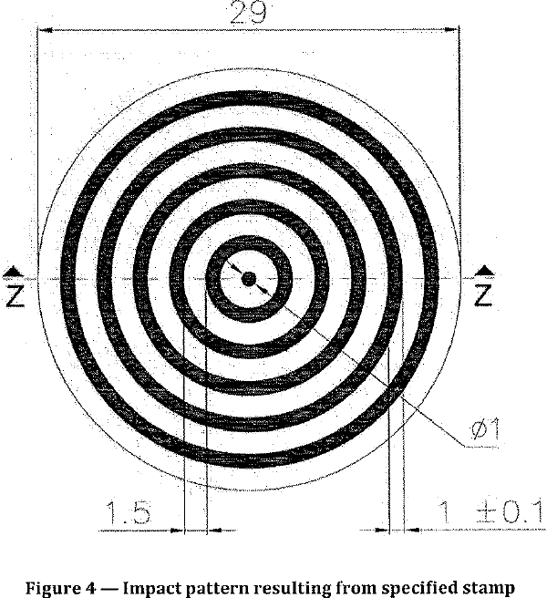 | 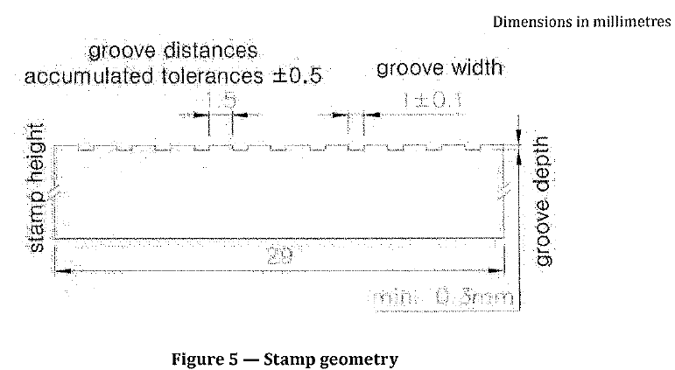
The guidance and steering system
The guidance and steering system will ensure the fulfillment of the method of testing indicated in art. 8.5 of the SM ISO/IEC 18745-1:2018 (ISO/IEC 18745-1:2018) standard, including providing the positioning of the passport/travel document in relation to the stamp as shown in Figure 6 of art. 8.5 of the SM ISO/IEC 18745-1:2018 (ISO/IEC 18745-1:2018) standard, it will ensure that the stamp with mass M is dropped from a height H in each of the locations shown in Figure 6, so that the product P = H*M has the value of 0.02 kgm, it will ensure the movement from the first to the last location progressing from left to right and from top to bottom, it will keep the surface of the stamp parallel to the surface of the passport/ travel document at the point of impact.
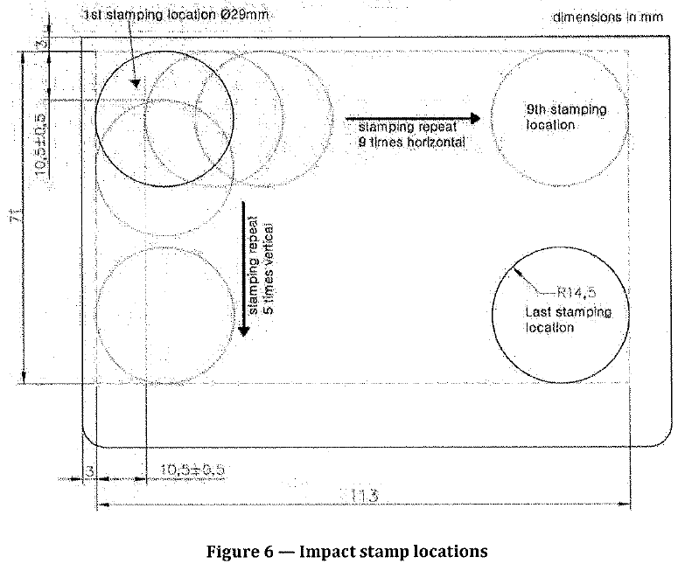
Solid surface
The solid surface must be flat, ensure the safekeeping of the passport/travel document for the entire test period, and must be made of rigid material that will not undergo changes due to the impact of the stamp with the document throughout the operating period of the equipment.
Warranty period of the Goods: minimum 12 months from the date of signing the Act of delivery-receipt of the Goods. During the warranty period, the Supplier will ensure the proper functioning of the Goods by removing any malfunctions or non-conforming operations within 15 working days from the moment of the request.
The equipment must be accompanied by:
- User manual;
- Technical description or other document that certifies the compliance of the equipment with the requirements of the method of testing from art.8.5 of SM ISO/IEC 18745-1: 2018 (ISO/IEC 18745-1:2018) standard, including specifying the concrete dimensions of the seal, the groove profile, the durability of the material, the mass M(kg) of the stamp and the nominal height H(m) and other important aspects related to the operation of the equipment.
Lot no. 2
Equipment for carrying out tests according to art. 8.11 (art. 10.15) "Abrasion stress method"
from the standard SM ISO/IEC 18745-1:2018 (ISO/IEC 18745-1:2018)
The equipment must be capable of creating mechanical abrasions on the data page of the passport/travel document. The equipment must meet the requirements set out in art. 8.11 of the SM ISO/IEC 18745-1: 2018 (ISO/IEC 18745-1:2018) standard, including containing a test load for creating the abrasion, guidance and steering system to ensure compliance with a test method established in art. 8.11 of the SM ISO/IEC 18745-1:2018 (ISO/IEC 18745-1:2018) standard, a flat, solid surface for holding the passport/travel document, other parts.
The test load
The test load must have a diameter of D=15mm, on which the front page material can be attached as an abrasive element; the abrasive material must be able to be attached to the test load without protruding beyond the edge of the passport. The design of the test load must ensure, if necessary, the possibility of changing the abrasive material.
The guidance and steering system
The guidance and steering system will ensure the fulfillment of the test method indicated in art. 8.11 of the SM ISO/IEC 18745-1:2018 (ISO/IEC 18745-1:2018) standard, including the application during testing on the surface tested by the pressure test load L = 14 000 (± 5 %) N/m²; moving the test load at a speed V=2.5-7.5 cm/s so that the abrasion axis is parallel to the MRZ of the data sheet in accordance with Figure 15 of art. 8.11 of the standard SM ISO /IEC 18745-1: 2018 (ISO/IEC 18745-1:2018). The amplitude of the test load movement related to the horizontal axis, as shown in Figure 15 (between the two rows of the MRZ), shall be at least 20 mm. The test equipment may move/rotate the test load between cycles during the test.
The steering system must ensure testing with the creation of mechanical abrasion on the entire data page, including the MRZ area and other visual control areas (photo of the holder, personalization data, pre-printed elements, etc.).
The steering system must ensure the performance of at least 500 abrasion cycles. The test cycle shall be proportional to the set speed (V = between 2,5 cm/s and 7,5 cm/s).
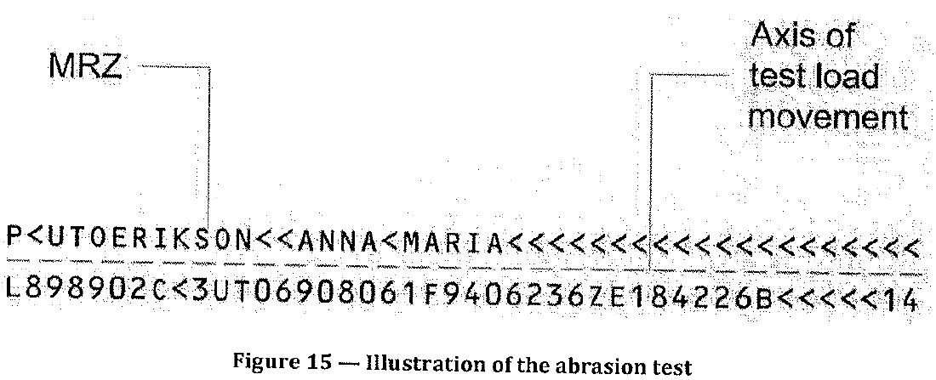
Solid surface
The solid surface must be flat, ensure the safe keeping of the passport/travel document during the entire period of the test, and must be made of a rigid material that will not undergo changes due to the creation of mechanical abrasions by the load test on the document throughout the operating period of the equipment.
Warranty period of the Goods: minimum 12 months from the date of signing the Act of delivery-receipt of the Goods. During the warranty period, the Supplier will ensure the proper functioning of the Goods by removing any malfunctions or non-conforming operations within 15 working days from the moment of the request.
The equipment must be accompanied by:
- User manual;
- The technical description or other document, which certifies the compliance of the equipment with the requirements of the test method from art. 8.11 of SM ISO/IEC 18745-1: 2018 (ISO/IEC 18745-1:2018) standard, including specifying the diameter of the test load, the pressure formed by the test load, the speed of movement of the test load relative to the document, the amplitude of the movement of the test load, the number of abrasion cycles (indicated above) and other important aspects related to the operation of the equipment.

