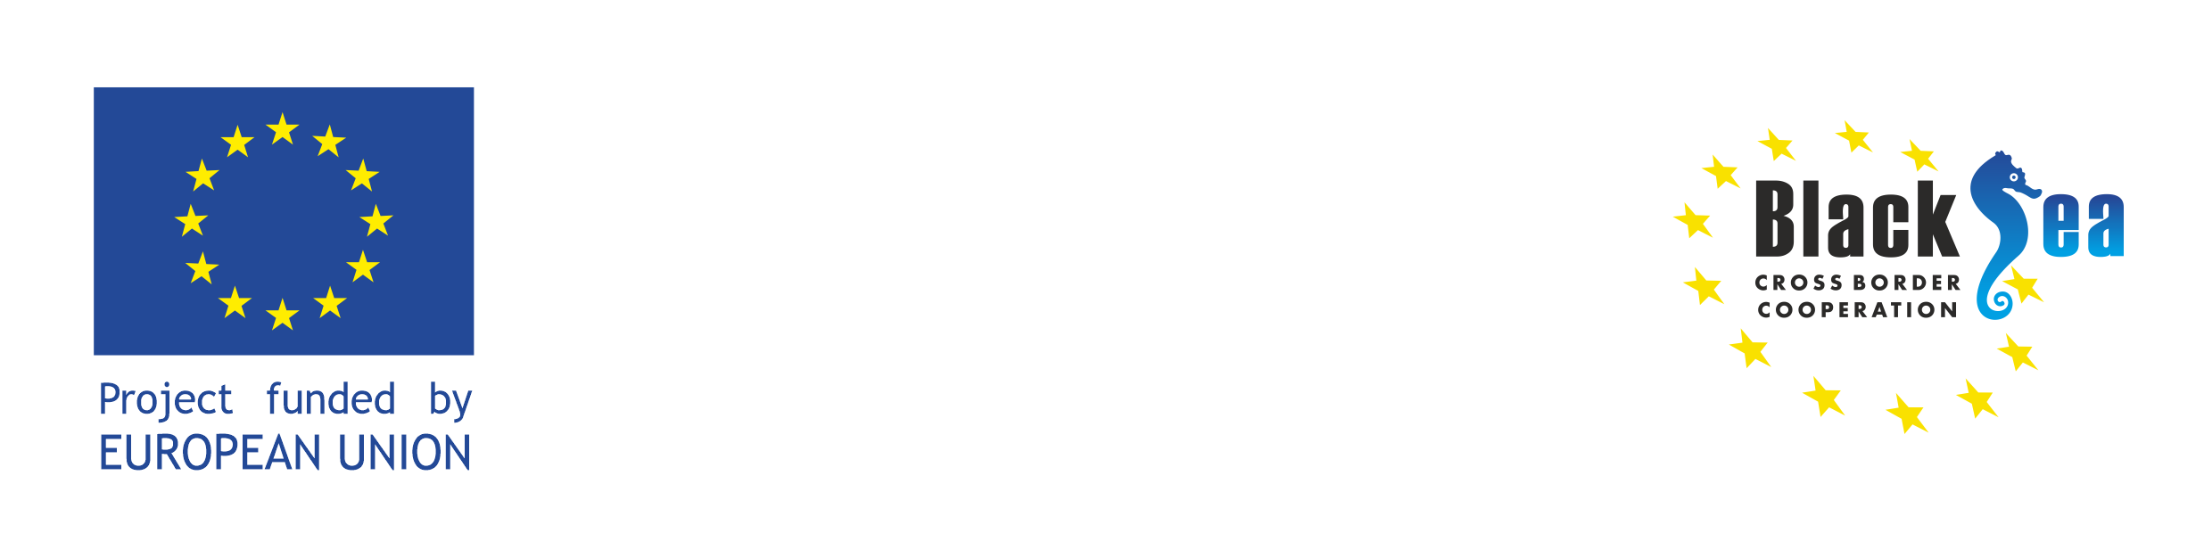
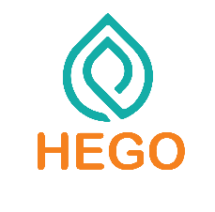

Herbs for Growth
HEGO PROJECT

Business Forum in Moldova (A.T3.4)
November 18, 2022
Moldexpo
Strada Ghioceilor 1, Chișinău 2008

This Business Forum is carried out in the framework of the EU BSB funded HEGO Project.
Organization for Entrepreneurship Development (ODA) has been entrusted to undertake the implementation of the HEGO project in Moldova. The purpose of the meeting is to inform the project's key stakeholders about the goals, upcoming steps, and expected outputs of the project. The workshop will also host a stakeholder discussion which will give an opportunity to identify the existing issues in the herb sector. The event will take place in a hybrid format.
Zoom link for joining: will be added

The event will be conducted in Romanian.
English simultaneous interpretation will be provided.



AGENDA

10:00 – 10:30 | Registration of the participants
10:30 – 10:45 | Opening remarks  Rodica Crudu  HEGO Project Coordinator ODA
10:45 – 11:00 | Presentation of the HEGO – Herbs for growth project  Olga Moraru  HEGO Project Specialist ODA
11:00 – 12:00 | Herbs cultivation industry in Moldova. Challenges and opportunities  Representative of Moldovan Association of Aromatic and Medicinal Plant Producers “Aromeda” [tbc]
12:00 – 12:40 | Presentation of the Moldova Lavender Association  Alexandru Bădărău [tbc]  President of the Association
12:40 – 13:10 | Presentation of the operational plan for the creation and operation of the Herb Cluster within HEGO project  Natalia Calenic [tbc]  Vice President Moldova Chamber of Commerce and Industry
13:10 – 14:00 | Coffee bfreak
14:00 – 16:00 | Visiting the SMEs Expo and meetings with Project participants.

