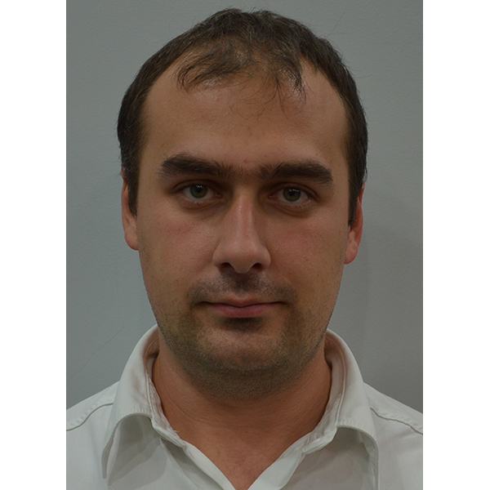
ŞERVAN ADRIAN
29/1 Livadarilor street Mobile: +373 (0) 79 99 00 66 Codru, Chisinau, Republic of Moldova
Date of birth: 07.11.1981 E-mail: adrian.servan7@gmail.com
Marital status: married

- Adaptable, enthusiastic and innovative.
- A good sense of humor and tolerant.
- Ability and genuine interest in learning new skills.
- Ability in promoting and implementing organization’s policies.
- Organized and logical thinker, able to work unsupervised.

Education:
1998 - 2003  1994 - 1998 |  | Licensed in Law  State University of Republic of Moldova  Specialty: Public Law  National Middle School № 62, Kishinev
Out-of-University Education:
April 2001  November-December 1999  July 2000  September 2000  September 2000  September 1997 - May 1999  September 2002 - June 2003 |  | Training at IATP Internet Access Training Program.  Graduated courses:  HTML and JavaScript  Internet and E-mail  Web Pages Design  Photoshop  FTP  International Language School "Linguata"  Graduated A, B, C levels for adults.  Special Progress: the 3rd place at Republic interschool Olympiad  Programming in "PROLOG"  University of Applied Sciences of Moldova
Work Experience:
August 2017 - present | Moldovan Association of ICT Companies
 | Legal Consultant
01.07.2014 – August 2017 | „Rusagro-Prim” SRL
 | Head of Legal Department
01.01.2014 – 24.06.2014 | Foreign Capital Company „Suvorov-Vin” Ltd  (including „Kazayak-Vin” SA)
 | Head of Legal Department
09.08.2007 - 17.04.2014 | Foreign Capital Company „Cviza-M” Ltd
 | Director
07.07.2007 – 31.12.2013 | Foreign Capital Company „Vistarcom” Ltd  (Green Hills Market)
Head of Legal Department

Main responsibilities:
- Representing interests in courts;
- Representing interests at all public bodies: Police, General Prosecution, Fiscal Inspectorate, Consumer Rights Agency, Veterinary Agency, Public Health Center, Territorial Cadastral Office, Licensing Chamber, Chamber of State Registration, Commerce Department, local public bodies and other control bodies;
- Working with notaries, experts, inspectors;
- Obtaining all the authorizations, like: operational, sanitary, veterinary, licenses, their extension, etc.;
- Drawing up contracts, including in English, legal documents, letters, answers to summons, etc.;
- Legal Consultation (recommendations, solutions).
12.06.2006 – 06.07.2007 | Foreign Capital Company „Green Hills Market” Ltd  (Green Hills Market)
 | Head of Legal Department
14.02.2007 – 06.08.2007 | Mixed Company „Megaparc” Ltd
 | Director
01.10.2003 – 12.06.2006 | Representation of Swiss Stock Company  „Green Hills Invest Holding” in Republic of Moldova
 | Lawyer
09.1999 – 02.2000 | Independent Journalism Center
Assistant (Volunteer)

Main responsibilities:
- Giving oral and written legal advices to the media representatives;
- Translating the draft laws in Romanian / English / Russian;
- Creating and managing the legal database in the media field.
11.2001 | Publishing the article:  "The evolution of the institution of peaceful reglementation of international disputes" in The National Law Journal № 8

Personal Skills:
Language Skills:  Driving License Holder since 07.11.2002  Computer knowledge: | Romanian – Native  Russian - Advanced  English - Good  Spanish, Italian - Beginner  Categories: “A”, ”B”, ”C”, ”D”, ”E”  Advanced user.  Practical knowledge of all necessary programs for fulfilling duties as a lawyer.

