
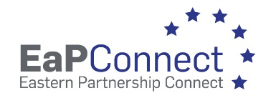

Chisinau, Moldova | December 12, 2023

Reference No: MD-23-01 – eduroam Wireless Infrastructure Extension (repeated)

Invitation to participate in procurement procedures

The Research and Educational Networking Association of Moldova RENAM (State identification number 1012620003140) intends to purchase the goods in scope of the European Union EaPConnect2 project (Grant Contract – External Actions of the European Union ENI/2019/407-452).

Specification of goods and delivery conditions are presented in Specification Form. The goods are VAT exempt.
Potential supplier should provide the following documents:
- Digitally signed proforma invoice in Euro;
- Digitally signed filled Specification Form;
- Digitally signed evidence of experience of delivery similar products on local market for at least 2 years (e.g. copy of contact or copy of act of delivery, etc.);

The proposal should be submitted via national tendering platform (MTender) – achizitii.md.

Evaluation criteria: in case all requirements concerning specification of goods and delivery conditions are met by the potential suppliers the bid will be awarded according to the best price.

We invite You to participate in the procurement procedures and submit a procurement offer not later than 14:00 at local time of December 26, 2023.

Annexes:
- Specification Form;
- Draft Contract.

Sincerely,

Research and Educational Networking
Association of Moldova RENAM
Chairman of RENAM Administration Council
Dr. Petru Bogatencov

