Request for Quotation

FROM | NORWEGIAN REFUGEE COUNCIL
Address | Bucuresti 41
City | Chisinau
Country | Moldova
Phone # | 076030069
Email | md.procurement@nrc.no

The office of the Norwegian Refugee Council invites your company to submit a price quotation for the following items in accordance with the requirements detailed below. You may use your company format, or fill up the table below. Please read carefully the instructions below.

Request for Quotation Requirements
RFQ # : | RFQ-MOL-CO-24-022 | Currency | MDL
RFQ Issuing Date: | 09.07.2024 | Bid Validity Period (days): | (Preferably 30 days)
RFQ Closing Date: | 17.07.2024 | Required Delivery Date: | 31.07.2024
RFQ Closing Time: | 15:00 | Required Delivery Destination: | Chisinau, Bucuresti 41
Questions to the RFQ | md.procurement@nrc.no | Required Delivery Terms: | N/A

# | Description |  | Specification | Photo | Unit | Estimated Qty | Unit price, incl. Tax (MDL) | Total Price incl. Tax (MDL)
1 | Foam beater |  | plastic 30 cm | 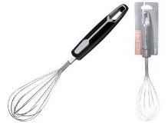 | piece | 16
2 | Pastry brush |  | silicon 20 cm |  | piece | 16
3 | Needle thermometer |  | digital needle thermometer 300" | 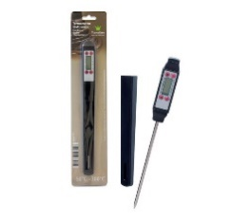 | piece | 16
4 | Muffin baking form |  | 6 places, up to 20 cm | 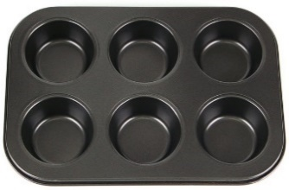 | piece | 16
5 | Baking tin 24 cm/28 cm |  | round metal shape | 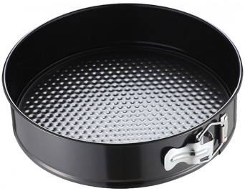 | piece | 16
6 | Rectangular baking dish |  | 24-29 cm, rectangular metal shape | 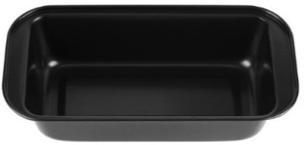 | piece | 16
7 | Silicone mat |  | 57.5 *47 cm, heat resistant | 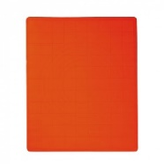 | piece | 16
8 | Graduated glass |  | 1500 ml, plastic | 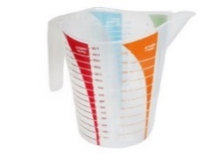 | piece | 16
9 | Kitchen scale |  | up to 5 kg, metal | 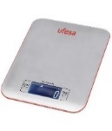 | piece | 16
10 | Cake stand |  | round plastic support | 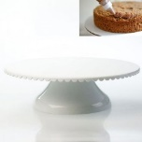 | piece | 16
11 | Pastry bag |  | 32 cm, in a set of 10 pcs | 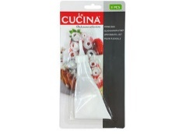 | piece | 16
12 | Spatula 22 cm |  | metal | 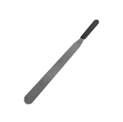 | piece | 16
13 | Angled spatula 15 cm |  | metal | 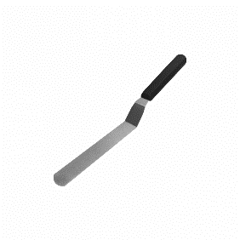 | piece | 16
14 | Flour sieve |  | round, diameter 20 cm | 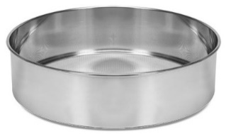 | piece | 16
15 | Mixer |  | power 350W, plastic material | 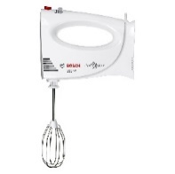 | piece | 16
16 | Savarin cake baking form |  | 22 cm, metal material | 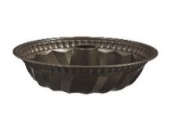 | piece | 16
17 | Baking forms |  | silicone material, in a set of 12 dishes, round shapes |  | piece | 16
18 | Mini electric oven |  | Mechanical control type  Maximum power consumed, W 2000 | 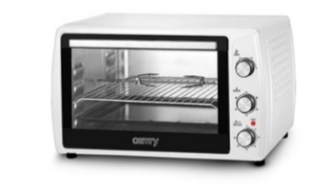 | piece | 16
19 | Dagger Knife Set |  | at least 4 piece set | 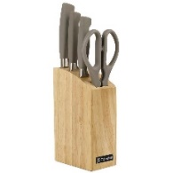 | piece | 16
20 | Chopper set |  | 3 pcs in set, material wood | 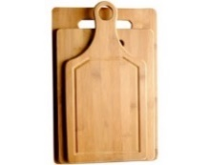 | piece | 16
21 | twisted |  | 50 cm, wooden material, with handles | 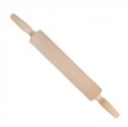 | piece | 16
22 | Silicone mat with marking 60x40 cm |  | Silicone with marking 60x40 cm | 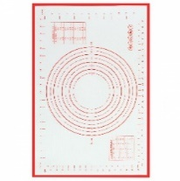 | piece | 16
23 | Silicone glove with cuff |  | 29x18 cm | 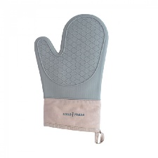 | piece | 16
24 | Axentia bowl |  | 20 cm, capacity up to 2 l | 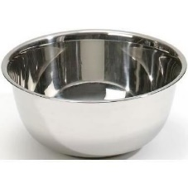 | piece | 16
25 | Dinnerware set |  | 2 saucepans, 1 saucer, 3 lids, diameter 16/18/20 cm, 1.8/2.5/3.4 l, stainless steel material | 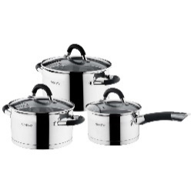 | piece | 16
26 | 5-piece kitchen utensil set |  | silicone material | 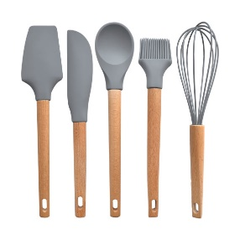 | piece | 16
27 | Citrus Juicer |  | plastic | 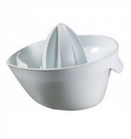 | piece | 16
28 | Silicone container with brush |  | silicon 20 cm | 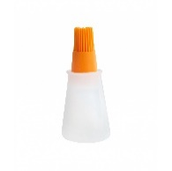 | piece | 16
29 | Knife for cutting dough |  | Serrated blade | 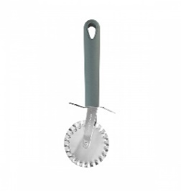 | piece | 16
30 | Dough scraper PROFESSIONAL 10x15 cm |  | 10x15 cm | 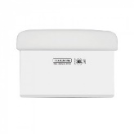 | piece | 16
31 | Food processor |  | Electric, 700W | 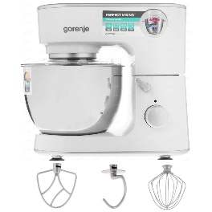 | piece | 16
32 | Set of baking forms |  | material metal, different sizes | 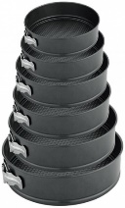 | piece | 16
37 | Delivery To Chisinau, Bucuresti 41 |  |  |  | Service | 1
 |  |  | TOTAL PRICE (including taxes and delivery)
Delivery of all items shall be made to Chisinau address mentioned in the Request for Quotation Requirements above.

All deliveries are expected door-to-door, which includes bringing items to the exact floor or level, as instructed by NRC staff during delivery.

Delivery Lead Time (in days, from receipt of NRC Purchase Order)-Chisinau
Bid Validity Period (in days from receipt of NRC Purchase Order):
Defects liability and warranty period for electric items:
Country of origin of the goods

Payment Terms: ___________

Payment Terms means the statement by a company about when and how it should be paid for goods or services that it has supplied, NRC prefer that Payment will be made after the delivery within 30 days of receipt of goods/ services, by bank transfer. If not, would you please provide us with your payment terms above.

Name

Position

Date Signature

Stamp

We, understand that activities and materials used under this project are subject to EU sanctions and that compliance with EU sanctions is mandatory. We undertake that through the implementation of activities under this contract, we will not engage in transactions with, or provide resources or support to, any individual or entity that is subject to sanctions administered by the European Union, the United Nations, or the United States. We further undertake to remain compliant with all origin of goods requirements and prohibitions stipulated under EU sanctions including, but limited to, Council Regulation (EU) No 692/2014 and Council Regulation (EU) 2022/263.

RFQ Terms & Conditions
Manner of Submission:
- By hand in a sealed envelope to NRC office located Address: Chisinau, Bucuresti 41
OR
- By email to the dedicated and secured email address: md.tenders@nrc.no (offers received on other email addresses will not be considered)
- Before the Closing date & Time mentioned above. Companies who do not submit their quotation by this deadline will not be considered

Valid offer should include the following documents:
- Filled & Signed RFQ
OR
- Detailed Bidder’s offer, preferably with the photos of the proposed items
- Annex 1: Ethical Standard Declaration (Signed)
- Copy of the Company's Extras

Requirements:
- All Bids must include all customs and taxes payable in the country of delivery unless the RFQ specifically requests differently
- Bids must be submitted in the currency indicated in the RFQ. Bids in other currency might not be accepted
- Bids must be valid for the validity period indicated in the RFQ. Bids not meeting this validity period might be disqualified
- All enquires and questions should be addressed to the email given in the RFQ details section. All questions and answers will be shared with all invited suppliers.
- NRC reserves the right to accept or reject the whole or part of your quotation based on the information provided. Incomplete quotations which do not comply with our conditions will not be considered.

Assessment Criteria:
- All bids received and accepted will be evaluated based on the following:
- Step 1: Administrative compliance check: Each bid will be checked to ensure compliance with all the RFQ requirements – PASS / FAIL
- Step 2: Technical Evaluation: All bids will be evaluated to be compliant with above specifications for each offer item – PASS / FAIL
- Step 3: Financial Evaluation: Price comparison will be based on the total least financial offer of the matching specifications.

NRC is obliged to ensure that its procurement decisions are clearly justified and documented and keeping within the Donors mandatory principles. In that regard, full and on-the-spot access must be granted to representatives of NRC, the Donor or any organisation or person mandated by it, to premises belonging to NRC or its contractors. The right to access shall include all documents and information necessary to assess or audit the implementation of the contract.  NRC also expects suppliers who process personal data to comply with the General Data Protection Regulation (EU GDPR) and any relevant national legislation. Suppliers processing personal data on an NRC contract will be required to sign a data processing / sharing agreement as part of the contract. Refusal to sign such an agreement constitutes refusal of the contract terms and forfeiture of the contract on the part of the supplier.  If the activities of the contract take place in areas with Explosive Hazards, NRC accepts no liability for injury and/or death to contractor’s staff or damage to contractor’s property. | Anti-money laundering, anti-bribery, anti-corruption and anti-terrorism legislation and donor regulations require NRC to screen contractors against various international lists to ensure due diligence. Submission of the quotation constitutes acceptance of these screening practices.  NRC aims to purchase products and services with minimum environmental impact. Environmental considerations form part of the NRC selection criteria, and NRC reserves the right to reject quotations provided by suppliers not meeting these standards.  All suppliers doing business with NRC should maintain high standards on ethical and environmental issues, respect and apply basic human and social rights, ensure non-exploitation of child labour, and give fair working conditions to their staff. Suppliers will be required to sign and submit an Ethical Standards Declaration, together with their bid.  NRC reserves the right to reject quotations provided by suppliers not meeting these standards.

Signature & Stamp

Please complete, sign and stamp the below table:

Bidder’s general business details

- General information
Company name:
Address:
Company Registration No:
Contact person:
Contact Telephone No:
Email/Fax:
Bank Name:
Bank Address / Branch:
IBAN:
Tax Number:
Date:
Stamp:

- Owners/Managers
Please fill in the below table with the full names and the year of birth of the company’s owner(s) and manager(s)*:

Full name | Date of birth

