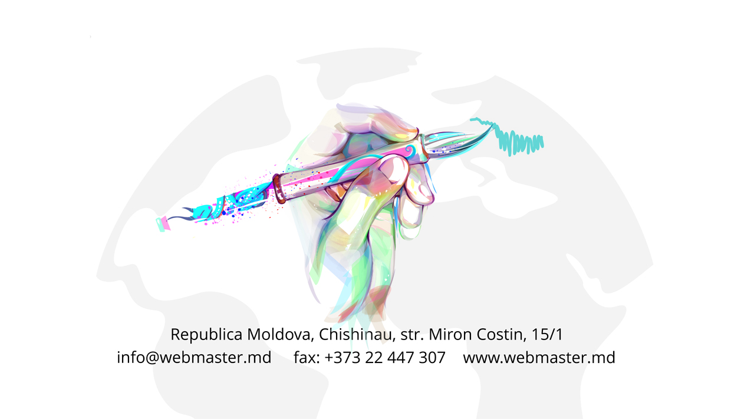
01.07.2021

Oferta comercială
pentru servicii de dezvoltare și mentenanța softului ”Registrul electronic de evidență al pacienților COVID-19”

Cuprins
Datele Companiei 3
Certificatul de inregestrare 4
Extras din registrul de Stat 5
Licența 6
Specialiști ce vor fi implicate in proiect 7
Exemple de Software dezvoltate de compania 22
Scrisori de recomandare 30
Ofertă de preț 38

Datele Companiei

Informatii Generale
Compania | „BRV ISTCOM” SRL
Data fundatiei | 22/07/2008
Marca Comerciala | Studio Webmaster
Directorul Companiei
Nume, prenume | Barcov Vadim
Forma de proprietate | Privata
Sediul | MD – 2068, RM, str. Miron Costin 15/1, of. 3
Tel. | 022 89 98 01 / 022 89 98 02 / 022 89 98 03
Mob. | +373 60 10 6666
Tel./fax | 022 44 73 07
Site | www.webmaster.md
E-mail | manager@webmaster.md
Rechizitele Companiei
Cod Fiscal | 1008600036970
Cod TVA | 0607818
IBAN MDL | MD41CM000225104980141054
Cod Bancar | CMTBMD2X498
Banca | BC “Comertbank” SA fil. 1

Numele, prenumele persoanei autorizate: |  | ______Barcov Vadim____
 | Data: | _____01/07/2021_______
 |  | 
 | Semnătura: | __________________________
 | L.Ș. | __________________________

Certificatul de inregestrare
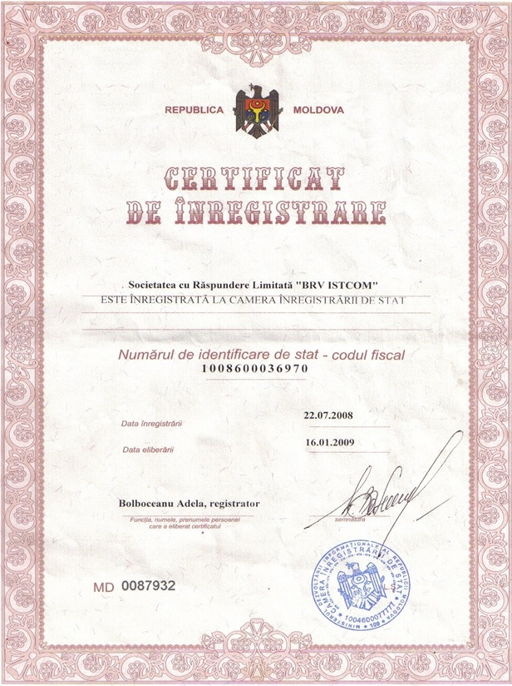

Extras din registrul de Stat
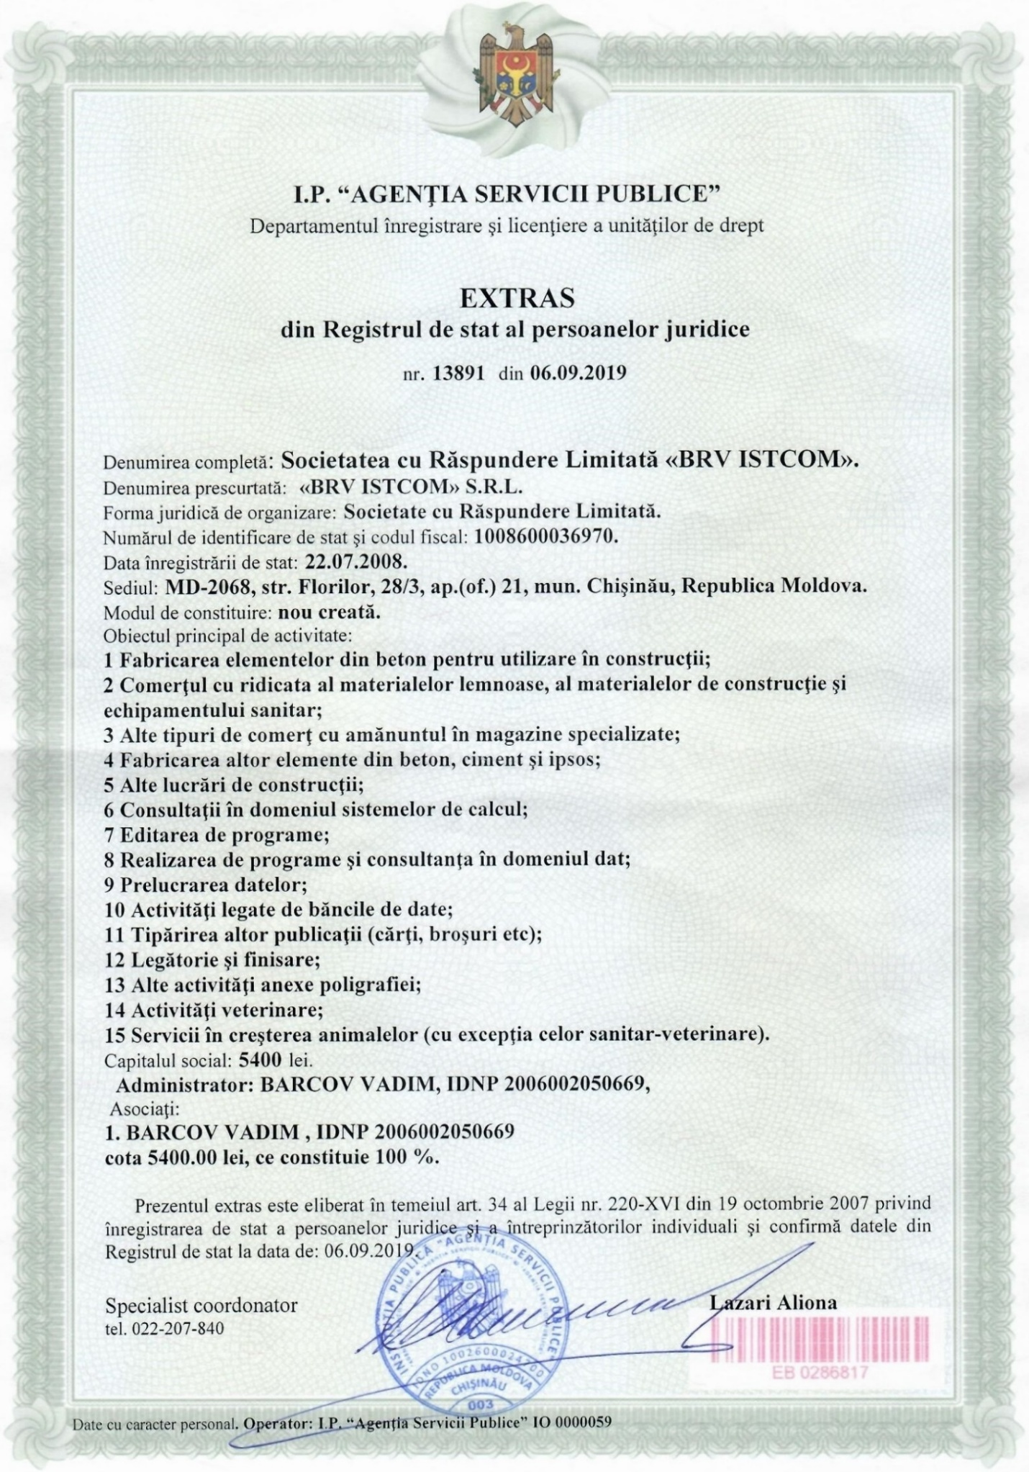

Licența
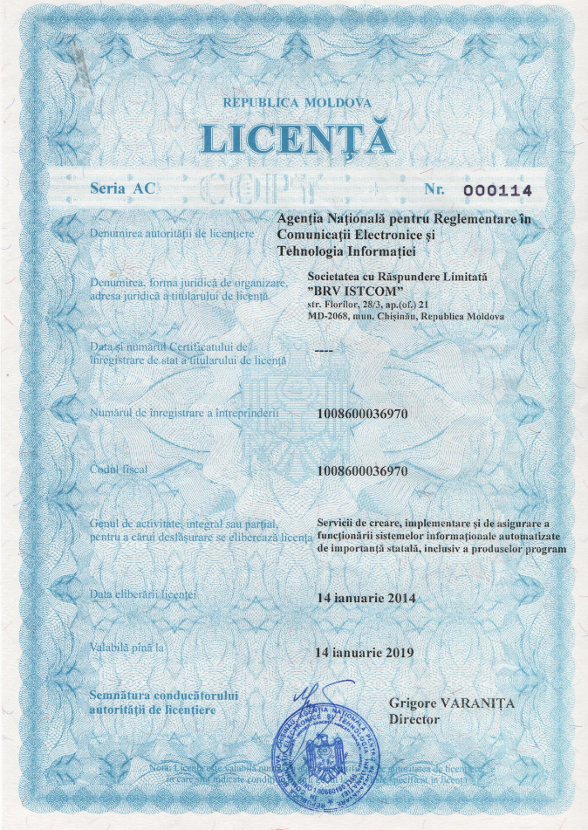

Specialiști ce vor fi implicate in proiect
PERSONAL INFORMATION
 | Capanji Igor
 | manager@webmaster.md
 | Date of birth 07/08/1993
 | Sex Male | Nationality Moldovan
 | Work experience 8 Years
EDUCATION AND TRAINING
09.04-28.05 | Training ”Profession director”  SBC Bussines Center
02.21  04.2019 | Training “ Effective sales technique”  SBC Bussines Center  Training “Internet - Marketing: The main types and features of promotion of sites”
02.21  04.2019 | “Benefits of Internet Marketing”
02.21  04.2019 | “The main types of Internet Marketing”
02.21  04.2019 | “Disadvantages Internet Marketing”
03-04.2018 | Sales & Marketing Forum
03-04.2018 | “Improving the efficiency of the company's services”
03-04.2018 | “Business and social networks
04.2018  2015-2017 | Training
04.2018  2015-2017 | “Work with objections”  Cycle 2  In the Field of: Journalism  Speciality: Journalism and Communication Sciences  Specialization: Journalist  Moldavian State University (USM)
2012 – 2015 | Cycle 1  In the Field of: Hystory  Speciality: Hystory and philosophy  Specialization: Worldwide History  Moldavian State University (USM)
PERSONAL SKILLS
Mother tongue(s) | Russian
Other language(s) | Understanding |  | Speaking |  | Writing
Other language(s) | Listening | Reading | Spoken interaction | Spoken production
Russian | C1 | C1 | C1 | C1 | C1
Romanian | C1 | C1 | C1 | C1 | C1
English | C1 | C1 | B1 | B1 | B1
Levels: A1/2: Basic user - B1/2: Independent user - C1/2 Proficient user
Common European Framework of Reference for Languages
Communication / managerial skills | Good communication skills gained through my experience as sales manager;  Leadership (currently responsible for a team of 6 peoples);  Good organizational skills;  Excellent work in a team;  Ability to Use "Positive Language";  The ability to plan and predict;  Customer service orientation;  Ability to work on your own initiative;  Attention to detail;  Flexibility and adaptability to changing workloads;  Problem-solving skills and project management ability;  The ability to find a way out of difficult situations;  Ability to work quickly and qualitatively, as well as fast switching between tasks.
Computer skills | Professional knowledge of Microsoft™ tools (Word™, Excel™, Power Point™);  Good command of graphic design applications (Adobe Photo Shop™).
Other skills | Leadership; Focus on results; Commitment; Independence; Tact; Stress Resistance; Responsible; Perseverance.
WORK EXPERIENCE
From 12.2017 | Employer: “BRVISTCOM” Ltd , trade mark “Webmaster Studio”  Business or sector: IT  “Studio Webmaster”, development of the sites and their promotion, as well as development of software, databases and business systems that enable streamlined business process.  Position(s) held: Sales Manager (Team Leader)  Activities performed:  - Maintaining and increasing sales of company services;  - Reaching the targets and goals set for area;  - Establishing, maintaining and expanding customer base;  - Servicing the needs of your existing customers;  - Increasing business opportunities through various routes to market;  - Setting sales targets for individual reps and team as a whole;  - Training sales staff;  - Allocating areas to sales representatives;  - Developing sales strategies and setting targets;  - Monitoring team performance and motivating them to reach targets;  - Compiling and analysing sales figures;  - Collecting customer feedback and market research;  - Manage the sales administration function, operational performance reporting, streamlining processes and systems wherever possible, and advising senior management on maximising business relationships and creating an environment where customer service can flourish;  - Keeping up to date with products and competitors.
05.2016 | Employer: Freelance  Business or sector: Journalism  Position(s) held: Journalism and communication  Activities performed:  - Search for information  - Communication with people;  - Writing and editing articles;

03.2013 | Employer: NGO “Ukrainian youth in Moldova”  Business or sector: Public Institutions  Position(s) held: Traineeship  - Activities performed: Dealing with telephone and email enquiries;  - Scheduling and attending meetings, creating agendas and taking minutes;  - Answering telephone calls;  - Managing databases;  - Handling correspondence;  - Implementing new procedures and administrative systems;  - Liaising with relevant organisations;  - Coordinating mail-shots and similar publicity tasks

PERSONAL INFORMATION
Iakovleva Marina
designer@webmaster.md
Date of birth 27/05/1985
Sex Female | Nationality Russian
Work experience 11 Years

EDUCATION AND TRAINING

12.2015 | Training “Friendly Web-Design for Frontend ”
12.2015 | “The main criteria for Web design”
12.2015 | “Uses graphics fonts in modern design”
12.2015 | “Design "at the front" ("tentative design")”
12.2015 | “Adaptive Design”
04.2015 | Training “Internet - Marketing: The main types and features of promotion of sites”
04.2015 | “Benefits of Internet Marketing”
04.2015 | “The main types of Internet Marketing”
04.2015 | “Disadvantages Internet Marketing”
04.2014 | Training
04.2014 | “Customer Service”
09.2012 | Training
09.2012 | Certificate of Excellence in Adobe Photoshop CS5
09.2012 | Computer Educational Center “SPECIALIST” at the Bauman Institute
07.2010 | Training
07.2010 | Certificate of Excellence in Corel Draw
07.2010 | Computer Educational Center “SPECIALIST” at the Bauman Institute
07.2009 | Training
07.2009 | Certificate of Excellence in Adobe Photoshop CS3
07.2009 | Computer Educational Center “SPECIALIST” at the Bauman Institute
2004 – 2008 | Cycle 1
2004 – 2008 | In the Field of: “Classic and Modern Languages”
2004 – 2008 | Speciality: “Modern Foreign Languages”
2004 – 2008 | Specialization: “Modern languages”
2004 – 2008 | The Institute of International Relations of Moldova (IRIM)

PERSONAL SKILLS

Mother tongue(s) | Russian
Other language(s) | UNDERSTANDING |  | SPEAKING |  | WRITING
Other language(s) | Listening | Reading | Spoken interaction | Spoken production
Russian | C1 | C1 | C1 | C1 | C1
Romanian | A2 | A2 | A2 | A2 | A2
English | C1 | C1 | C1 | C1 | C1
Spanish | B2 | B2 | B2 | B2 | B2
Deutsch | C1 | C1 | C1 | C1 | C1
Levels: A1/2: Basic user - B1/2: Independent user - C1/2 Proficient user
Common European Framework of Reference for Languages

Other skills | Leadership; Critical Thinking; Creativity; Focus on results; Commitment; Independence; Tact; Stress Resistance; Responsible; Perseverance.

WORK EXPERIENCE

From 12.2010 | Employer: “BRVISTCOM” Ltd , trade mark “Webmaster Studio”  Business or sector: IT  “Studio Webmaster”, development of the sites and their promotion, as well as development of software, databases and business systems that enable streamlined business process.  Position(s) held: Head Web Designer (Team Leader)  Activities performed:
From 12.2010 | - Meeting with clients to discuss requirements and/or project progress;  - Drawing up detailed website specifications;  - Designing page layouts including text size and colours;  - Developing of company style (logotype, business card, etc);  - Developing of flash animation and banners;
From 12.2010 | - Designing graphics, animations and manipulating digital photographs;  - Presenting initial design ideas to clients;
From 12.2010 | - Designing the website's visual imagery and ensuring it's in line with company branding policy or the requirements of the client;
From 12.2010 | - Proofreading content and making changes where necessary;  - Editing content, debugging code and re-designing web pages;  - Working with other web specialists including web developers and graphic designers;  - Post-sales technical support;  - Training of subordinates;  - Researching current design trends.
10.2010 - 12.2010 | Employer: “Casa Audio”  Business or sector: Services - The advertisement on the public transport  Position(s) held: manager, designer  Activities performed:  - Deal directly with customers either by telephone, electronically or face to face;  - Issuance and acceptance of goods;  - Provide pricing and delivery information;  - Order management;  - Advertisement design;  - Dealing with telephone and email enquiries.
03.2010 - 09.2010 | Employer: “SRL Terentiev - Benefis Art  Business or sector: Services  Position(s) held: designer, manager  Activities performed:  - Clients search;  - Order management;  - Making photos of ballet costumes;  - Photo finishing in adobe Adobe Photoshop;  - Web-site administration.
10.2007 - 12.2009 | Employer: Nais – Max Studio  Business or sector: Services  Position(s) held: Wed Designer  Activities performed:  - Teaching in Adobe Photoshop, Corel Draw, Adobe Flash;  - Web-site administration;  - Advertisement design.

Technical / Computer skills | Creative thinking;  Rapid creation of new ideas;  Creativity and Originality in Graphic and Design;  Experience in design of GUI software;  Good knowledge UI design;  Experience of Creating design;  The ability to express the scope of the specific customer's company in the design;  The high degree of responsibility;  Professional knowledge of Microsoft™ tools (Word™, Excel™, Power Point™);  Professional knowledge graphic design applications: Adobe Illustrator™, Adobe PhotoShop™, Adobe Photoshop Lightroom™, Corel Draw™;  Good architecture design and scalability problem solving.

PERSONAL INFORMATION
Simion Cushnir
Cusnir.simion@webmaster.md
Date of birth 12/06/1984
Sex Male | Nationality Moldovan
Work experience 10 Years

EDUCATION AND TRAINING

08.2013 | Training center “Vanar”
08.2013 | Web developopment, C++ programming, configuration and maintenance of servers
2014 - 2015 | Cycle 2  Master degree  Speciality: Cybernetics and Informatics  Specialization: Information Management  The Academy of Economic Studies of Moldova (ASEM)
2006 – 2009 | Cycle 1  Licentiate in Engineering  In the Field of: Informatics  Speciality: Mechanical Engineering  Specialization: Engineering  The State Agrarian University of Moldova

PERSONAL SKILLS

Mother tongue(s) | Russian
Other language(s) | UNDERSTANDING |  | SPEAKING |  | WRITING
Other language(s) | Listening | Reading | Spoken interaction | Spoken production
Russian | C1 | C1 | C1 | C1 | C1
Romanian | B1 | B1 | B1 | B1 | B1
English | А1 | А1 | А1 | А1 | А1
Deutsch | B1 | B1 | B1 | B1 | B1
Levels: A1/2: Basic user - B1/2: Independent user - C1/2 Proficient user
Common European Framework of Reference for Languages

Communication / managerial skills | Good communication skills gained through my experience as sales manager;  Leadership (currently responsible for a team of 10 peoples);  Flexibility and adaptability to changing workloads;  Problem-solving skills and project management ability;  The ability to find a way out of difficult situations;  Ability to work on your own initiative;  Attention to detail.

Elaborated projects | Total amount of elaborated web-sites – 260  Total amount of elaborated software – 80

Computer skills | Professional knowledge of Microsoft™ tools (Word™, Excel™);  Good knowledge of relational databases, version control tools and of developing web services;  Professional knowledge of graphic design applications (Adobe Photoshop™, Adobe Dreamweaver™, AutoCAD™);  Programming skills: HTML, CSS, Javascript, PHP, Symfony2 Developer, C++, jQuery;  Experienced user Visual Basic;  Experienced user (Windows).

Job-related skills | Professional knowledge of applications for programming (Visual C++™, Aptana Studio™);  Knowledge of languages of programming (PHP, HTML, DHTML, XHTML, CSS, Java Script (AJAX, JsHttpRequest, DOM, jQuery) C++, C, MySQL, XML);  Experience with Apache and MySQL web servers and databases;  Familiarity with SQL/NoSQL databases and their declarative query languages;  Knowledge of object oriented PHP programming;  Experience in third-party APIs: Google, Facebook, Ebay, etc;  Experience in the development of large projects using the language of the UML diagrams;  Good architecture design and scalability problem solving.

Other skills | Organized, Punctual, Detailed And Accurate, Passionate in web technologies.

WORK EXPERIENCE

From 05.2012 | Employer: “BRVISTCOM” Ltd , trade mark “Webmaster Studio”  Business or sector: IT  “Studio Webmaster”, development of the sites and their promotion, as well as development of software, databases and business systems that enable streamlined business process.  Position(s) held: Lead Programmer  Activities performed:  - Analysis of projects in development;  - Planning and analysis;  - Architecture underlying the program under development;  - Distribution of work and tracking tasks other team members;  - Training of new or less experienced developers;  - Audit of the source code modules of other developers;  - Advising developers on technology issues, and integration issues;  - Keeping customer support;  - Execution and participate in workshops.
01.2008 – 06.2011 | Employer: LTD «Cosmo Technology»  Business or sector: Services  Position(s) held: Customer Service Manager  Activities performed:  - Identifying the needs of customers in the products;  - Order management;  - Order goods, parts, accessories;  - Receipt and processing of customer orders;  - Coordination and monitoring of the necessary accounting documents;  - Hardware installation, testing, cleaning, troubleshooting.
11.2006 – 12.2008 | Employer: Institute of Agricultural Machinery «Mecagro»  Business or sector: Educational Institution  Position(s) held: Junior Research Worker  Activities performed:  - Carrying out scientific research  - Participation in the performance of experiments  - Monitoring and measurement - experiments  - Preparation, description and formulation of conclusions of the experiment  - The study of scientific and technical information  - Making report  - Implementation of the results of research and development.

Driving licence | “A”

PERSONAL INFORMATION
Victoria Morari
info@webmaster.md
Date of birth 04/01/1990
Sex Female | Nationality Moldovan
Work experience 6 years

EDUCATION AND TRAINING

2012 | Training center “Vanar”
2012 | Web developopment, C++ programming
2008-2012 | Cycle 1  Licentiate in Mathematics and Informatics  In the Field of: Informatics  Speciality: Mathematics and Computer Science  Specialization: Mathematics and Computer Science  The Moldova State University

PERSONAL SKILLS

Mother tongue(s) | Romanian
Other language(s) | UNDERSTANDING |  | SPEAKING |  | WRITING
Other language(s) | Listening | Reading | Spoken interaction | Spoken production
Romanian | C1 | C1 | C1 | C1 | C1
Russian | B2 | B2 | B2 | B2 | B2
English | B1 | B1 | B1 | B1 | B1
Levels: A1/2: Basic user - B1/2: Independent user - C1/2 Proficient user
Common European Framework of Reference for Languages

Communication / managerial skills | Good communication skills;  Flexibility and adaptability to changing workloads;  Ability to multi task and meet deadlines;  Good time management skills;  Attention to detail;  Team spirit.

Elaborated projects | Total amount of elaborated web-sites – 105  Total amount of elaborated software – 13

Computer skills | Professional knowledge of Microsoft™ tools ( Word™, Excel™, PowerPoint™, Access™);  Professional knowledge of applications for programming Aptana Studio™;  Good knowledge of graphic design applications: Adobe Photoshop™, Adobe Dreamweaver™, Corel Photopaint™, AutoCAD™;  Experienced user (Windows).

Job-related skills | Solid knowledge of programming language PHP, C++, C, JavaScript, Objective-C SQL, CSS, HTML, ActionScript;  Good knowledge XML, DHTML, Pascal, XHTML, AJAX, JsHttpRequest, DOM, jQuery;  Experience creating email friendly HTML ;  Good knowledge of relational databases, version control tools and of developing web services;  Experience with Apache and MySQL web servers and databases;  Good knowledge secure object-oriented software packages and web sites;  General knowledge with in developing software;  Experience in third-party APIs.

Other skills | Precise, Attentive, Organized, Employing analytic methods, Feeling and inspiring friendliness;.

WORK EXPERIENCE

03.2014 | Employer: “BRVISTCOM” Ltd , trade mark “Webmaster Studio”  Business or sector: IT  “Studio Webmaster”, development of the sites and their promotion, as well as development of software, databases and business systems that enable streamlined business process.  Position(s) held: PHP Web Developer( Layout Creation)  Activities performed:  - Revealing technical problems and procedures;  - Optimizing troublesome routines or transactions;  - Resolves CMS issues; creating, troubleshooting, and debugging scripts;  - Installed customized modules and proprietary software packages;  - Extend and alter existing projects to meet business requirements.
09.2012 - 12.2013 | Employer: “ LOCOS INTERNATIONAL” Ltd  Business or sector: IT  Position(s) held: Computer Operator  Activities performed:  - Preparing daily production schedule and handles user requests;  - Monitoring computer and network systems using operating systems utilities;  - Performing daily backup of systems;  - Researches error messages;  - Implementing problem reporting and assistance on various systems for departmental users;  - Maintaining applicable records including user lists, clients.

PERSONAL INFORMATION
 |  | Dașchevici Serghei
 |  | daschevici.serghei@webmaster.md
 |  | Date of birth15/02/1995
 |  | Sex Male | Nationality Moldovan
 |  | Work experience 7 Years
EDUCATION AND TRAINING
03.21-05.21  08.2016 |  | Bussines Center “SBC”  Bussines Training ”Profession director”  Training center “Vanar”
 |  | Web developopment, C++ programming, configuration and maintenance of servers
2015 - 2020 |  | Cycle 1  Master degree  Speciality: Cybernetics and Informatics  Specialization: Information Management  The Slavic University
PERSONAL SKILLS
Mother tongue(s) |  | Russian
Other language(s) |  | UNDERSTANDING |  | SPEAKING |  | WRITING
 |  | Listening | Reading | Spoken interaction | Spoken production
Russian |  | C1 | C1 | C1 | C1 | C1
Romanian |  | C1 | C1 | C1 | C1 | C1
English |  | А1 | А1 | А1 | А1 | А1
Levels: A1/2: Basic user - B1/2: Independent user - C1/2 Proficient user
Common European Framework of Reference for Languages
Communication / managerial skills |  | Good communication skills gained through my experience as sales manager;  Leadership (currently responsible for a team of 6 peoples);  Flexibility and adaptability to changing workloads;  Problem-solving skills and project management ability;  The ability to find a way out of difficult situations;  Ability to work on your own initiative;  Attention to detail.
Elaborated projects |  | Total amount of elaborated web-sites – 260  Total amount of elaborated software – 80
Computer skills |  | Professional knowledge of Microsoft™ tools (Word™, Excel™);  Good knowledge of relational databases, version control tools and of developing web services;  Professional knowledge of graphic design applications (Adobe Photoshop™, Adobe Dreamweaver™, AutoCAD™);  Programming skills: HTML, CSS, Javascript, PHP, Symfony2 Developer, C++, jQuery;  Experienced user Visual Basic;  Experienced user (Windows).
Job-related skills | Professional knowledge of applications for programming (Visual C++™, Aptana Studio™);  Knowledge of languages of programming (PHP, HTML, DHTML, XHTML, CSS, Java Script (AJAX, JsHttpRequest, DOM, jQuery) C++, C, MySQL, XML);  Experience with Apache and MySQL web servers and databases;  Familiarity with SQL/NoSQL databases and their declarative query languages;  Knowledge of object oriented PHP programming;  Experience in third-party APIs: Google, Facebook, Ebay, etc;  Experience in the development of large projects using the language of the UML diagrams;  Good architecture design and scalability problem solving.
Other skills | Organized, Punctual, Detailed And Accurate, Passionate in web technologies.
WORK EXPERIENCE
From 05.2017 |  | Employer: “BRVISTCOM” Ltd , trade mark “Webmaster Studio”  Business or sector: IT  “Studio Webmaster”, development of the sites and their promotion, as well as development of software, databases and business systems that enable streamlined business process.  Position(s) held: Lead Programmer  Activities performed:  - Analysis of projects in development;  - Planning and analysis;  - Architecture underlying the program under development;  - Distribution of work and tracking tasks other team members;  - Training of new or less experienced developers;  - Audit of the source code modules of other developers;  - Advising developers on technology issues, and integration issues;  - Keeping customer support;  - Execution and participate in workshops.
06.2014 |  | Employer: “BRVISTCOM” Ltd , trade mark “Webmaster Studio”  Business or sector: IT  “Studio Webmaster”, development of the sites and their promotion, as well as development of software, databases and business systems that enable streamlined business process.  Position(s) held: Junior Programmer  Activities performed:  - Analysis of projects in development;  - Planning and analysis;  - Advising developers on technology issues, and integration issues;  - Execution and participate in workshops.  .
PERSONAL INFORMATION
Polisciuk Andrew
andrei.webmaster@gmail.com
Date of birth 17.06.1997
Sex Male | Nationality Moldovan
Work experience 3 Years

EDUCATION AND TRAINING

05.2018 | IT integrator training center
05.2018 | Web development, C++ programming, configuration and maintenance of servers.

PERSONAL SKILLS
Mother tongue(s) | Russian
Other language(s) | UNDERSTANDING |  | SPEAKING |  | WRITING
Other language(s) | Listening | Reading | Spoken interaction | Spoken production
Russian | C1 | C1 | C1 | C1 | C1
Romanian | C1 | C1 | B1 | C1 | C1
English | B1 | B1 | B1 | B1 | B1
Levels: A1/2: Basic user - B1/2: Independent user - C1/2 Proficient user
Common European Framework of Reference for Languages

Communication / managerial skills | Problem-solving skills;  Multi-tasking;  Ability to pay attention to details.

Computer skills | Professional knowledge of Microsoft™ tools (Word™, Excel™);  Pretty good knowledge of relational databases, version control tools and of developing web services;  Professional knowledge of graphic design applications (Adobe Photoshop™, Adobe Dreamweaver™, AutoCAD™);  Programming skills: HTML, CSS, Javascript, PHP, Symfony2 Developer, C++, jQuery, C#.  Experienced user (Windows).

Job-related skills | Knowledge of languages of programming (PHP, HTML, DHTML, XHTML, CSS, Java Script (AJAX, JsHttpRequest, DOM, jQuery) C++, C, MySQL, XML);  Familiarity with SQL/NoSQL databases and their declarative query languages;  Familiarity with Python programming language.  Knowledge of object oriented PHP programming;

Other skills | Negotiation and persuasion, Confidence, Perseverance and Motivation.

WORK EXPERIENCE
From 02.2019 | Employer: “BRVISTCOM” Ltd , trade mark “Webmaster Studio”  Business or sector: IT  “Studio Webmaster”, development of the sites and their promotion, as well as development of software, databases and business systems that enable streamlined business process.  Position(s) held: Developer  Activities performed:  - Optimizing troublesome routines and transactions;  - Analysis of the users’s needs;  - Writing codes;  - Creating, testing and developing software;  - Audit of the source code modules;  - Analysis of technology issues, and integration issues;  - Extend and alter existing projects to meet business requirements;  - Collaboration with other computer specialists.
From 09.2018 | Employer: “Unifan” Ltd  Business or sector: Study  Position(s) held: Developer  Activities performed:  - Websites development;  - Support of the web-sites;  - Content managing;  - 1C managing.

Exemple de Software dezvoltate de compania

Solutie CRM Student Travel
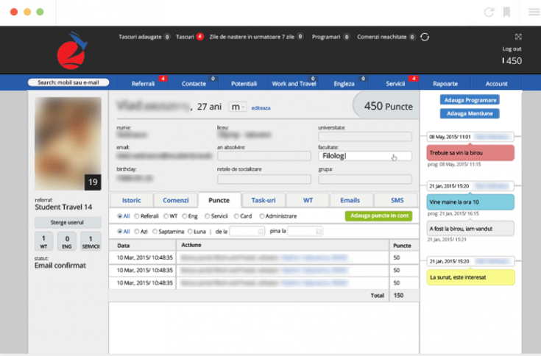
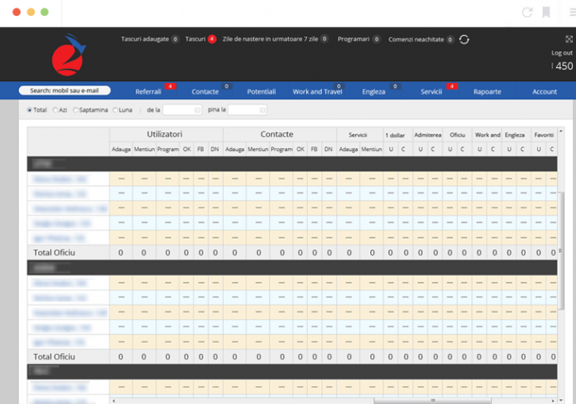
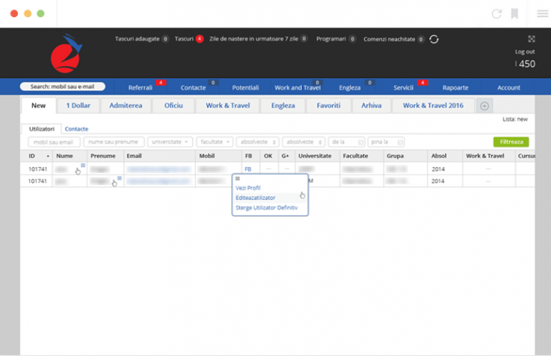

Sistemul ERP
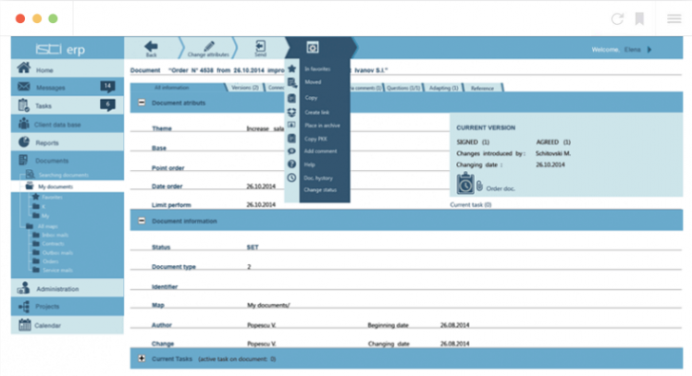
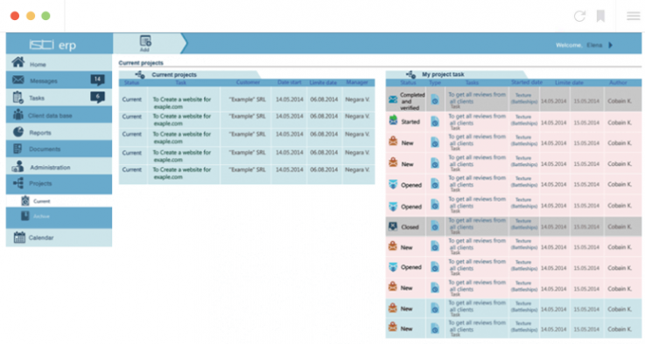
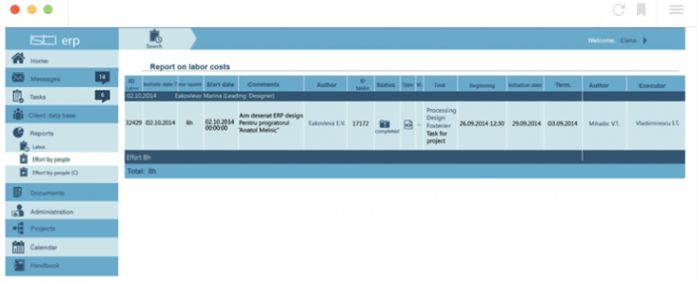

Sistemul CRM
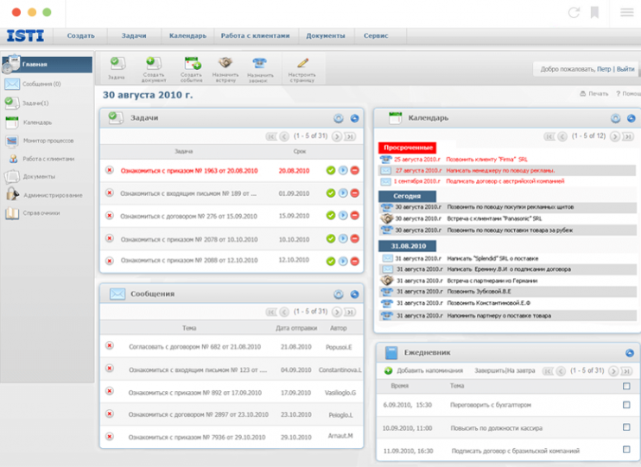
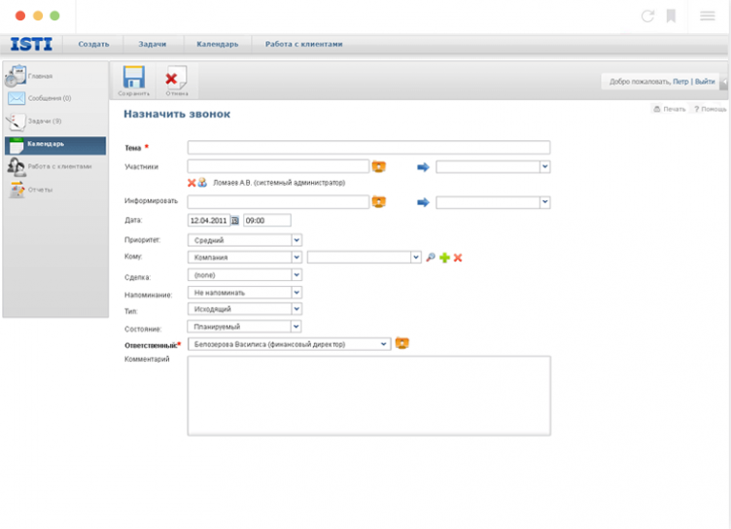
Calculator Leasing on-line
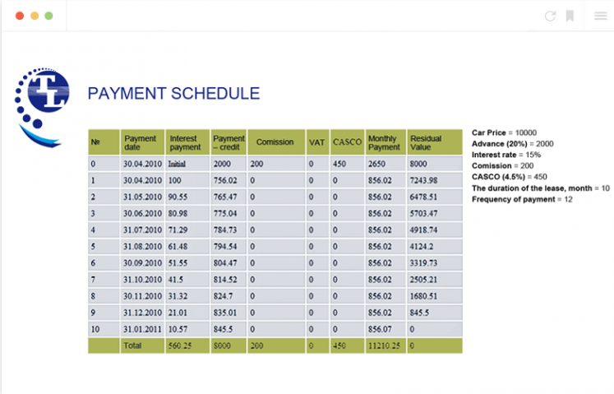
Creare soft constructorul ferestrelor 1.1.12
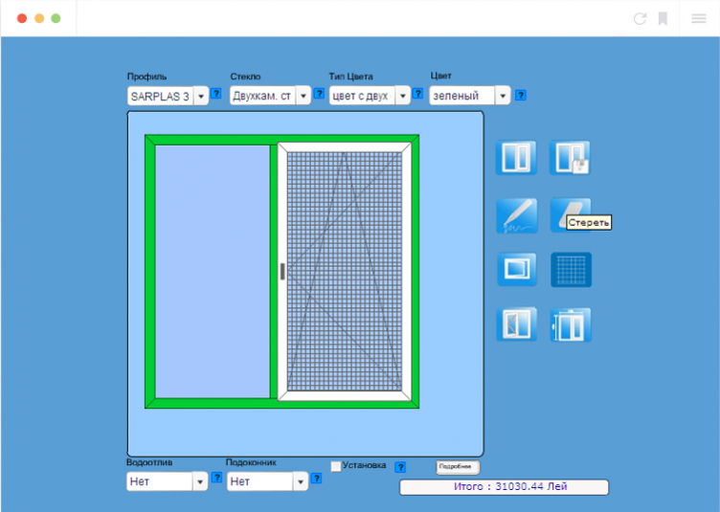

Creare software pentru automatizarea evidenței înterprinderii
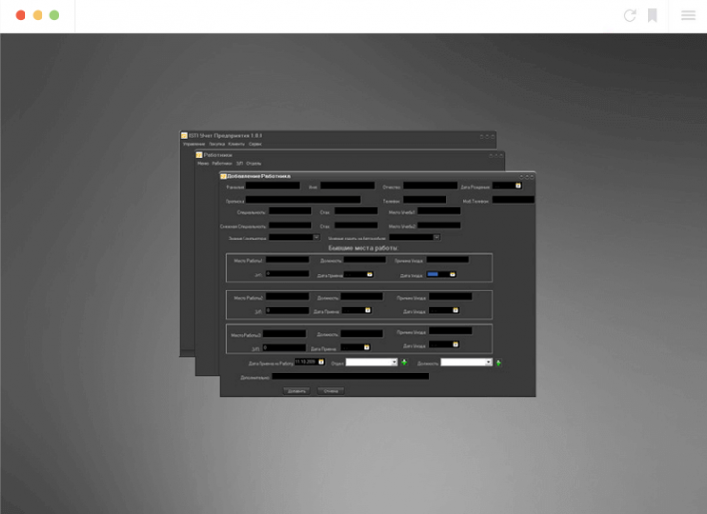
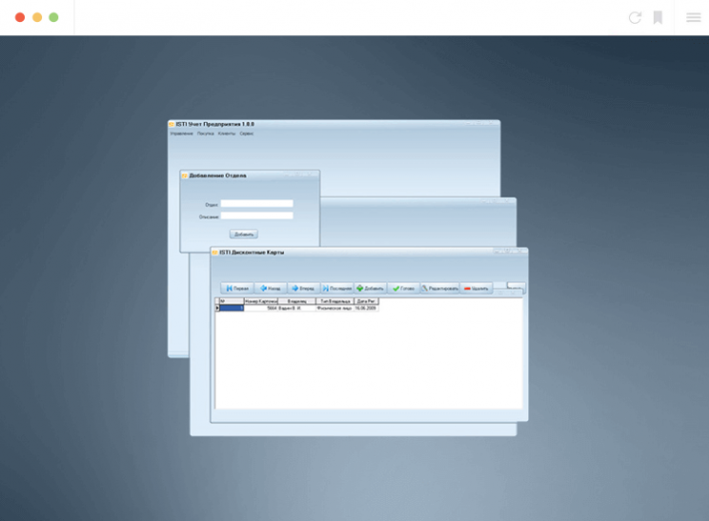
Creare programa pentru automatizarea evidenței depozitului
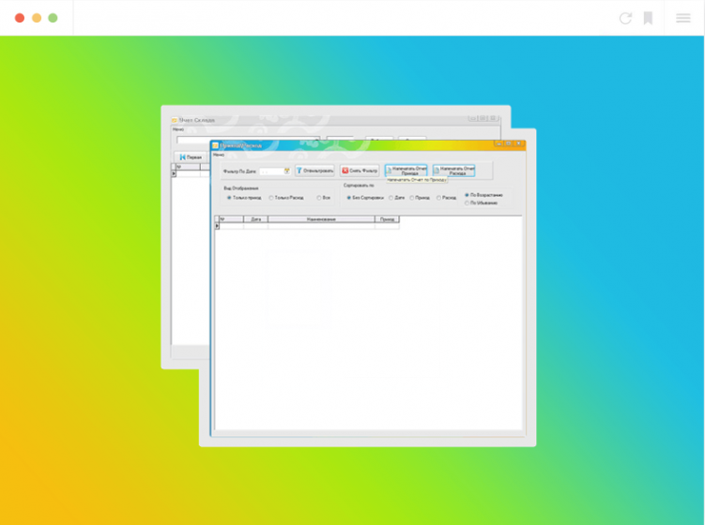
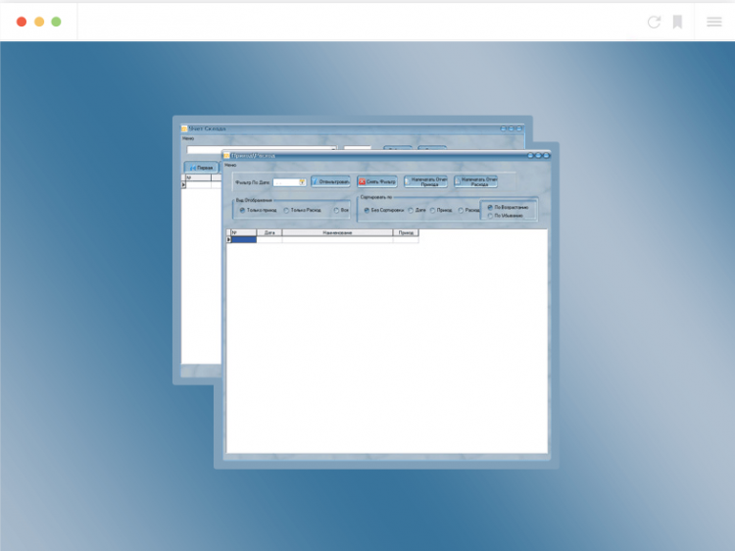
Informații despre clienți și programarea evenimentelor
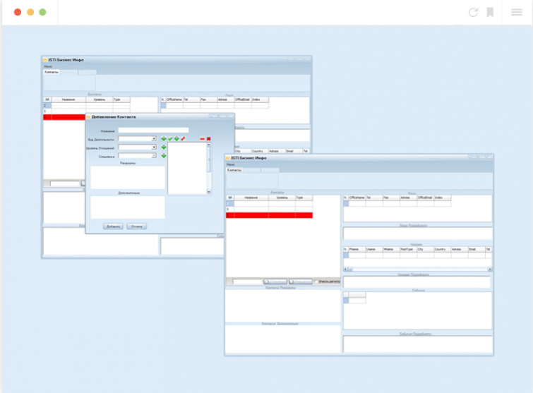
Creare software logistics calculator
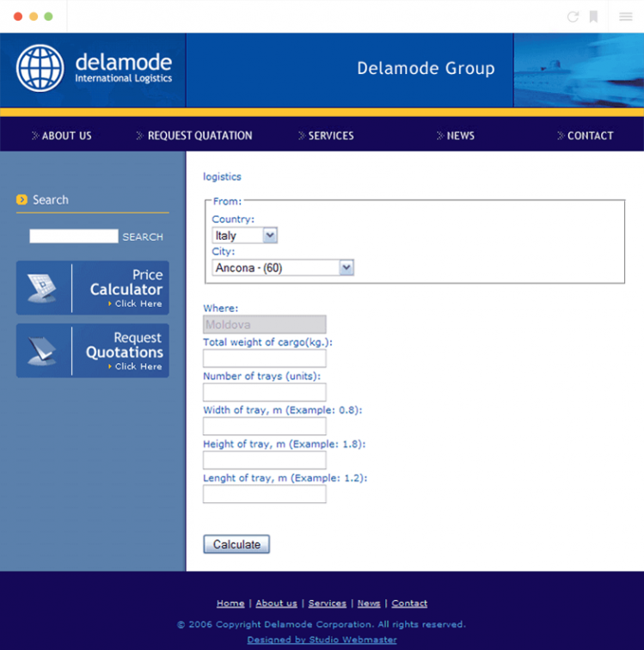

Health for you
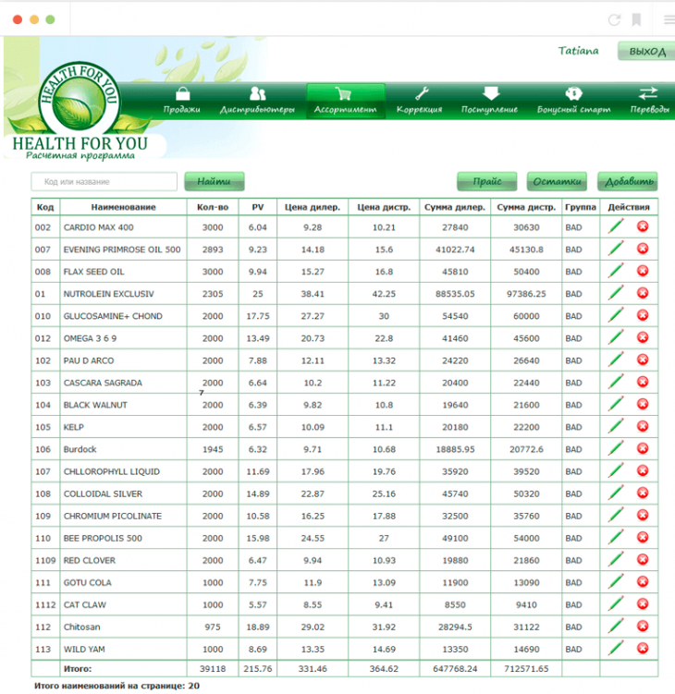
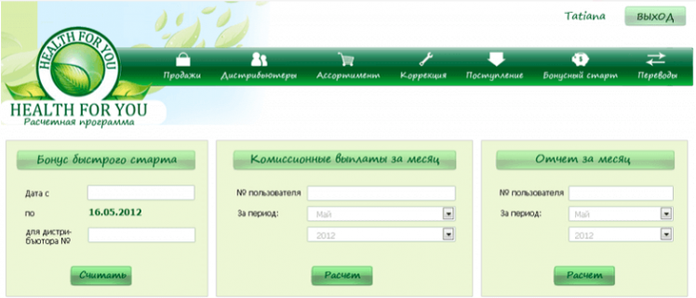
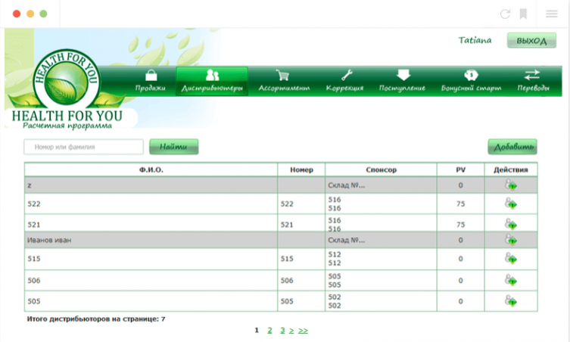

Scrisori de recomandare
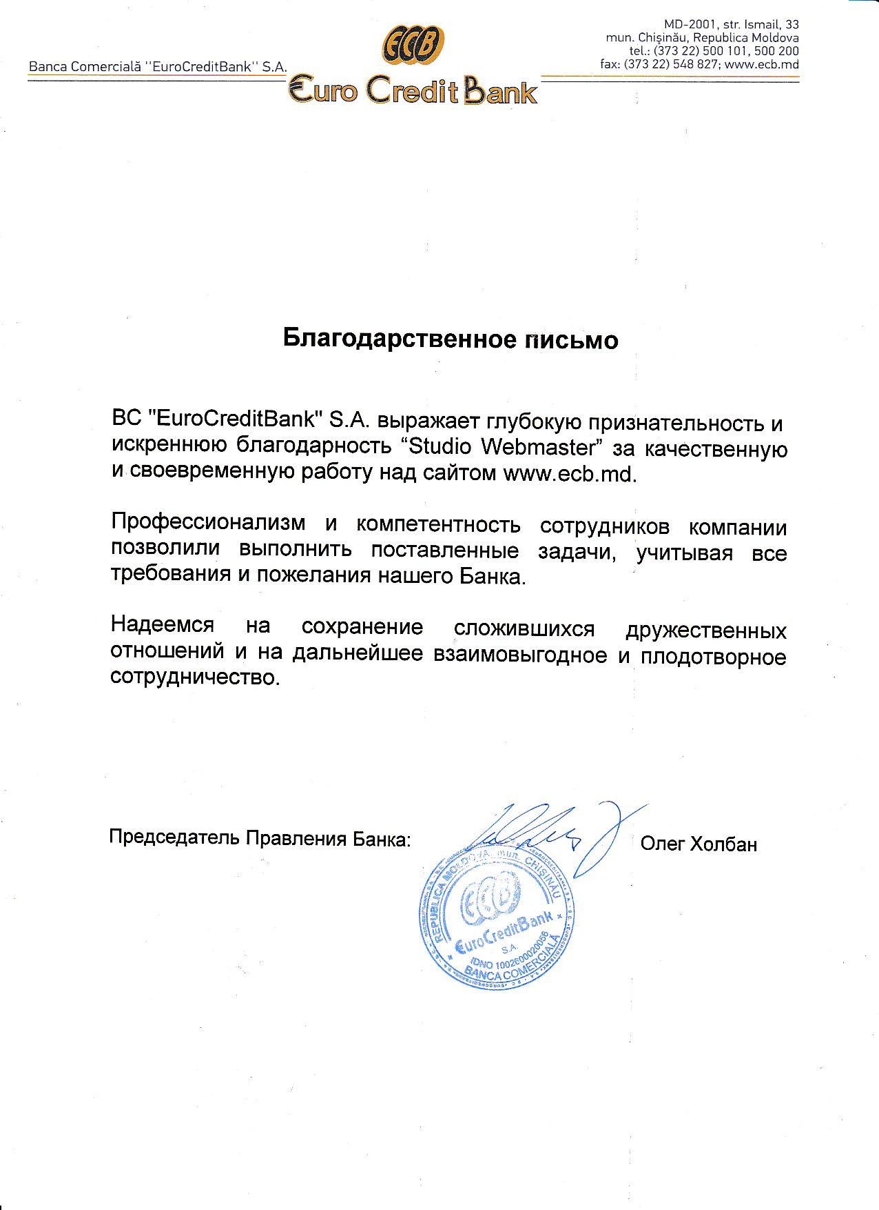
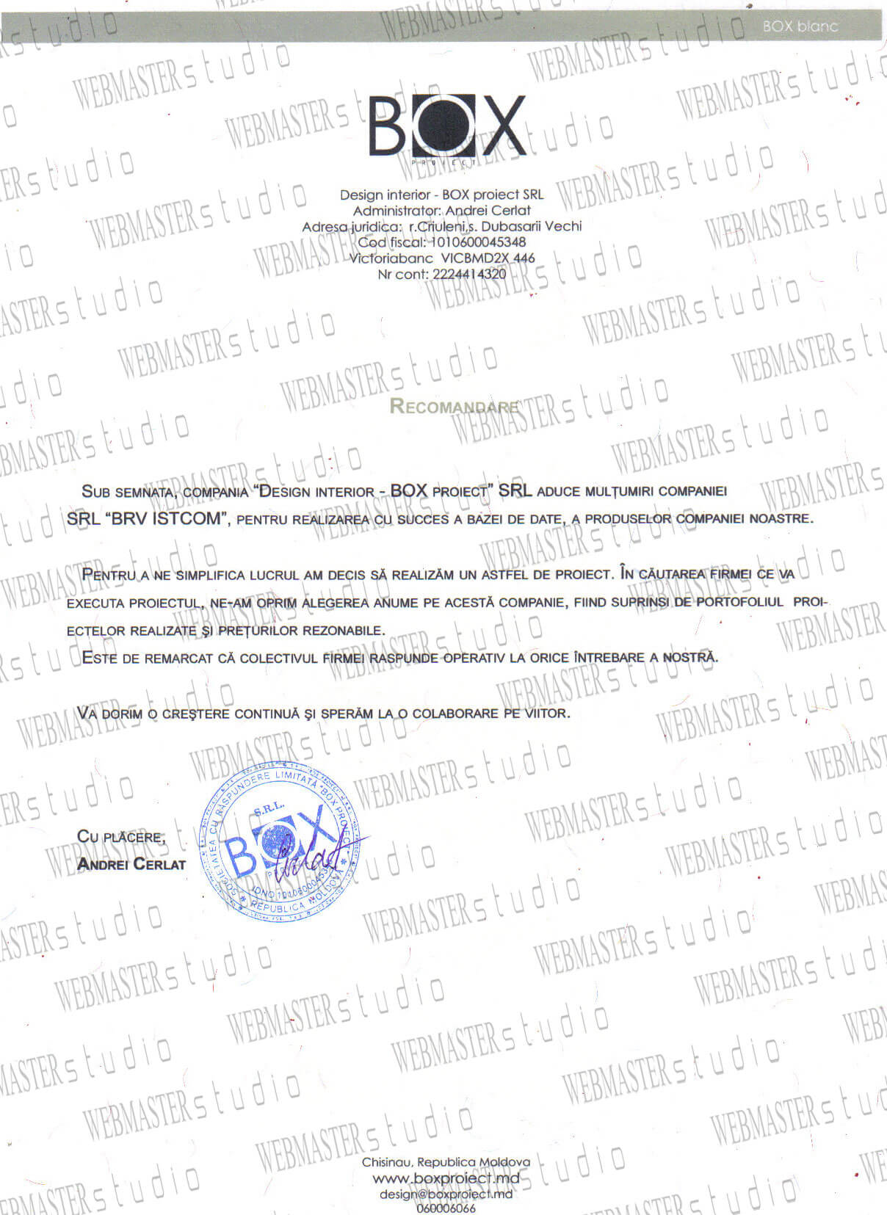

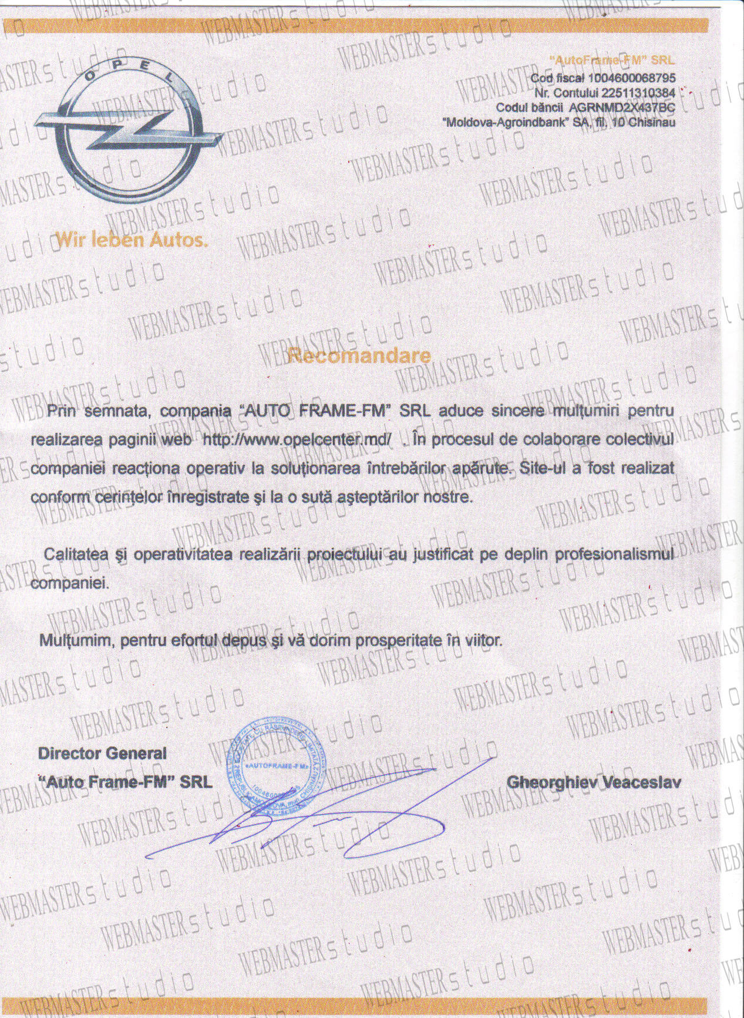

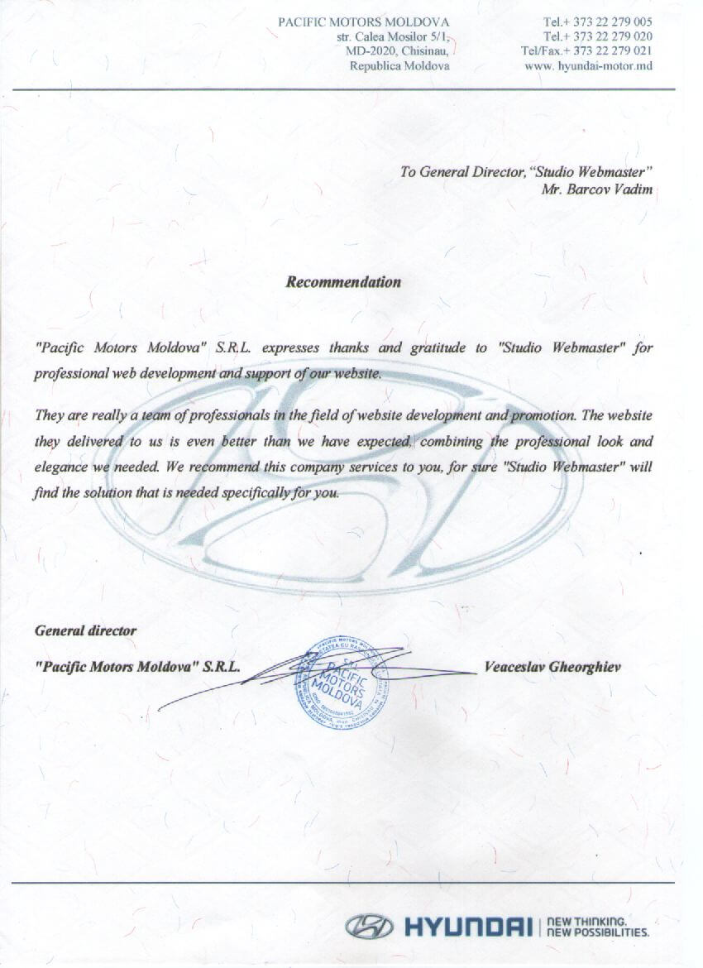

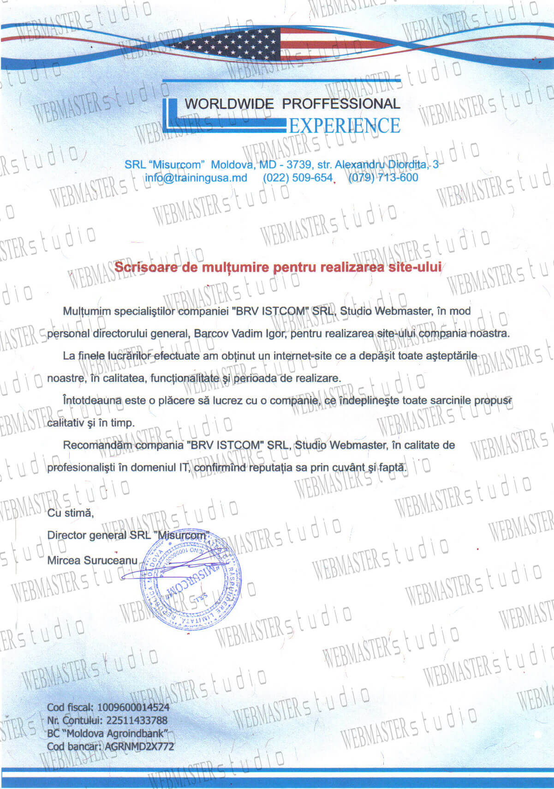

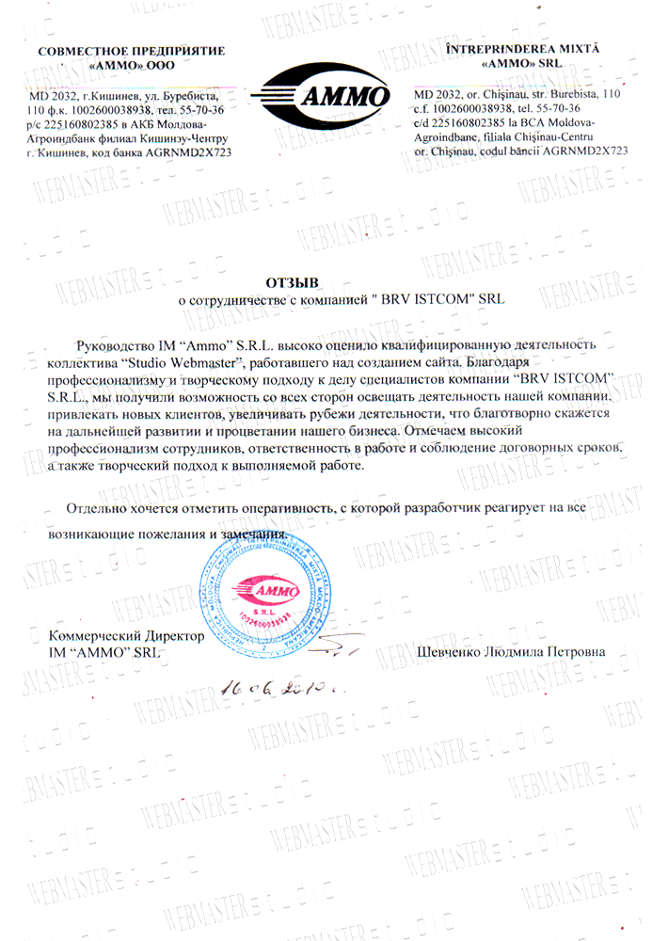

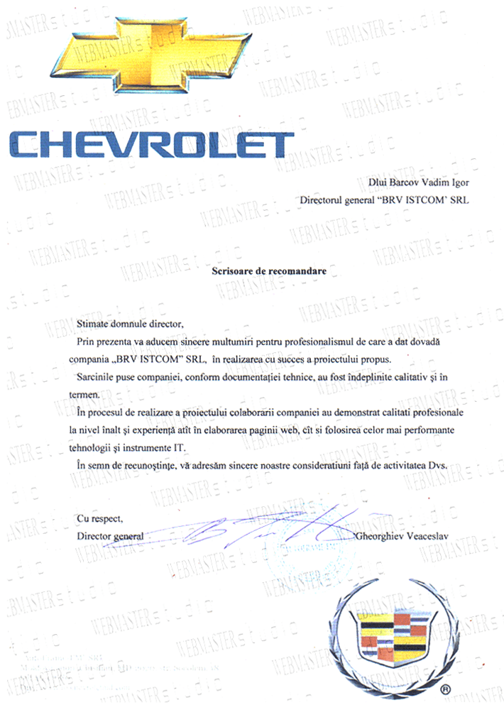
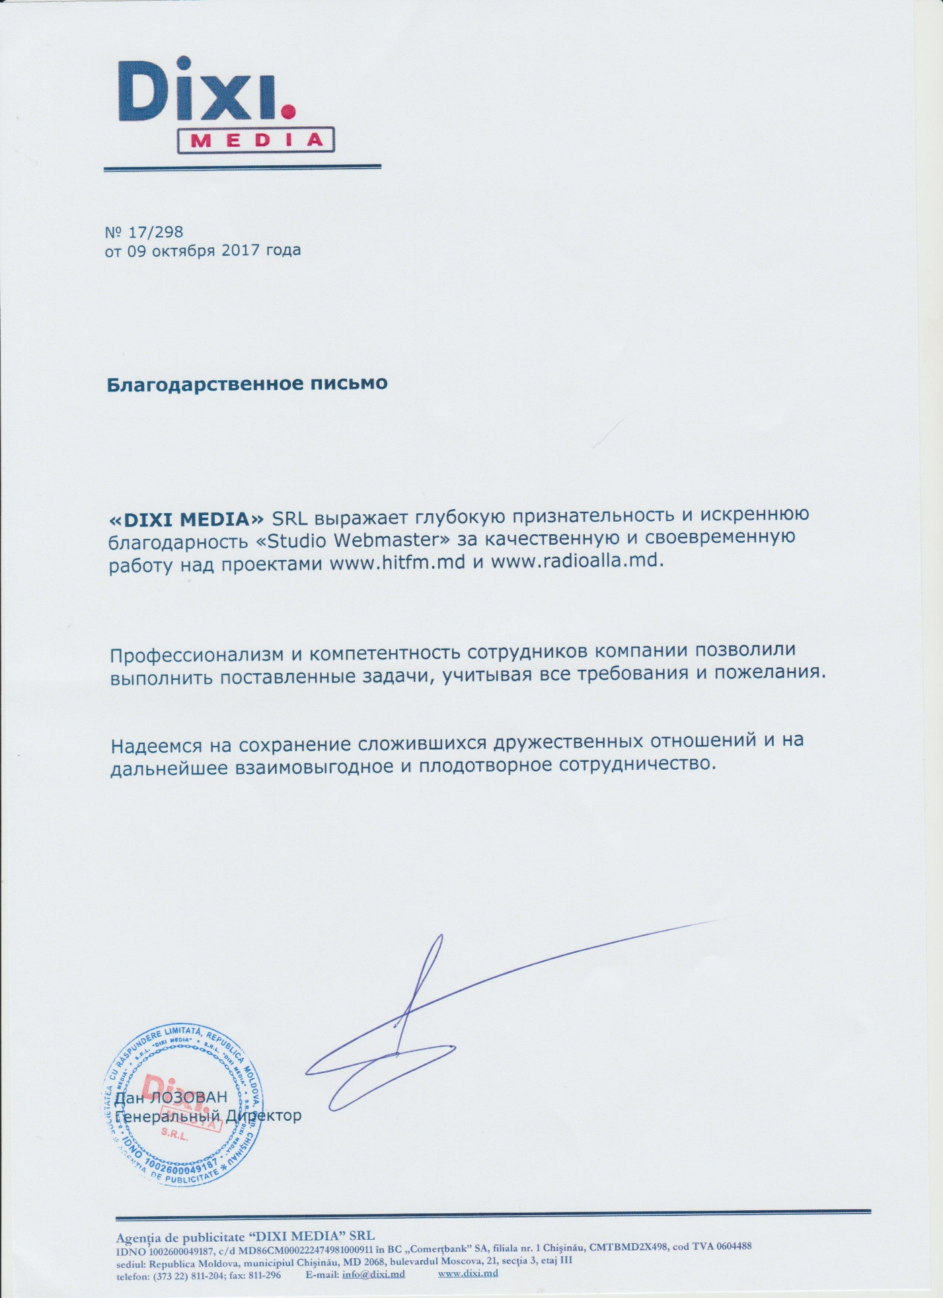

Ofertă de preț
Denumirea companiei: | “BRV ISTCOM“ SRL
IDNO (cod fiscal): | 1008600036970
Adresa juridică: | MD-2068, RM, mun.Chisinau, str. Florilor, 28/3, ap.21
Telefon de contact (fix/fax): | Tel: +(373) 22-899-801,  Tel: +(373) 22-899-802,  Tel: +(373) 22-899-803,  Fax: +(373) 22-447-307
Telefon de contact (mobil): | +37360106666
Email: | info@webmaster.md
Numele, prenumele persoanei de contact: | Igor Capanji – Șef Departamentului de Vânzări
Pagina web/Facebook: | webmaster.md
Experiența în domeniu a companiei (ani): | 13
Succintă descriere a prezenței pe piață, portofoliu de proiecte similare, clienți*: | BRV ISTCOM furnizează servicii IT de peste 12 ani. Compania are o bază imensă de clienți și a creat site-uri precum:  - ecb.md  - comertbank.md  moldexpo.md  - 4roti.md  - autoshina.md  - mobvaro.md  - happybabby.md  - vanille.md  - cadourionline.md  si alte proiecte voluminoase si interesante.  Pentru a vedea protofoliu mai detaliat accesati link-ul dat:  https://webmaster.md/ro/portofoliu/site-uri-proiectare-dezvoltare-si-promovare-a-site-urilor/

Numele, prenumele persoanei autorizate: _Barcov Vadim_

Semnătura _________________ Data _____01/07/2021_____

L.Ș. (după caz, poate fi aplicată semnătura electronică)

Activități | Acțiuni | Termen de realizare | Preț  cu TVA/fara TVA
1.Elaborarea sarcinii tehnice | 1.1. Analiza cerințelor, elaborarea și prezentarea a Sarcinii Tehnice pentru elaborarea solutiei IT;  1.2. Alegerea metodei și strategiei soluției si prezentării datelor interne; | 10 zile | 5400/4500
2. Programarea | 2.1. Dezvoltarea și testarea Produsului Minim Viabil;  2.2. Crearea subsistemului sau blocului de control în scopul verificării corectitudinei introducerii datelor în baza de date;  2.3. Crearea unui mecanism în cadrul softului menţionat, cu perspectiva posibilităţii de a importa şi exporta informaţia medicală ce ţine de spitalizarea, tratarea si externarea pacienţilor cu infecţia Covid 19 din alte softur;  2.4. Lansarea softului(softul va fi completat cu diferite casete de dialog;), ajustarea și completarea funcționalităților soluției IT în faza de exploatare; (necesitatea unor îmbunătățiri să fie toate asumate de prestator);  2.5. Participanții la dezvoltarea softului vor colabora prin intermediul integrării unei Aplicații de Management al Proiectelor la alegere;  2.6. Softul va fi dezvoltată și testată iteractiv, asigurând feedback continuu cu cerințele beneficiarului/utilizatorului; | 25 zile | 21600/18000
3. Servicii de garanție | 3.1. Dezvoltatorul va asigura 12 luni din data aprobării/semnării software-ului, servicii de garanție, mentenanță și suport pe parcursul cărora se va obliga să corecteze fără plată orice deficiență și eroare depistată în funcționarea.  3.2. Activitatile de mentenenta softului vor include:  - Monitorizarea functionalitatii softului;  - Pastrarea si salvarea integritatii bazei de date;  - Inlaturarea bag-urilor;  - Efectuarea optimizarilor necesare in codul softului;  - Efectuarea unor lucrari de programare la solicitarea beneficiarului: functionalitati noi minore si medii in baza celor existente, ajustarea rapoartelor, crearea rapoartelor la cerere, sau noi in baza celor existente, alte lucrari la solicitarea beneficiarului(contra cost);  Oferirea garanției (înlăturarea erorilor de elaborare în perioada de executare) pe o perioadă de 12 luni;  Conținutul IT solutiei va fi proiectat în limbile română și engleză, iar limba implicită va fi limba română;  Resursa se va baza pe un ciclu de dezvoltare continuu pentru a facilita ulterioarele actualizări/modificări ale acesteia. | 12 luni | -
TOTAL |  | 35 zile | 27 000/22 500
Oferta a fost întocmită în conformitate cu caietul de sarcini – Dezvoltarea si mentenanta softului “Registrul electronic de evidenta al pacientilor COVID-19”

BRV ISTCOM S.R.L.
(Denumirea operatorului economic)
adresa juridică: MD-2068, RM, mun.Chisinau, str. Florilor, 28/3, ap.21
sediul: MD – 2068, RM, str. Miron Costin 15/1, of. 3
tel/fax: 022 44 73 07
e-mail: manager@webmaster.md

