Curriculum vitae
Personal information | 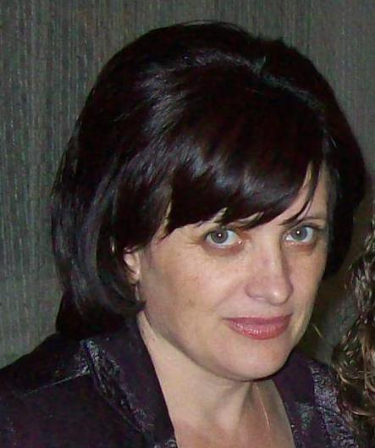
Family name: | Savca
First names: | Tatiana
Date of birth: | 21.08.1962
Nationality: | Moldavian
Education: | Higher education

Institution (Date from - Date to) | Degree(s) or Diploma(s) obtained:
Academy of Public Administration under the President of the Republic of Moldova, Chisinau, (2005 – 2006) | Management, Master's degree
Academy of Public Administration under the Government of the Republic of Moldova, Chisinau (1999 − 2003) | Doctoral Studies “The Organization and Management of State Institutions”, Field of Research “Public Policy”
Academy of Public Administration under the Government of the Republic of Moldova, Chisinau (1996 – 1998) | Public Administration, master's degree
Moldova State University, Chisinau  1979 − 1984 | Applied mathematics, mathematician, university degree
Language skills: competence on a scale of 1 to 5 (1 - excellent; 5 - basic)
Language | Reading | Speaking | Writing
Romanian (native) | 1 | 1 | 1
Russian | 1 | 1 | 1
English | 3 | 4 | 4

Membership of professional bodies:
- Co - founder of the NGO Center of Excellence in Public Management, Chisinau (from 2013).
Other skills: (e.g. Computer literacy, etc.)
- Experience in local government, regional development, management, training of civil servants.
- Research in the theory and practice of Public Administration, Public Policy, Gender Equality.
- Knowledge and experience in project management.
- Computer Skills (MS WORD, MS EXCEL, MS ACCESS, INTERNET...).
Present position:
- Head of department Methodological assistance for public authorities
Years within the firm: |  | Academy of Public Administration - Institute of Public Administration, 1998 up to present
Key qualifications:
1997 - 2017 | Over 25 Professional Development Courses graduated in the fields: art and science of public administration, sustainable development, strategic planning, project management, public service quality management, change management, public policy, impact analysis, regional development, public procurement, public property management and leadership, e-Learning system.
2018 | Training of Trainers „Diaspora. Migration and Development”, Chisinau, Certificate nr. 34178  Training for watchdog organization, Citizens Network Watchdog Poland, USAID, Chisinau, 12-13 September, certificate  Training of Trainers „Gender equality”, AAP, UN WOMEN, certificate nr. 34689, 14.12.2018  Training „Gender mainstreaming in public policies”, Gender-Centru, Clubul Politic 50/50
2019 | Training of Trainers „Impact Analysis in the process of substantiating the draft normative acts”, World Bank Group, DAI, Chisinau  Internal Public Managerial Control, Training, AAP, Chisinau, nr. 36535, 27.11.2019  Course: Management and Leadership, dbb akademie (Germany), Ukraine, 2019
2020 | Course: Internal auditor for quality management systems (SM EN ISO 9001:2015), ISM, nr.078/21.02.2020
2021 | Seminar: „Access to the EBSCO database”, 10.03.2021  Course: „e-Learning - effective way of professional training of civil servants”, 21-22.01.2021  Course: „ARTICULATE STIRYLINE - tool for creating, modifying and publishing e-Learning courses in SCORM format”, 12-13.05.2021  Course: Document management, 25.02.2021  Methodical seminar: „Organization and realization of studies in online master's programs: accumulated experience and prospects for capitalization”, 04-05.05.2021  Course: „Project Manager”, 13-17.12.2021
2022 | Training of Trainers „Management and Leadership Training”, GIZ, dbb akademie (Germany), Georgia, 2022
Specific experience in the region:

Country | Date from - Date to
Moldova  Experience in the field of public policy, impact analysis, management and leadership, local development and promoting gender equality;  Individual consulting contracts (UN-Women, PNUD Moldova, Soros Moldova, Сentrul CONTACT, AO IVC, GENDER-Centre, USAID Comunitatea Mea Program); | 2015-2023

Professional experience
Date from - Date to | Location | Company & reference person (name & contact details) | Position | Description
1984 - 1986 | Bender, Republic of Moldova | Silk Factory | Mathematician, Automated System of Management | - Computer’s programs
1986 -1992 | Bender, Republic of Moldova | Youth’s Town Committee | Manager | Organization and performance
1992 - 1995 | Village of Carnatenii Noi, Republic of Moldova | Collective Farm “Victoria” | Head-economist | business planning  control activity  monitoring and evaluation
1995 -1998 | Village of Carnatenii Noi, Republic of Moldova | Carnatenii Noi, Mayoralty | Secretary of local council | Local council activity
1998 – 30 October, 2022 | Chisinau, Republic of Moldova | Academy of Public Administration | Head of  The Quality Management Department | Quality Management System;  course “Public Policy”, “Planning in Public Administration”, „Project Management”  Training activities in the European and UNDP Projects
2023 | Chisinau, Republic of Moldova | Institute of Public Administration, MSU | Head of department Methodological assistance for public authorities | cooperation with local and central public administration; providing methodological assistance to public authorities
Publications
3 books (co-author); 5 guides (co-author); over 50 scientific articles in public administration, public policy and public management.

T.Savca 2023

