Request for Quotation

FROM | NORWEGIAN REFUGEE COUNCIL
Address | Bucuresti 41
City | Chisinau
Country | Moldova
Phone # | 076030069
Email | md.procurement@nrc.no

The office of the Norwegian Refugee Council invites your company to submit a price quotation for the following items in accordance with the requirements detailed below. You may use your company format, or fill up the table below. Please read carefully the instructions below.

Request for Quotation Requirements
RFQ # : | RFQ-MOL-CO-24-024 | Currency | MDL
RFQ Issuing Date: | 09.07.2024 | Bid Validity Period (days): | (Preferably 30 days)
RFQ Closing Date: | 17.07.2024 | Required Delivery Date: | 31.07.2024
RFQ Closing Time: | 16:00 | Required Delivery Destination: | Chisinau, Bucuresti 41
Questions to the RFQ | md.procurement@nrc.no | Required Delivery Terms: | N/A

# | Description |  | Specification | Photo | Unit | Estimated Qty | Unit price, incl. Tax (MDL) | Total Price incl. Tax (MDL)
1 | Disposable collar |  | paper material | 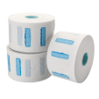 | piece | 9
2 | Round pot of paint |  | plastic | 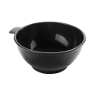 | piece | 9
3 | Water sprayer |  | plastic 330 ml | 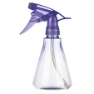 | piece | 9
4 | Paint brush |  | narrow |  | piece | 9
5 | Paint comb brush |  | It is made of durable plastic, which makes it resistant to chemicals contained in hair dyes. | 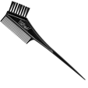 | piece | 9
6 | Ergonomic scissor |  | Super Cut classic 6” , 32 ace | 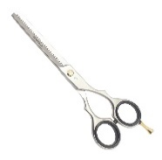 | piece | 9
7 | Ergonomic scissor |  | clipper 5.5" | 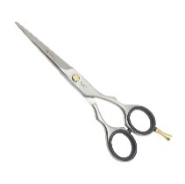 | piece | 9
8 | Professional comb |  | Cod: E00113 | 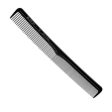 | piece | 9
9 | Professional comb |  | with metal tail | 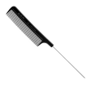 | piece | 9
10 | Delimiter Comb |  | with separator d+B161+C161:A161:M192 | 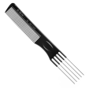 | piece | 9
11 | Thermal brush |  | D18 MM | 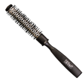 | piece | 9
12 | Thermal brush |  | D30 MM (termobrushing) | 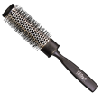 | piece | 9
13 | Double-sided tunnel comb |  | bilateral | 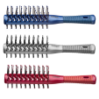 | piece | 9
14 | Master's apron |  | Poliester | 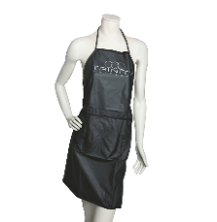 | piece | 9
15 | Hairdressing cape |  | Equivalent to Wahl | 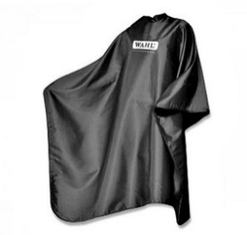 | piece | 9
16 | Wig clip |  | plastic (minimum 6 in a set) | 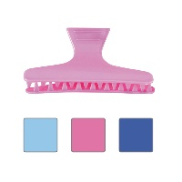 | Set | 9
17 | Hair clip |  | plastic (minimum 6 in a set) | 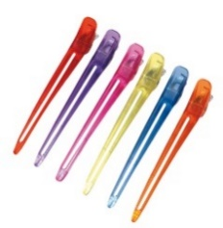 | piece | 9
18 | Hair dryer |  | Super dry 2000 w with tourmaline | 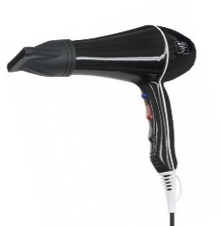 | piece | 9
19 | Clipper |  | Typ 1400 bordo | 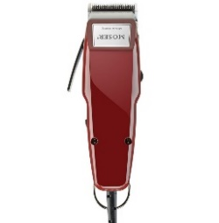 | piece | 9
20 | Tool bag |  | Medium size | 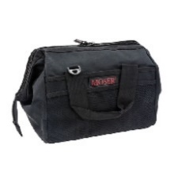 | piece | 9
21 | Thermal brush |  | D24 mm | 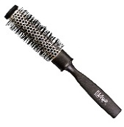 | piece | 9
22 | Hair removal brush |  | Small size | 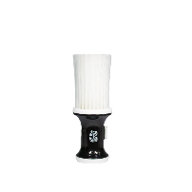 | piece | 9
23 | CeraStyle hair straightener |  | Equivalent to Moser | 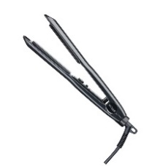 | piece | 9
24 | Comb with rare teeth |  | Equivalent to Eurostil | 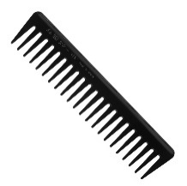 | piece | 9
25 | Professional bun and toupee brush |  | Equivalent to Eurostil | 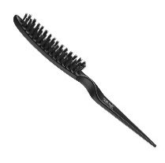 | piece | 9
26 | Thermal glove |  | 3 degete |  | piece | 9
27 | Curling iron |  | Titanium Curl 25 mm black | 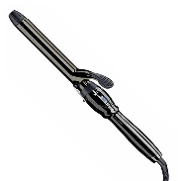 | piece | 9
28 | Extra strong hold spray |  | Equivalent to Tassel | 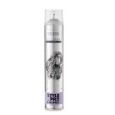 | piece | 9
29 | Volume powder |  | Equivalent to Tassel | 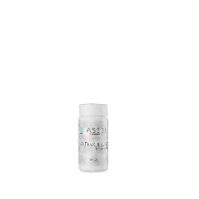 | piece | 9
30 | SCALES |  | Equivalent to Tassel | 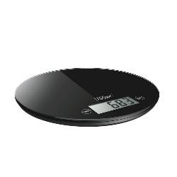 | piece | 9
31 | Thermal protection spray |  | Equivalent to Tassel | 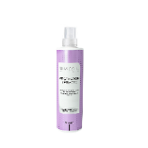 | piece | 9
32 | Trinness curler 9 mm |  | Trinness 9 mm | 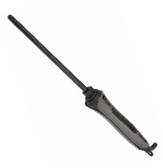 | piece | 9
33 | Tool trolley |  | Equivalent to Hairway | 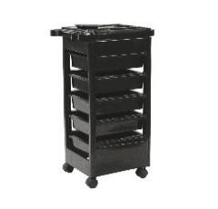 | piece | 9
34 | Holder for brushes and comb |  | material metal | 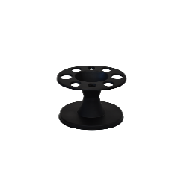 | piece | 9
35 | Thermal brushing |  | D-42 mm | 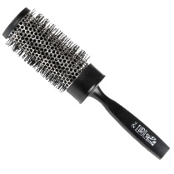 | piece | 9
36 | Quartz sterilizer |  | Equivalent to Ronney | 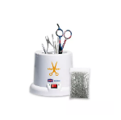 | piece | 9
37 | Delivery To Chisinau |  |  |  | Service | 1
 |  |  | TOTAL PRICE (including taxes and delivery)
Delivery of all items shall be made to Chisinau address mentioned in the Request for Quotation Requirements above.

All deliveries are expected door-to-door, which includes bringing items to the exact floor or level, as instructed by NRC staff during delivery.

Delivery Lead Time (in days, from receipt of NRC Purchase Order)-Chisinau
Bid Validity Period (in days from receipt of NRC Purchase Order):
Defects liability and warranty period for electric items:
Country of origin of the goods

Payment Terms: ___________

Payment Terms means the statement by a company about when and how it should be paid for goods or services that it has supplied, NRC prefer that Payment will be made after the delivery within 30 days of receipt of goods/ services, by bank transfer. If not, would you please provide us with your payment terms above.

Name

Position

Date Signature

Stamp

We, understand that activities and materials used under this project are subject to EU sanctions and that compliance with EU sanctions is mandatory. We undertake that through the implementation of activities under this contract, we will not engage in transactions with, or provide resources or support to, any individual or entity that is subject to sanctions administered by the European Union, the United Nations, or the United States. We further undertake to remain compliant with all origin of goods requirements and prohibitions stipulated under EU sanctions including, but limited to, Council Regulation (EU) No 692/2014 and Council Regulation (EU) 2022/263.

RFQ Terms & Conditions
Manner of Submission:
- By hand in a sealed envelope to NRC office located Address: Chisinau, Bucuresti 41
OR
- By email to the dedicated and secured email address: md.tenders@nrc.no (offers received on other email addresses will not be considered)
- Before the Closing date & Time mentioned above. Companies who do not submit their quotation by this deadline will not be considered

Valid offer should include the following documents:
- Filled & Signed RFQ
OR
- Detailed Bidder’s offer, preferably with the photos of the proposed items
- Annex 1: Ethical Standard Declaration (Signed)
- Copy of the Company's Extras

Requirements:
- All Bids must include all customs and taxes payable in the country of delivery unless the RFQ specifically requests differently
- Bids must be submitted in the currency indicated in the RFQ. Bids in other currency might not be accepted
- Bids must be valid for the validity period indicated in the RFQ. Bids not meeting this validity period might be disqualified
- All enquires and questions should be addressed to the email given in the RFQ details section. All questions and answers will be shared with all invited suppliers.
- NRC reserves the right to accept or reject the whole or part of your quotation based on the information provided. Incomplete quotations which do not comply with our conditions will not be considered.

Assessment Criteria:
- All bids received and accepted will be evaluated based on the following:
- Step 1: Administrative compliance check: Each bid will be checked to ensure compliance with all the RFQ requirements – PASS / FAIL
- Step 2: Technical Evaluation: All bids will be evaluated to be compliant with above specifications for each offer item – PASS / FAIL
- Step 3: Financial Evaluation: Price comparison will be based on the total least financial offer of the matching specifications.

NRC is obliged to ensure that its procurement decisions are clearly justified and documented and keeping within the Donors mandatory principles. In that regard, full and on-the-spot access must be granted to representatives of NRC, the Donor or any organisation or person mandated by it, to premises belonging to NRC or its contractors. The right to access shall include all documents and information necessary to assess or audit the implementation of the contract.  NRC also expects suppliers who process personal data to comply with the General Data Protection Regulation (EU GDPR) and any relevant national legislation. Suppliers processing personal data on an NRC contract will be required to sign a data processing / sharing agreement as part of the contract. Refusal to sign such an agreement constitutes refusal of the contract terms and forfeiture of the contract on the part of the supplier.  If the activities of the contract take place in areas with Explosive Hazards, NRC accepts no liability for injury and/or death to contractor’s staff or damage to contractor’s property. | Anti-money laundering, anti-bribery, anti-corruption and anti-terrorism legislation and donor regulations require NRC to screen contractors against various international lists to ensure due diligence. Submission of the quotation constitutes acceptance of these screening practices.  NRC aims to purchase products and services with minimum environmental impact. Environmental considerations form part of the NRC selection criteria, and NRC reserves the right to reject quotations provided by suppliers not meeting these standards.  All suppliers doing business with NRC should maintain high standards on ethical and environmental issues, respect and apply basic human and social rights, ensure non-exploitation of child labour, and give fair working conditions to their staff. Suppliers will be required to sign and submit an Ethical Standards Declaration, together with their bid.  NRC reserves the right to reject quotations provided by suppliers not meeting these standards.

Signature & Stamp

Please complete, sign and stamp the below table:

Bidder’s general business details

- General information
Company name:
Address:
Company Registration No:
Contact person:
Contact Telephone No:
Email/Fax:
Bank Name:
Bank Address / Branch:
IBAN:
Tax Number:
Date:
Stamp:

- Owners/Managers
Please fill in the below table with the full names and the year of birth of the company’s owner(s) and manager(s)*:

Full name | Date of birth

