According to Annex No. 21 of the Standard Documentation,
approved by Order of the Minister of Finance
No. 115/15.09.2021, effective as of 01.10.2021

TERMS OF REFERENCE
Services
(free translation)

1. GENERAL DESCRIPTION INFORMATION

Contracting authority: Deposit Guarantee Fund in the Banking System, located at 180 Ștefan cel Mare și Sfânt Blvd., office 1312, MD-2004, Chișinău, Republic of Moldova
Object of the procurement: Integrated and customized Management Information System (MIS) for the digitalization of FGDSB’s operational processes.
CPV code: 72200000-7 - Software programming and consultancy services

1. SERVICE REQUIREMENTS:
No. | CPV code | Name of goods/services | Unit of measurement | Quantity | Full technical specifications required, Reference standards | Estimated value, excluding VAT, MDL
Lot: Integrated and customized Management Information System (MIS) for the digitalization of FGDSB’s operational processes
1 | 72200 000-7 | Integrated and customized Management Information System (MIS) for the digitalization of FGDSB’s operational processes  - Module 1 Payment of guaranteed bank deposits  - Module 2 FGDSB operational activity  - Module 3 Financial records | pc. | 1 | Detailed technical conditions are described in the Terms of Reference. | 1 667 000,00
2 | 79633  000-0 | Training services related to the integrated information system | serv. | 1 |  | 1 667 000,00
3 | 72212  422-3 | Person-hours for additional developments and change requests during the implementation and warranty period (50 person-hours) | serv. | 1 | Additional developments and change requests will be calculated based on man-hours and will not exceed 50 hours. They will be paid according to the effective volume requested. | 1 667 000,00
Total estimated value, MDL |  |  |  |  |  | 1 667 000,00

Head of the working group:
Dionis Catanoi
(digitally signed)
Annex No. 1 to the Terms of Reference
Technical specifications

[This table will be completed by the tenderer in columns 2, 3, 4, 6, 7, and by the contracting authority in columns 1, 5.]

Procurement procedure number______________of_________
Object of the procurement: Integrated and customized Management Information System (MIS) for the digitalization of FGDSB’s operational processes .
Name of goods/services | Name of model of goods/services | Country of origin | The manufacturer | Full technical specification requested by the contracting authority |  | Full technical specification proposed by the tenderer | Reference standards
1 | 2 | 3 | 4 | 5 |  | 6 | 7
Lot: Integrated and customized Management Information System (MIS) for the digitalization of FGDSB’s operational processes
Integrated and customized Management Information System (MIS) for digitizing FGDSB's operational processes  - Module 1 Payment of guaranteed bank deposits  - Module 2 FGDSB operational activity  - Module 3 Financial records |  |  |  | According to the requirements in the Terms of Reference
Training services related to the integrated information system
Person-hours for additional developments and change requests during the implementation and warranty period (50 person-hours)
TOTAL
Signed:_______________ First name, last name:_____________________________ In my capacity as: ________________
Tenderer: _______________________ Address: __________________________

Annex 2 to the Terms of Reference

Price specifications
[ This table will be completed by the tenderer in columns 5, 6, 7, 8, and 11 as necessary, and by the contracting authority in columns 1, 2, 3, 4, 9, and 10.]

Procurement procedure number______________of_________
Object of the procurement: Integrated and customized Management Information System (MIS) for the digitalization of FGDSB’s operational processes .
CPV code | Name of goods/services | Unit of measurement | Quantity | Unit price (excluding VAT) | Unit price (including VAT) | Amount, excluding VAT | Amount, including VAT | Delivery/service completion date |  | Budget classification (IBAN) |  |  | Discount  %
1 | 2 | 3 | 4 | 5 | 6 | 7 | 8 | 9 |  | 10 |  |  | 11
Lot: Integrated and customized Management Information System (MIS) for the digitalization of FGDSB’s operational processes
72200000-7 | Integrated and customized Management Information System (MIS) for the digitalization of FGDSB’s operational processes  - Module 1 Payment of guaranteed bank deposits  - Module 2 FGDSB operational activity  - Module 3 Financial records | pc . | 1 |  |  |  |  | Delivery time according to implementation requirements*
79633000-0 | Training services related to the integrated information system | serv | 1 |  |  |  |  | Delivery time according to implementation requirements*
72212422-3 | Person-hours for additional developments and change requests during the implementation and warranty period (50 person-hours) | Serv. | 1 |  |  |  |  | Additional developments and change requests will be calculated based on man-hours and will not exceed 50 hours. They will be paid according to the actual volume requested.
 | TOTAL
* According to implementation needs, but no later than the maximum deadline for commissioning the integrated IT system by 30 November 2026.

Signed:_______________ Name, Surname:_____________________________ In the capacity of: ______________

Tenderer: ___________________ Address: ________________________________________________________

Annex 3 to the Terms of Reference

Total cost of ownership
The form is dedicated to the Tenderer's response to the financial offer requirements and is intended to describe the components of the total cost of ownership.

The total cost of ownership includes all costs related to the development and implementation of the solution, as well as support and maintenance costs and estimated additional developments for a period of 5 years after the solution is put into operation.

No | Name | Contract period | Year 1 | Year 2 | Year 3 | Year 4 | Year 5 | TOTAL (EUR/MDL/USD)
1 | Integrated and customized Management Information System (MIS) for the digitalization of FGDSB’s operational processes  - Module 1 Payment of guaranteed bank deposits  - Module 2 FGDSB operational activity  - Module 3 Financial records |  | n/a | n/a | n/a | n/a | n/a
2 | Training services related to the integrated information system |  | n/a | n/a | n/a | n/a | n/a
3 | Person-hours for additional developments and change requests during the implementation and warranty period (50 person-hours) |  | n/a | n/a | n/a | n/a | n/a
4 | Post-implementation maintenance and support services | n/a
5 | Development services, based on change requests estimated at 50 man-hours after the warranty period expires | n/a
TOTAL COSTS |  | 0 | 0 | 0 | 0 | 0 | 0 | 0

* The amounts in the table shall be indicated without VAT

Signed:_______________ Name, Surname:_____________________________ In the capacity of: ________________

Tenderer: _______________________ Address: _________________________

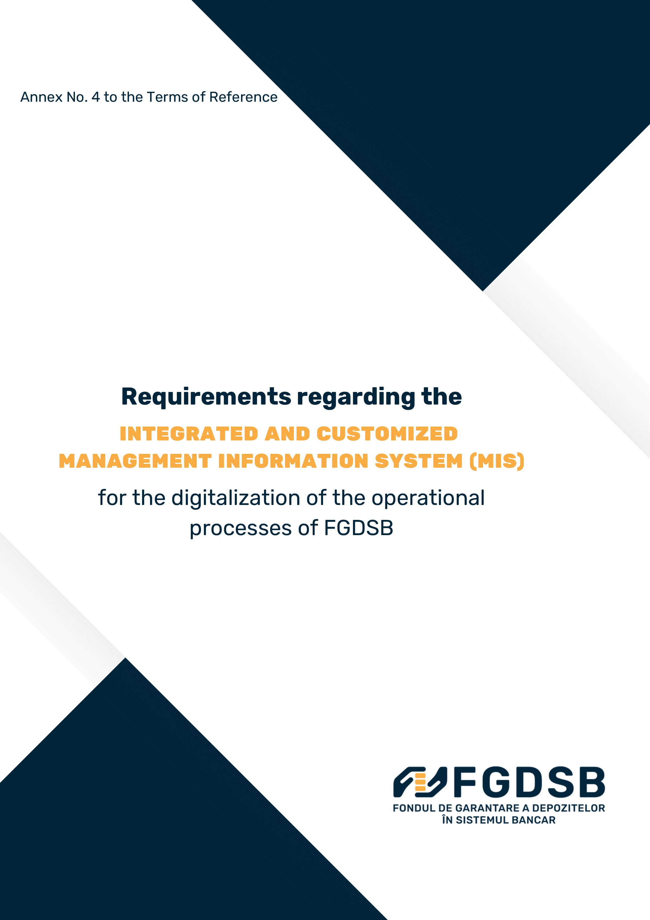
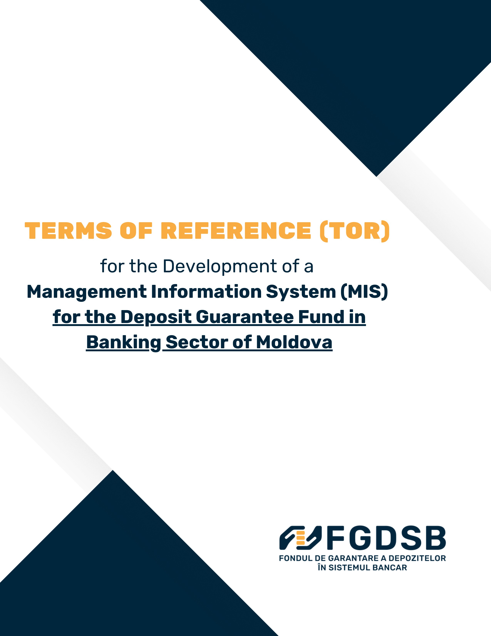

TERMS OF REFERENCE (TOR)
for the Development of a
Management Information System (MIS) for the Deposit Guarantee Fund in Banking System of Moldova

Contents

1. Introduction 2
2. Objectives 2
3. Scope of Work 3
4. Deployment Options and Requirements 4
5. Functional Requirements 4
6. Non-Functional Requirements 5
7. Deliverables. 5
8. Integration with External Platforms and Services. 5
9. Implementation Timeline 6
10. Budget and Pricing 6
11. Service Level Agreement (SLA) During Maintenance and Support Phase. 6
12. Other required information 6
13. Submission of a proposal 7
14. Evaluation Criteria. 7
15. Contact Information 10
Annex to the Requirements regarding the Management Information System (MIS) 11
1. Tailor-made Guarantee Deposits Payout Module 11
2. FGDSB Daily Operation Module 23
3. Financial Bookkeeping Module 28
General Requirements 29
Glossary of Terms 32

1. Introduction
The Deposit Guarantee Fund in Banking System (FGDSB is seeking for national / international IT developer to develop and maintain a tailor-made, robust 3-modular Management Information System (MIS) to improve its operational efficiency and ensure seamless fulfillment of all FGDSB’s functions, including smooth processing of a large quantity of data, internal connectiveness between different functional modules and with financial accounting.
FGDSB was established as a legal entity of public law on July 1, 2004, based on Law No. 575 of December 26, 2003, of the Republic of Moldova on deposit guarantee in the banking system.
The primary objective of FGDSB is to protect deposits held by individuals and legal entities in all member institutions of the deposit guarantee scheme. This ensures the protection of depositors' interests in case their deposits become unavailable, guaranteeing the reimbursement of insured amounts within the coverage limit.
FGDSB administers the Bank Deposit Coverage Fund (FADB) and the Bank Resolution Fund (FRB). The Bank Deposit Coverage Fund guarantees deposits in both national and foreign currency held by individuals and legal entities, whether resident or non-resident, in all member institutions.
Any bank licensed by the National Bank for deposit-taking activities automatically becomes a member institution of the Bank Deposit Coverage Fund from the date the licensing decision comes into effect.
Legislation Regulating FGDSB's Activities:
- Law No. 160 of June 22, 2023, on deposit guarantee in banks;
- Law No. 232 of October 3, 2016, on bank recovery and resolution;
- Regulation on informing depositors by the Deposit Guarantee Fund in the banking system and its member institutions, approved by FGDSB Administrative Council Decision No. 05/1 of December 21, 2023;
- Regulation on regular reporting to FGDSB, determination, and payment of ordinary contributions to the Bank Deposit Coverage Fund, approved by FGDSB Administrative Council Decision No. 03/3 of November 29, 2023;
- Regulation on the conditions for imposing, determining, and collecting special contributions to the Bank Deposit Coverage Fund, approved by FGDSB Administrative Council Decision No. 07/1 of February 27, 2024.
- Law No. 133 of 08.07.2011 on the protection of personal data, Official Monitor No. 171-175 of 14.10.2011.

2. Objectives
MIS should allow:
- Automation of operational processes;
- Verification/validation of large volumes of data;
- Processing of large volumes of data;
- High-level security;
- Minimization of operational risks;
- Modular implementation to support scalability, parameterization, and efficient management;
- Secure and efficient real-time processing of payments to depositors, including integration with the Instant Payment System MIA (IPS) (including the BNM’s Central Addressing Scheme (CAS) Proxy for verifying payment details), DNS and RTGS solutions provided by the National Bank of Moldova (BNM);
- Multiple options for compensatory payments to depositors:
- via an online platform, and
- via a paying agent;
- Integration with government services MPass and MConnect;
- User-friendly interfaces for clients, paying agents, FGDSB staff, and administrators, with full reporting and secure access control;
- Implementation on own servers or cloud-based, with detailed hardware and software requirements for each implementation type;
- Backup options;
- Archiving;
- Other functionalities.

3. Scope of Work
The vendor will develop, test, deliver and maintain the MIS.
The development may be distributed in stages. Based on the offers received FGDSB can decide on some modules/submodules not to be developed.
Three main MIS modules are:
- Tailor-made Guarantee deposits payout software Module supporting direct/indirect payment to depositors (individual and legal entities):
  - Import of data on depositors and their deposits from a bank in liquidation in specified uniformed formats;
  - Searching, sorting and exporting data;
  - Processing of data at FGDSB;
  - Storing depositor information in Single Customer View (SCV) format.
  - Payment to depositors in regular payout process through online platform;
  - Payment to depositors in accordance with Temporary-higher coverage Regulation;
  - Option of indirect payment to depositors via Payout Agent Bank, including limited access of its end-users to FGDSB’s interface payment Module;
  - Documentation upload.
- FGDSB daily operation Module, including, but not limited to:
  - Reporting from outside parties and databases, including:
    - Regular reporting by member banks in prescribed uniform reporting forms;
    - Regular receipt of data and information from National Bank of Moldova based on MoU, in prescribed uniform reporting forms;
    - Member banks register.
  - Deposit Guarantee Fund management, including:
    - Calculation and collection of initial contributions;
    - Calculation and collection of regular contributions;
    - Calculation and collection of special contributions;
    - Investment of DGF funds.
  - Risk management, including:
    - Analysis of deposits;
    - Analysis of DGF;
    - Analysis of member banks;
    - Risk ranking of member banks (risk-based methodology);
    - Target Fund calculation.

- Financial Bookkeeping, including:
  - General ledger and book keeping for the purpose of interacting with and subsequently recording information in FGDSB’s accounting management solution (automated or through file import/export).;
  - Internal evidences;
  - Debt management;
  - Investments management.

4. Deployment Options and Requirements
The system must support independent modules for flexible pricing and allow deployment either on-premises or via cloud infrastructure (e.g., MCloud). Vendors must provide hardware and software specifications for both options:
4.1. On-Premises Deployment/Installation
- Detailed server specifications, storage requirements, and network infrastructure;
- Security measures for physical and digital protection;
- Backup and disaster recovery solutions.
4.2. Cloud Deployment (e.g. MCloud)
- Virtual environment specifications, including compute and storage needs;
- Data encryption, secure access protocols, and compliance with cloud security standards;
- Scalability options and disaster recovery plans.

5. Functional Requirements
- Modular Design: The system must be designed in independent modules/submodules, with pricing provided per module/submodule and for all the modules together.
- Dashboard customized per role.
- Security: Data encryption, secure authentication, and role-based access control.
- Performance: High-speed processing for real-time payments and data retrieval.
- Estimated data volume in the case of a compensation payment procedure (depositors and payments):
Activity / Metric | Medium bank case | Large bank case | Notes
Logins to the personal cabinet and payment request for a payment case initiated by FGDSB (over 2–3 days) | ~100,000 logins | ~1,000,000 logins | There can be simultaneously multiple payment cases for different banks.
Payments executed in a payment case initiated by FGDSB (over 2–3 days) | ~100,000 payments | ~1,000,000 payments
Depositors in SCV format stored in MIS | ~100,000 depositors | ~1,000,000 depositors | ~3,000,000 total depositors in the banking system

- Compliance: Adherence to regulatory requirements for data protection and financial operations.
- Audit Trails (Logs): Comprehensive logging of user activities and system transactions, with possibility to access and analyze these activities. Storage of logs for a minimum period of 5 years.
- Four eyes principle: All financial transactions must be approved by at least two different people.

6. Non-Functional Requirements
- Reliability: System uptime of at least 99.9%, with contingency plans for system failures.
- Scalability: Support for increasing data volumes and additional features in the future.
- User Experience: Intuitive and user-friendly interfaces for deponents, FGDSB internal users and other types of external users.
- Integration: Seamless integration with banking systems, SAPI (RTGS/DNS), IPS, and external reporting databases.

7. Deliverables.
- Modular MIS with specified functionalities.
- Instructions for import of data from a bank in liquidation.
- User manuals and training services for FGDSB staff.
- Integration with NBM Proxy, SAPI (RTGS/DNS), IPS, existing reporting solution with possibility to further integrate with other banking systems.
- Integration with the accounting solution or automation of the recording operations within the accounting solution
- Configuration and setup for payment processing.
- Full documentation of system architecture, deployment requirements, and hardware requirements
- Information about the total costs for post-implementation support and maintenance (provide all costs for a period of 5 years).

8. Integration with External Platforms and Services.
To ensure efficient, secure, and interoperable operation, the system must be integrated with the following platforms and services:
- MConnect;
- MPass;
- Instant Payment System (MIA), including Central Addressing Scheme
- Automated Domestic Payments System (ADPS), both DNS and RTGS;
- Electronic Notification Services (e-mail / SMS);
- FGDSB’s internal accounting system (1C Enterprise) – integration or automation of operations;
- APIs for integration of the designated paying agent;
- Other systems, as necessary (to be determined during the analysis and design stage).

9. Implementation Timeline
The project will be structured into phases, including:
- Requirements analysis and system design;
- Development and integration;
- Testing, user training, and system deployment;
- Maintenance and technical support.
Vendors are required to submit a proposed timeline for the implementation of all modules/submodules specified in the ToR. The final timeline and corresponding implementation stages will be determined in agreement with the winning bidder, based on the selected modules/submodules to be implemented at each stage.

10. Budget and Pricing
- Vendors must provide a pricing for implementation and deployment of entire MIS solution, with a specification for each module/submodule.
- The pricing details for all other services necessary for the system's implementation must be indicated.
- The offer should include 50 man-hours for additional developments and change requests during the implementation and warranty period.
- Costs for hardware, cloud infrastructure, and additional licenses needed which are not part of the offer should be outlined.
- Costs for 5 years of maintenance and support (support in case of deposit payout shall be included in annual maintenance) must be provided.
- Subsequent costs for development services, based on change requests in an estimated volume of 50 man-hours annually, for a period of 5 years after the solution's deployment, should be specified.
- Vendors should provide clear and detailed cost breakdown for implementation and maintenance for all modules and deployment options.

11. Service Level Agreement (SLA) During Maintenance and Support Phase.
The vendor must provide in its offer information that includes:
- Provided technical support, response time and resolution time with SLA depending on the issue severity;
- Regular system updates and patches to ensure security and performance;
- Scheduled maintenance windows with prior notification (at least 48 hours in advance);
- Clear incident reporting and tracking mechanism;
- Clear mechanism for reporting and tracking incidents, including a detailed centralized report with the issue, impact, resolution, status, deadline, etc.
- Solution should have regular data backups and verification of backup integrity.

12. Other required information
- Company portfolio of implemented projects;
- At least 2 references from previous projects related to financial institutions.

13. Submission of a proposal
- Technical Proposal: As per Annex No. 1 to the Terms of Reference
- Detailed description of the proposed technical solution, based on the Requirements for the integrated and customized Management Information System (MIS) for the digitalization of FGDSB’s operational processes
- Financial Proposal: As per Annex No. 2 to the Terms of Reference
- Total Cost of Ownership (TCO) of the system for a period of 5 years: As per Annex No. 3 to the Terms of Reference

14. Evaluation Criteria.

Nr. | Criteria | Description | Weight | Scoring Criteria
1. | Total Cost  of Solution * | Evaluation of the total cost of the solution, including licensing, development, testing, commissioning, training, and maintenance and support for a period of 5 years. | 40% | - 50 points: Lowest total cost  - 40 points: 2nd lowest total cost  - 30 points: 3rd lowest total cost.  - 20 points: 4th lowest total cost  - 10 points: 5th lowest total cost  - 5 points: After 5th lowest total cost
2. | Technical Proposal Quality and Compliance with Requirements | Evaluation of how well the vendor has elaborated the technical proposal, with focus on: the completeness and structure of the response, the vendor’s understanding of the objectives, and the extent to which the proposed solution meets the functional and non-functional requirements outlined in the ToR. | 25% | - 50 points: Exceptionally well-structured and comprehensive proposal that fully addresses all ToR requirements, demonstrates deep understanding of the context and objectives, and is fully compliant with all functional and non-functional requirements.  - 35 points: Well-structured proposal that addresses almost all ToR requirements, shows clear understanding of objectives, and includes only minor compliance gaps (<3).  - 25 points: Adequately structured proposal that covers most ToR requirements, shows general understanding of objectives, and has moderate compliance gaps (3–5).  - 15 points: Poorly structured proposal with vague or incomplete responses to ToR requirements and significant compliance gaps (>5).  - 5 points: Superficial or generic proposal with substantial non-compliance and no clear understanding of the requirements.
3. | Technical Expertise and Experience | Evaluation of the vendor’s expertise in developing and implementing similar projects, especially in the financial or banking sector. | 15% | - 50 points: more than 2 similar verifiable projects implementations.  - 35 points: 2 similar verifiable projects implementations.  - 15 points: 1 similar verifiable projects implementations.  - 0 points: No experience in similar projects
4. | Price transparency | Detailed breakdown of costs for implementation, modules, and deployment options. | 5% | - 50 points: clear and detailed cost breakdown for implementation and maintenance for all modules and deployment options  - 35 points: clear and detailed cost breakdown for modules implementation but no breakdown for maintenance or deployment option  - 15 points: clear and detailed cost breakdown presented but not for all modules  - 1 point: no cost breakdown presented, or the cost structure is ambiguous or unclear
5. | Presentation of Hardware and Software Specifications | Evaluation of proposed hardware and software requirements for both on-premises and cloud deployment options. | 5% | - 50 points: Comprehensive and realistic specifications for both on-premises and cloud deployment;  - 35 points: Detailed specification only for one option;  - 15 points: Limited details provided;  - 0 points: Specifications are unclear or missing.
6. |  | Assess the proposed timeline for development, testing, and deployment, as well as the clarity and feasibility of the project plan. | 5% | - 50 points: Detailed and realistic timeline with clear milestones and deliverables.  - 35 points: Feasible timeline with minor ambiguities in the plan.  - 15 points: Unrealistic or poorly structured timeline.  - 0 points: No timeline or project plan provided.
  Timeline and project plan
7. |  | Evaluate any innovative features or enhancements that add value beyond the requirements in the ToR | 5% | - 50 points: Highly innovative proposals with significant added value.  - 35 points: Some innovative features that provide notable benefits.  - 15 points: Limited innovation with minor additional value.  - 0 points: No innovation or added value proposed.
  Innovation and value-added proposals
* The total cost of the solution shall be calculated based on the information provided in Annex 3 to the Terms of Reference.

Note: Maintenance and support costs, and subsequent estimated costs for development services, based on change requests, for a period of 5 years after the solution is placed in production are not included in the estimated amount of the tender procedure, but they are important for the evaluation of the overall value of the offer (total cost of owning the solution).
Final Score Calculation
Each vendor’s score is calculated based on their performance in each criterion, multiplied by the respective weight. The final score is computed using the following formula:

Final Score = (Total Cost of Solution Score × 0.40) + (Technical Proposal Quality and Compliance Score × 0.25) + (Technical Expertise Score × 0.15) + (Price Transparency Score × 0.05) + (Hardware and Software Specifications Score × 0.05) + Timeline and Project Plan Score × 0.05) + (Innovation and Value-Added Score × 0.05)
The offer with the highest Final Score will be declared the winning offer.
In the event that the submitted offers exceed the budgeted amount for the tender procedure, FGDSB reserves the right to select none of the participants as the winning offer. This decision will be made in accordance with the best interests of the project and the available budget.

15. Contact Information.
For questions and proposal submission, please contact:
- Dionis CATANOI
- Deposit Guarantee Fund in Banking System (FGDSB)
- Chisinau, Stefan cel Mare si Sfint bvd., 180, office 1312
- Email: dionis.catanoi@fgdsb.md
- Phone: +373-696-26-863

Annex to the Requirements regarding the Management Information System (MIS)

DESCRIPTION OF BUSINESS PROCESSES,
DATA AND DOCUMENTATION FLOWS

1. Tailor-made Guarantee Deposits Payout Module
I. Initiation of the payment procedure
1. NBM withdraws the license of Bank X according to the legislation in force. Customer deposits become unavailable.
II. Liquidator submits files (SCV) of depositors
2. Within a maximum of 3 working days from the date on which Bank X's deposits become unavailable, on the basis of detailed instructions previously submitted by the FGDSB, the liquidator submits to the FGDSB the requested data on depositors whose deposits are guaranteed.
3. It uploads the files (SCV) on the guaranteed depositors and the related data respectively through a secure channel.
4.The SCV data files transmitted by the liquidator must contain relevant information necessary for the identification of the depositors and the determination of the guaranteed amounts to be paid out.
Several separate SCV files are expected to be received, structured as follows:
- one file, which will contain general information about Bank X in liquidation, (attached below in the table);
    - SCV files related to DEPONENTS, ELIGIBLE INDIVIDUALS;
    - SCV files of ELIGIBLE CORPORATE DEPONENTS;
    - SCV files related to DEPOSITS HELDS BY ELIGIBLE DEPONENTS;
    - Aggregated SCV file.
Each of these files must include the following personal data fields, necessary in the process of validation and payment of the guaranteed compensation:
a) Regarding BANK X, whose license has been withdrawn by the NBM:
1. | Bank name
2. | Legal address
3. | BIC code
4. | IDNO
5. | Date of license withdrawal
6. | Name of liquidator
7. | Contact details of the liquidator
  - SCV files related to DEPONENTS, ELIGIBLE INDIVIDUALS:
Nr. | Name of the field | Field description | Format (text / numeric, option) | Mandatory / Optional
1. | Unique ID of the depositor | Customer Unique Identification Number | Text | Mandatory
2. | Name | Name of the depositor | Text | Mandatory
3. | First name | Depositor's first name | Text | Mandatory
4. | Resident status | Resident or non-resident | Option | Mandatory
5. | Citizenship | Citizenship of the depositor | Option | Mandatory
6. | Sex | Gender of the depositor | Option | Optional
7. | Employment status | Occupational status (e.g. student, employed, unemployed, retired, etc.) | Text | Optional
8. | Type of identity card | Type of identification document (e.g. ID card, passport, etc.) | Text | Mandatory
9. | Date of birth | Date of birth in the format dd-mm-yyyy | Date | Mandatory
10. | The city | Locality (domicile) | Text | Mandatory
11. | Postal code | Postal code for the address | Text | Optional
12. | Street | Street name | Text | Mandatory
13. | Street number | Street number | Text | Optional
14. | Block nr | Block nr | Text | Optional
15. | Country of residence | Country of permanent residence of the depositor | Text | Mandatory
16. | Mobile phone number | Depositor's mobile phone number | Number | Mandatory
17. | E-mail address | Depositor’s e-mail address | Format e-mail | Optional
18. | IBAN in a different financial institution | IBAN of a current account opened with another bank of the depositor (for alternative payment, if applicable) | IBAN | Optional

  - SCV files of ELIGIBLE CORPORATE DEPONENTS (LE):
Nr. | Name of the field | Field description | Format (text / numeric, option) | Mandatory / Optional
1. | Entity name | Full name of legal entity | Text | Mandatory
2. | Legal form of organization | Type of legal entity (e.g.: SRL, SA, II, etc.) | Text | Mandatory
3. | Fiscal code (IDNO) | Unique registration code in the State Register of Legal Entities | Text | Mandatory
4. | Date of state registration | Date on which the legal entity was officially registered | Date | Mandatory
5. | City | Locality of legal address | Text | Mandatory
6. | Postal code | Postal code corresponding to the address | Text | Optional
7. | Street | Street name | Text | Mandatory
8. | Street number | Street number | Text | Optional
9. | Block nr | Block number | Text | Optional
10. | Country | Country where the depositor is legally established | Text | Mandatory
11. | Residence status | Indicates if the legal entity is resident or non-resident in the Republic of Moldova | Text | Optional
12. | Phone number | Legal entity contact number | Number | Mandatory
13. | E-mail address | Official e-mail address of the legal entity | Text | Mandatory
14. | Administrator name | Name of the entity's administrator | Text | Mandatory
15. | Administrator first name | Administrator first name | Text | Mandatory
16. | Unique admin ID | Unique administrator ID number | Text | Mandatory
17. | Type of identity document of the administrator | Type of identity document of the administrator (ex.: identity card, passport) | Text | Mandatory
18. | Country of residence of the administrator | Country of permanent residence of the administrator | Text | Mandatory
19. | Phone number of the administrator | Administrator's contact number | Number | Mandatory
20. | IBAN in another financial institution of LE | IBAN of a current account opened in another bank of Legal entities (for alternative payment, if applicable) | IBAN | Optional

  - SCV files related to DEPOSITS HELDS BY ELIGIBLE DEPONENTS:
Nr. | Name of the field | Format (text / numeric, option)
1. | IDNP/ IDNO/ Identity Card No
2. | IBAN | 24 characters (valid IBAN format)
3. | Location of branch (where the account is opened) | Text
4. | Address of branch (street, number) | Text
5. | Status: Guaranteed, available for payment (01)/ Partially guaranteed (02)/ Guaranteed but temporarily unavailable (03) | Cod – 01; 02; 03
5. | Account type: Individual/Common | Option
6. | Deposit type: Current / Term / Card | Option
7. | Share of the account held* | >0$≤$1
8. | Currency | MDL/EUR/USD/etc.
9. | Deposit amount, according to the share, account currency
10. | Amount of the deposit, according to quota share, MDL equivalent
11. | Amount of interest accrued/calculated and not yet paid, according to the share, account currency
12. | Amount of interest, according to the share, MDL equivalent
13. | Total balance of eligible deposits: amount of the deposit + interest (MDL equiv.), according to the share rate | (10+12)
14. | Amount temporarily unavailable, according to quota share, equiv. MDL
*Joint Accounts: The liquidator must identify the joint accounts and specify the share for each account holder. Based on this, the compensation amount will be calculated.
Information regarding the eligible deposits of the bank’s clients is presented for each individual depositor. Accordingly, for joint deposits, the information will be provided based on the share held by the respective depositor.

  - The liquidator will present an aggregated SCV file, which will consolidate essential information regarding the eligible depositors and the amounts to be compensated
Nr. | Name of the field | Field description | Format (text / numeric, option) | Mandatory / Optional
1. | Unique ID of the depositor | Customer Unique Identification Number | Text | Mandatory
2. | Name | Name of the depositor | Text | Mandatory
3. | First name | Depositor's first name | Text | Mandatory
4. | Total balance of eligible deposits, MDL equivalent | Cannot have negative values | Number | Mandatory
5. | Calculated amount of guaranteed deposits, MDL equivalent | It is equal to or less than the coverage level. It cannot have negative values | Number | Mandatory
6. | Temporary unavailable amount, MDL equivalent | Amount of deposits guaranteed but temporarily unavailable | Number | Mandatory
7. | Amount of compensation, MDL equivalent (available for payment) | It is equal to or less than the coverage level. It cannot have negative values | Number | Mandatory
8. | Part of total balance above the coverage level | It cannot have negative values | Number | Mandatory
9. | Coverage level | The coverage level established according to the legislation at the date of unavailability of deposits (200 000 MDL) | Number | Mandatory
10. | Account transactions from third parties in the last 3 months. Yes/ No** | Depositors, whose total balance of eligible deposits is greater than the coverage level, must be identified.  If the depositor claims a 200% compensation, this will be a first criterion for identifying eligible depositors. | Yes/No | Mandatory, if 4>9
** Transfers from personal accounts, including from other banks (identification by IDNP/IDNO/Passport No.) and interest paid by the bank will not be taken into account.
- Upon importing the SCV file, the system shall allow FGDSB to view the aggregated data submitted by the liquidator, presented both in numerical and percentage format. This functionality will facilitate the analysis of trends in eligible deposits and compensation amounts, enabling comparison with previous reports and identification of any significant variations.
The system will provide a mechanism for approving or rejecting electronic forms(files) to verify whether the received file complies with the required format, whether all mandatory fields are completed, and whether the reported values correspond with those stored in the system. If the discrepancies are minor and do not affect the overall accuracy, the file may be accepted and processed. At the same time, FGDSB must have the option to reject the file in case of non-compliance. Approval or rejection consists in completing a note, choosing the status (Accepted or Rejected), confirming the chosen decision. The information system will notify the bank-liquidator of the need to examine the list (SCV files).
- Additionally, the system must be integrated with the accounting module to ensure clear tracking of the amounts to be paid and to enable the creation of receivables and provisions accordingly.
The payment process must be flexible and controllable, allowing FGDSB to initiate payments in stages — for example, first for individual depositors, and later for legal entities. Moreover, the system shall include notification functionalities, allowing messages to be sent to depositors via SMS, email, or a combination of both, depending on the selected communication strategy. For this purpose, integration with an external SMS messaging service will be required. The user with the role of administrator must have the functionality to create a form to write and send notifications to a group of users (SMS or email). Information on successful email/SMS delivery would be welcome.
Notes:
*MIS will generate, on the basis of the data submitted by the liquidator - SCV depositors, eligible individuals, eligible legal entities and eligible deposits - an aggregated SCV file, identical in structure and content to the one submitted by the liquidator, in order to be able to compare and verify the correctness of the data submitted by the liquidator, highlighting any inconsistencies or errors.
* Temporary High Balances (200% coverage level): The liquidator is not obliged to provide the information on this category of depositors separately, unless requested by the depositor. Thus, the depositor will submit the request and the FGDSB will ask the liquidator for additional information on the confirming documents to validate the request. Payment of the compensation for these deposits will be made by the FGDSB, either through the paying agent or by transfer of the guaranteed amount via the platform.
*In the case of a merger of member institutions, the liquidator will submit the data separately for each bank participating in the process, in case their deposits become unavailable within 3 months after the completion of the merger process.
*The IDNP/IDNO/ID card number data are used to identify (and aggregate) depositors' accounts at bank X. Based on these data (IDNP/IDNO/ID card number) it is validated whether the depositor is the holder of the additional bank account indicated for the transfer of the compensation. Also, a personal cabinet is created on the platform for each depositor, in which information on the identity of the depositor and the details of the compensation due per bank (in case there are several banks in liquidation)
*MIS will validate the correctness of the submitted data by checking the correct formats of the fields and the correspondence between the reported deposits and the information on the FGDSB clearing platform.
It will allow sorting the data according to different criteria, automatically process the data and calculate the compensation amount. The MIS will cross-check the information received from the liquidator by performing cross-checks and will notify about errors or inconsistencies detected.
*Secure authentication credentials must be created for the liquidator to access the platform and transmit information in a protected manner.
*After uploading the SCV files, the MIS will generate the necessary information to perform the accounting entries related to the compensation payment process.
III. Information to depositors
5. After receiving the list from the liquidator, within 4 working days at the latest, FGDSB will prepare and publish an official notice in the mass media, social networks, the institution's website, in accordance with the legal provisions.
6. Based on the information received from the liquidator, FGDSB will send a message (e-mail / SMS / other option) to the depositors informing them about the start of the procedure for payment of the guaranteed deposits and providing the depositors with details on the payment methods (attach the link to the payment platform, name the paying agent, indicate the official website of the FGDSB).
IV. Payment procedure
- Depositors may choose one of the available payment methods: online payment platform or paying agent.

A. Payment of compensation through the FGDSB online payment platform
The general indicative flow for the authentication and payout process is described in the following scheme. The final flow can be adjusted based on the proposals from the vendor.
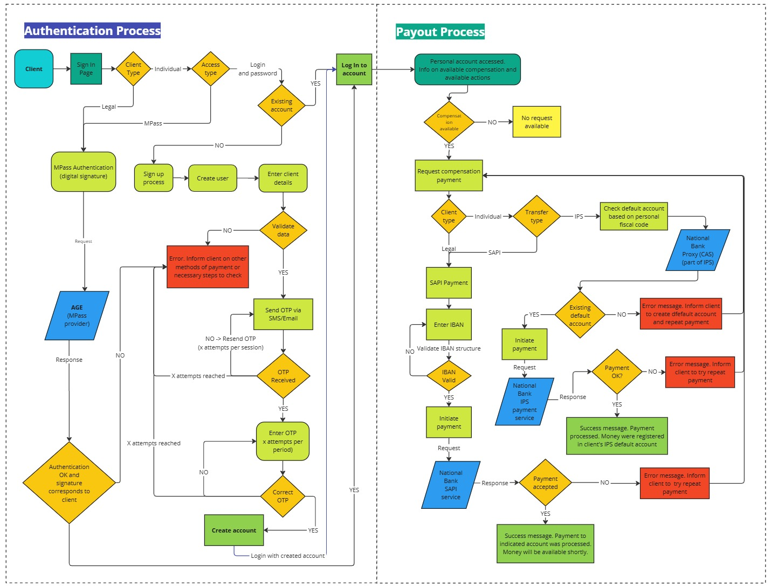
8. Guaranteed depositors can access the payment platform by clicking on the link received by e-mail/message or directly via the website.
9. The depositors' authentication on the FGDSB platform will be performed:
- Legal entities - only by electronic signature, applied by the entity administrator. The IDNO in the signature must match the IDNO of the eligible legal entity depositor.
- Individuals - by electronic signature or manual completion of the boxes containing personal data.
10. Validation of the electronic signature is done through the Electronic Government Agency service - MPass.
11. For individuals who enter personal data manually, their validation is done by comparing them with the list submitted by the liquidator. The list of mandatory data to be validated will be described in detail in an additional requirement. Security and encryption methods must comply with national standards and GDPR requirements.
12. Depositors whose data do not match the list of the liquidator will be identified by the MIS and notified with an error message. In this case, depositors will have the option to receive the compensation only via the paying agent.
13. For authentication, MIS will send a unique code (OTP) to the depositor's e-mail address or SMS to the telephone number indicated by the depositor and which coincides with the one provided by the liquidator. The depositor will enter the code on the platform, and if it is correct, the system will validate the data and grant access to the clearing platform, allowing the depositor to create an account and set a password.
Note: The provider may propose other validation methods that will ensure the identification of the guaranteed depositor.
14. Once the depositors have created an account on the FGDSB Payment Platform, they have access to all information on the guaranteed amounts.
15. In the event when the deposits of several member institutions become unavailable, depositors will be able to view data on the amounts guaranteed separately for each bank. The claim for compensation will be submitted separately for each member institution.
16. Depositors may request payment of the compensation to a bank account held in another licensed bank in the Republic of Moldova. Depositor will introduce the IBAN number to receive the compensation amount. If they do not have another account, they can withdraw the amount of the guaranteed deposit in cash at a branch of the paying agent or open a bank account at a later stage and enter the valid data into the system.
17. MIS will verify the validity of the bank account (IBAN and IDNP/IDNO/ID card No.) and will authorize the payment only if it is opened in the name of the depositor aiming the compensation. The verification shall be carried out on the basis of the information available within M-Connect or MIA Instant Payments (as the case may be). In case of IPS MIA transfer, if no default account is found, selection of this method will be disabled with an explanatory message.
18. The platform will allow transfer of the total amount of compensation available at the time of payment only in one installment. Payment will be made in national currency only. Payment cannot be made on amount greater than the eligible amount
19. The MIS will allow payments to be made through both the Automated Domestic Payment System (AIPS) and the MIA Instant Payment System. FGDSB will decide on the payment system available for each category of depositors (should be configurable from MIS per depositor type).
20. Holders of deposits pledged as collateral, pledged as security, subject to sequester or in litigation may authenticate themselves on the payment platform and request payment only on the amount of the pledged deposit available at the time of the request, and the amount of the temporarily unavailable deposit will be reimbursed to the depositor only after the latter has discharged all obligations and received confirmation from the liquidator. The total amount of compensation must not cumulatively exceed the coverage level.
21. Receipt of compensation through a representative or in the case of inheritances will be available through the paying agent or FGDSB based on the additional confirmation from the liquidator, and only after presentation of the confirming documents (power of attorney, guardianship, curatorship, certificate of heirs, etc.).
22. The MIS will allow temporary high balances depositors to apply for the payment of the additional amount of compensation through their personal account. This option will be available only to depositors who have eligible deposits above the coverage level and who have had inflows (other than between own accounts or interest payment by the bank) in their accounts in the last 3 months. In order to submit the application, they are required to upload the confirming documents, previously submitted to the bank, on the platform. The FGDSB will verify the information/documents received and, if necessary, may request the depositor to submit the original documents or certified copies. The FGDSB will have the option to accept/refuse the depositor's request.
B. Payment of compensation via the paying agent
23. Payment by the paying agent will be an option for payment of compensation.
24. The paying agent will need to have access to information on covered depositors and compensation amounts via an API, or limited access to the dedicated MIS platform.
25. Depositors will fill in an application form and submit the necessary documents (ID card/passport/ID) at the paying agent.
26. The payment made to each depositor through payment agent will be recorded in real time in MIS (using Agent dedicated platform or API), ensuring transparency and immediate update of the transaction status.
27. The paying agent will have access to certain data necessary to identify the depositor and the amount of compensation to be reimbursed:
For legal entities:
Name | IDNO | Administrator first name, last name | IDNP Administrator | Date of state registration | Compensation amount
For individuals:
Name | First name | IDNP/ identity card number | Date of birth | Compensation amount
28. MIS will allow FGDSB to generate customized and detailed reports in different formats (CSV, PDF, Excel, XML, etc.), which will include information on:
- eligible/guaranteed depositors;
- status of compensation payments;
- errors or discrepancies occurred in the data verification process;
- history of claims and payments made;
- financial analysis related to the amount of compensation made separately for each payment method (compensation platform or paying agent)
- payment method (AIPS or IPS);
- daily reconciliation of payments made (through the platform or paying agent) and generation of the information necessary for accounting of the operations in the FGDSB accounting system.
The reports will be accessible in real time on the clearing platform and will allow FGDSB to sort and filter the data based on different criteria (to be determined in the requirements analysis and design stage).
29. The platform will allow the authentication of several types of users, such as:
- the liquidator (presentation of the list of guaranteed depositors),
- employee of FGDSB (will have access to the settings for processing and validation of compensation claims, payment management and generation of financial reports);
- depositors (request the transfer of compensation to another bank account);
- paying agent (access to the list of guaranteed depositors and reconciliation reports).

30. Clients (depositors) management within MIS for FGDSB:
- Designated user roles will have access in MIS to the information on each client in Single Customer View (SCV) format (with all data included in the SCV files above)
- Modifications to client information will be restricted only to a specific user role (FGDSB employee), ensuring compliance with the "four-eyes" principle, registering logs and history of who initiated and who authorized these changes in MIS. Authorization of such changes is intended to be available only for the manager role.
- Ensure non duplication of clients
- View the list of clients and search for specific client.
- View information related to client’s activity on the payout platform.
- View history of compensations that were available per client and the corresponding payments made (type, payout method, period, other criteria) with possibility to access the payment document (payment order or transfer).

    - FGDSB Daily Operation Module
The daily operational module and daily processes.
This module integrates information related to the current operations carried out by FGDSB on behalf of the funds it manages, as well as data concerning its own financial resources. Currently, FGDSB manages two funds: the Bank Deposit Coverage Fund and the Bank Resolution Fund. The information system must allow the creation of new compartments structured according to the logic of the existing funds. Each fund has member institutions that contribute to the formation of its resources.
General dashboard: On the main dashboard, it will be necessary to display information such as: current availabilities (balances in current and deposit accounts); the total financial means of each fund; the latest available value of deposits and depositors; the coverage ratio of the funds; upcoming contribution amounts and their payment deadlines; ongoing payments; loans due for repayment, etc.
2.1. GENERAL ADMINISTRATION:
  - Funds Management. In line with its activities, it is important that the functionality provides the option to create a new fund, edit, or archive an existing fund type.
  - Management of the List of Member Institutions:
- Functionality to allow the options to include, edit, and archive the member institutions. A financial institution can be a member of multiple funds simultaneously, but not necessarily.
- Setting risk categories applicable for a defined period, with the historical record being maintained, which will be used for calculating specific indicators.
- Viewing data regarding the activities of member institutions (from monthly reports received from institutions or information received from BNM), organized separately for each institution.

  - DEPOSITS, DEPOSITORS AND CONTRIBUTIONS:
      - Monthly records of deposits, number of accounts and depositors in the banking system. Based on the data reported by the banks, the information will be aggregated to determine the aggregate value of deposits, total no. of depositors, no. of accounts at the end of each month. The data will be used to determine the size of ordinary contributions imposed on banks. The system should allow the data to be analyzed according to different criteria, including: category of depositor, amount of deposits, eligibility, evolution compared to previous periods, etc.
Reports in this section:
- Deposit’s and depositor’s statistics according to Forms 01 and 02 (see more);
- Reports related to ordinary and special contributions;
- Analysis of the full coverage according to different coverage levels;
- Deposit forecast report for the next 3-5 years;
- Other reports.
      - Calculation, Recording, and Collection of Contributions Separated by Funds:
- Calculation and collection of initial contributions:
- Viewing the initial contributions collected from member institutions.
- Determining the initial contributions for new members, and monitoring of its collection.
- Calculation and collection of regular contributions:
- Contributions for which the amount and payment term can be set manually.
- Contributions for which the amount and payment term are calculated automatically, taking into account the risk category of the member institution, and other indicators.
- Calculation and collection of special contributions (imposed on institutions in special cases for covering deficits):
- Manual calculation and recording, with subsequent monitoring of its collection.
- Automatic calculation and recording, with subsequent monitoring of its collection.

  - FINANCIAL RESOURCES:
- Daily record of the balances on the accounts of FGDSB must be structured by type of accounts, currency, availability in days.
- Recording of the total financial means of the funds, structured into inflows and outflows. The structure of this grouping will be fixed, including inflows and outflows of financial resources as follows:
- Inflows: ordinary contributions from banks, special contributions, investment income, late payment penalties, other sources.
- Outflows: invested financial means, withdrawals for the formation of the FGDSB budget, compensation payments, financing of resolution actions.
- Recording of the total financial means of the business account (FGDSB), structured into inflows and outflows. Will be structured by compartments that can be adjusted annually (will be described in the additional technical requirements).
- Inflows: receipts from managed funds, investment income, other sources.
- Outflows: payments to suppliers/service providers, other outflows.
- Initiation of Payments
- Possibility to create payments for operational activity of the FGDSB;
- Support single and bulk payments using imported files (from 1C Enterprise, excel, xml);
- Possibility to initiate compensation payment from Customer profile;
- Payment options include RTGS, DNS, and IPS;
- Implementation of the four-eyes principle for all payments initiated by system users;
- IPS payments must be possible 24/7, while DNS/RTGS payments are subject to predefined schedules.
- Determining/assessing and revising the target level of the bank deposit coverage fund
For this report it is important to develop the possibility to input initial data in order to run two simulations. These simulations will be used to establish the minimum resource requirement for the Bank Deposit Coverage Fund. An indicator will be obtained, expressed as a percentage of the total volume of guaranteed deposits, which will be used to determine the size of annual contributions.
Initial data include: assets and capital of the bank; value of deposits (term and sight); value of the loan portfolio, categorized by performance; provisions and guarantees. On the basis of the initial data, banks will be classified according to their size, exposure to shocks for credit risk, and will be analyzed based on specific scenarios.
Detailed information will be described in the additional technical requirements (during the requirements analysis and design phase).
- Loans and related costs
- Management of loans contracted by the Funds, with visualization of repayment schedules and payment notifications.
- Calculation and accrual of calculated interest, transitioning interest to payment according to the repayment schedule.
- Loans and interests payments forecast.
Report on the debts portfolio (per funds). The report will include information related to the available FGDSB lines of credit, the lender, the maximum amount, the costs, and the period during which they are available. Other information related to loans contracted.

  - INVESTMENT ACTIVITY OF THE FGDSB
FGDSB separately manages three accounts (FADB-Bank Deposit Coverage Fund, FRB-Bank Resolution Fund and FB-Business Account) and conducts investment activity on behalf of the funds' resources managed in accordance with LP160/2023, approved investment policies. The investment process includes planning, approving, implementing, monitoring, evaluating, and reporting investments in low-risk liquid assets.
The investment portfolios of the FGDSB may consist of the following financial instruments:
- Government Securities - Treasury Bills and Government Bonds, issued by the Ministry of Finance R.M.;
- Term deposits with the NBM in MDL and foreign currency;
- Securities issued by EU governments;
- Euro deposits with the European Central Bank;
- Securities of highly rated international financial institutions (Moody's, S&P).
      - Investment portfolio management
- Detailed and separate records of investment portfolio;
- Records of all in/out transactions of financial instruments;
- Evidence of the value of financial instruments at amortized cost and fair value;
- Record of income received by assets, portfolios, issuers, etc.;
- Calculation and record of allocated income related to each asset;
- Simulating the fair value of assets based on hypothetical interest rates;
- Automated/manual import of interest rates set at auctions for the issuance of VMS (usually bi-monthly);
- Manual input/automatic import of the primary data related to the financial instrument, such as: type, ISIN, date of purchase, issue, maturity, price, quantity;
- Automatic calculation of other financial instrument characteristics, e.g.: par value, yield, maturity, income, etc.;
- Automatic portfolio position and related adjustments.
      - Annual investment plan
- Generate the Annual Investment Plan;
- Enter investment limits, thresholds and monitor compliance;
- Comparison between planned and realized investments;
- Automatic reporting on the execution of the Annual Investment Plan.
      - Monitoring and reporting
The following important aspects should be taken into account when defining reports:
- Asset structure by type, issuer, currency, date of purchase, maturity (residual and initial), yield, periods, etc.;
- Provision of data on investment transactions, including associated indicators and revaluations of financial instruments;
- Generation of standard and customized reports (PDF, Excel, other formats);
- Automated alerts related to investment activity.
Reports types
(1) Report on the overall investment portfolio of the FGDSB: totaling data from the investment portfolio of the Bank Deposit Coverage Fund, Bank Resolution Fund, Business Account.
(2) Report on the investment portfolio at a given point in time.
(3) Report on investments made at a given period.
(4) Report on investments repurchased in a given period.
(5) Report on future investment flows. The report will include the future flows categorized according to the availability of the investment: immediately available (deposit accounts), available within the next 7; 8-91; 92-182; 183-364; >364 days.
(6) Report on the investment portfolio at book value and fair value (discounted). For this report, at least a partially automated mechanism should be implemented, where auction results will be systematized. Based on the latest available results the revaluation of the investment portfolios will be implemented. The re-evaluation will track which investments will not be able to be capitalized at minimum acceptable costs for the FGDSB in order to inform decisions on efficient portfolio management.
(7) Report on investment income calculated and received/to be received in a given period. The report will include information for each investment instrument, structured by type and reference period. It shall reflect the calculated income and the time of its receipt. If the income relating to a particular instrument has not been received during the reference period, the report shall indicate separately the date on which the income falls due.
(8) Report on the performance of the investment portfolio. The report will be generated on the basis of established indices. Value of the indices should be configurated in the system.

  - MANAGEMENT REPORTS, DATA EXCHANGE AND CONTRACTS
  - Reporting. Processing and presentation of data reported by banks for a specific date or for a period, per bank/ collection of banks or total (total deposits, eligible deposits, guaranteed deposits, excluded deposits, by type of client, eligible deposits per available data on coverage amount).
- Integration and data extraction from existing database (existing reporting solution platform), or creation of a new similar platform.
- Visualization of data evolution per system / per bank and financial indicators, including graph visualization.
- Report on paid compensations for a period by payout method, agent, per financial institution in liquidation, client type, type of deposit, type of compensation and other criteria.
- Unpaid compensations report.
- Report on Sufficiency of funds for covering each member institution.
- Estimation on sufficiency of funds for different coverage amounts.
- Other types of reports.
  - Contracts management
- Management of contracts and additional agreements signed by FGDSB with suppliers and payment agents.
- Centralized storage of contracts and related documents;
- Generate reports on active, expired contracts.
  - Exchange of information with the National Bank of Moldova:
- Incoming data from NBM related to each financial institution;
- Outcoming data from FGDSB to NBM based on the existing data in MIS.

3. Financial Bookkeeping Module
The Financial Bookkeeping module will include the following essential features and functionalities:
- General ledger with multi-currency accounting capabilities.
- Automation of reconciliation processes.
- Automatic recording and tracking of account transactions and viewing detailed statements for each account.
- Real-time and historical views of fund balances by account type (e.g., Deposit Coverage Fund, Resolution Fund, Business Account), account, and currency.
- Detailed account-level transaction history with period-specific balances and average balance computations.
- Comprehensive dashboard for monitoring key financial metrics and fund performance.
- Automatic import and application of official exchange rates from the National Bank of Moldova (via XML integration).
- Integrated budget control functionality, including budget formulation, allocation, and expense tracking.

MIS needs to be integrated with the accounting solution within FGDSB (1C Enterprise) or to have automated recording operations within the accounting solution. The main operations are (but not limited to):
  - Exporting payments from the MIS into the accounting solution.
  - Exporting investment information from the MIS into the accounting solution.
  - Exporting other financial data from the MIS that need to be recorded in the accounting solution.
  - Calculating and importing/exporting provisions and other types of increases.
  - Exporting/importing balances and accounting transactions.
  - Automated import/export of other financial data between the MIS and the accounting solution.
The integration/exchange of information can be done via API or automated file exchange (XML, or other file formats).

General Requirements:
1. Users and Access Rights functions:
- User management and role-based access control.
- Configurable permissions to support the principle of least privilege.
- Implementation of secure sign-in procedures, potentially exploring MPass for user registration and authentication.
- Audit trails for all user activities to ensure compliance and security.
2. Dashboard and other requirements software-hardware:
- MIS will provide a role-based customized dashboard, ensuring that each category of users has access only to the functionalities, data, and reports relevant to their specific responsibilities.
- User interfaces will be developed in the Romanian language.
- API interfaces with external information systems.
- Scalability in terms of both the number of users and the volume of information managed.
- All performance tests will be conducted before the delivery of the software solution.
- Performance tests will include at least two components: load testing and stress testing.
- Creation of a database backup.
- Data restoration from the backup.

    - Documentation requirements of the information system:
- The user manual describes the components of the information system accessible to different human user roles.
- The administrator manual describes the workflow management functions, the overall IT system, and the manual procedures required to maintain and operate the software solution.
- The solution includes a brief description of the IT system.

    - Final product and delivered components:
- Final product packaged for easy installation in the proposed technology environment;
- Technical task updated and completed during development;
- Technical design;
- System configuration document.
Knowledge transfer and support includes artifacts and services:
- Training materials;
- User and administrator training;
- Assistance during system piloting;
- System acceptance testing assistance;
- Assistance in putting the system into production;
- Troubleshooting deficiencies identified during piloting and acceptance testing.

5. NBM Payment Channels Integration:
SAPI integration (DNS/RTGS) (as per NBM technical documentation):
- Integration via APIs with NBM for receiving and sending ISO 20022 MX messages using NBM API for RTGS and DNS
  - OR another option is to use NBM STP Adapter
    - Participant Core application interacts with the Adapter locally (inside Participant’s LAN). Adapter takes care of secure and robust remote communication (serves one user connection per instance) with the Core System (in NBM). For every adaptor certain settings can be enabled to automatically digitally sign content of outgoing messages and verify digital signatures of messages incoming from the Core System.
    - Adapter can interact with Participant core application by means of the following interfaces:
      - SOAP based web services;
      - File exchange;
      - JMS (for MQ integration)
- Signing of messages
- Payment initiation messages (pacs.008, pacs.009) and process corresponding confirmation messages (pacs.002, camt.054) or error messages
- Receiving of payment messages (pacs.008, pacs.009, pacs.010) and corresponding confirmation messages (camt.054)
- Session report based on camt.053 and validation with executed payments.
6. Instant Payments System integration (IPS) (as per NBM technical documentation)
- Integration with the National Bank of Moldova (NBM) Proxy (Central Addressing Scheme, CAS) to retrieve default account details via Alias
- Send and receive ISO 20022 MX messages using NBM API
- Payment initiation messages (pacs.008), processing confirmation or rejection messages (pacs.002, STAT, or RJCT), or error messages.
- Receiving of payment messages (pacs.008) and confirmation (pacs.002, STAT)
- Signing of messages
- Capability to retrieve and validate transaction reports from IPS (using NBM API), including clearing session validations (camt.053), and validate payments executed with the reports.
- Ability to initiate payments in real time, ensuring 24/7 payment processing for IPS transactions.
7. General data and indicators:
There should be a section where it will be possible to configure and edit in MIS the nomenclature (different texts, values and indicators) used for several purposes within the system. Examples of values (but not limited to):
  - Guarantee amount (with period of application);
  - Setting of Business days (working days);
  - BIC codes and names of payment providers;
  - Applicable limits for automatic payments initiated by client;
  - Change configurations of APIs;
  - Payment systems available for each category of depositors;
  - Currencies;
  - Applicable sign in options per client type;
  - Residence statuses;
  - Client types;
  - Types of identity documents;
  - Countries;
  - Legal forms of organization;
  - Employment statuses;
  - Citizenship;
  - Guarantee status and corresponding code;
  - Account types;
  - Guarantee scheme members and corresponding information;
  - Payment agents;
  - Target Fund Rate (with period of application);
  - Values indicators used for reports;
  - Other.
Note: other mandatory indicators will be included during the requirements analysis and design stage.

Glossary of Terms:
List of Depositors
Structured digital files, prepared and submitted by the liquidator, containing detailed records of depositors. These files are not a simple list, but include mandatory formats, personal data, account balances and legal qualifications as per the technical specifications of the FGDSB.

SCV (Single Customer View)
Standardized data set on personal and contact data of eligible depositors, both natural and legal persons, necessary for their identification, as well as on eligible deposits held in the bank whose license has been withdrawn by the NBM, which the liquidator is obliged to transmit to the FGDSB within 3 working days from the date of unavailability of deposits.

Eligible Depositor
An individual or legal entity, the holder of a deposit or, in the case of a joint account, each of the holders of a deposit, that is not excluded from coverage under LP 160/2023.
Joint Account
An account opened in the name of two or more persons or over which two or more persons exercise rights based on the signature of one or more of those persons.
Temporary Unavailable Deposit
Deposit that is due and payable but has not been paid by the member institution in accordance with the legal or contractual conditions applicable when the National Bank of Moldova has ordered the forced liquidation of that member institution (deposits pledged as collateral, given as collateral, subject to seizure or subject to legal proceedings).
Excluded Deposits
Deposits not guaranteed by the Deposit Guarantee Fund in the banking system, including:
- Deposits of legal entities controlled by the member institution;
- Deposits placed by other banks or other organizations licensed or authorized by the NBM, CNPF or foreign supervisory authorities;
- Deposits of central or local public authorities, including foreign;
- Deposits declared illicit by court order and deposits originating from activities related to money laundering and terrorist financing;
- Deposits whose holders have not been or cannot be identified;
- Deposits or other instruments that count towards the member institution's regulatory capital, according to applicable legislation.

Guaranteed Deposits
That part of the eligible deposit, including accrued interest, calculated at the date of unavailability of the deposit, which does not exceed the coverage level prescribed by law and is guaranteed by the deposit guarantee scheme.
Temporary High Balances (deposits with a 200% coverage level)
Deposits that benefit from an increased coverage level of 200% for a period of up to 3 months after the amount has been credited or from the date on which the deposits can be legally transferred, if they arise from events such as: deposits by individuals arising from real estate transactions involving immovable property for rental purposes; amounts deposited as settlements or compensation arising from divorce, retirement, dismissal, disability, death; and deposits by individuals arising from the payment of insurance compensation or reparation for damages caused by crime or unlawful conviction.
Compensation platform
The official online portal through which the FGDSB will transfer to eligible depositors, to a bank account in another member institution, the amount of compensation due.
Paying Agent
The bank appointed by the Deposit Guarantee Fund to compensate a member institution's depositors in cases where their deposits become unavailable.
OTP (One Time Password)
A unique code, valid for a short period of time, sent to the depositor's registered email or telephone number, used for secure authentication on the clearing platform.
MConnect
Is the interoperability platform developed by the Government of the Republic of Moldova. It serves as a technological solution to ensure secure and standardized data exchange and interoperability between various information systems used by public institutions and other stakeholders.
MIA (Instant Payment System)
Instant payment system allowing fast and secure transfers based on the beneficiary's telephone number.
MPass
National electronic identification and signature service, provided by the Electronic Government Agency, used to validate electronic signatures.
SAPI (Automated Domestic Payments System)
The system through which payments in Moldovan Lei are made on the territory of the Republic of Moldova.

Note: For the purposes of this document, the terms and definitions shall be interpreted in accordance with the provisions of Law No. 160/2023.

Translator’s explanatory note: The translation of the Tender Documents is provided as a free translation from Romanian, which is official and bidding version.
See detailed Business processes description in the Annex to the Requirements for the Management Information System (MIS).
Minimum costs represent the purchase value of the investments plus the income accumulated up to the date of sale of the securities, without the invested capital being affected.

